16 October 2019

Response form for the Joint Consultation Paper concerning amendments to the PRIIPs KID

Date: 16 October 2019
ESMA 30-201-535
Responding to this paper
The European Supervisory Authorities (ESAs) welcome comments on this consultation paper setting out proposed amendments to Commission Delegated Regulation (EU) 2017/653 of 8 March 2017 (hereinafter “PRIIPs Delegated Regulation”).

The consultation package includes:
• The consultation paper
• Template for comments

The ESAs invite comments on any aspect of this paper. Comments are most helpful if they:
• contain a clear rationale; and
• describe any alternatives the ESAs should consider.

When describing alternative approaches the ESAs encourage stakeholders to consider how the approach would achieve the aims of Regulation (EU) No 1286/2014 (hereinafter “PRIIPs Regulation”).

Instructions
In order to facilitate analysis of responses to the Consultation Paper, respondents are requested to follow the below steps when preparing and submitting their response:
- Insert your responses to the questions in the Consultation Paper in the present response form.
- Please do not remove tags of the type <ESA_QUESTION_PKID_1>. Your response to each question has to be framed by the two tags corresponding to the question.
- If you do not wish to respond to a given question, please do not delete it but simply leave the text “TYPE YOUR TEXT HERE” between the tags.
- When you have drafted your response, name your response form according to the following convention: ESA_PKID_nameofrespondent_RESPONSEFORM. For example, for a respondent named ABCD, the response form would be entitled ESA_PKID_ABCD_RESPONSEFORM.
- The consultation paper is available on the websites of the three ESAs and the Joint Committee. Comments on this consultation paper can be sent using the response form, via the ESMA website under the heading ‘Your input - Consultations’ by 13 January 2020.
- Contributions not provided in the template for comments, or after the deadline will not be processed.

Publication of responses
All contributions received will be published following the close of the consultation, unless you request otherwise in the respective field in the template for comments. A standard confidentiality statement in an email message will not be treated as a request for non-disclosure. A confidential response may be requested from us in accordance with ESAs rules on public access to documents. We may consult you if we receive such a request. Any decision we make not to disclose the response is reviewable by ESAs Board of Appeal and the European Ombudsman.

Data protection

The protection of individuals with regard to the processing of personal data by the ESAs is based on Regulation (EU) 2018/1725. Further information on data protection can be found under the Legal notice section of the EBA website and under the Legal notice section of the EIOPA website and under the Legal notice section of the ESMA website.

General information about respondent

Name of the company / organisation | Norwegian Consumer Council
Activity | Non-financial counterparty
Are you representing an association? | ☒
Country/Region | Norway

Introduction
Please make your introductory comments below, if any:

<ESA_COMMENT_PKID_1>
The Norwegian Consumer Council is an independent organization who has represented Norwegian consumers interest since 1952. The consumer council had a crucial role in the clearance work that followed a decade of misselling structural products in Norway by providing judicial clarity about the consumer rights in matters of complex packaged retail investment products by several legal proceedings.
The supreme court in Norway pronounced the verdict in the Roeggen-case in 2013 making it clear that DNB - the largest bank in Norway – that “[125]:
The bank's disclosure obligation must […] be evaluated strictly. It does not mean a requirement that all conceivable situations must be described. But in the sale of risky and complex products to non-professional investors, the bank must assure itself that the customer understands the content of the transaction he is entering into, and not provide misleading or erroneous information about important circumstances of significance for the investment decision”. The verdict also states “[128] … the bank has a responsibility to provide correct, level-headed and realistic information when it enters into agreements with small savers and inexperienced investors. The bank should have, as the professional party, emphasised to a greater degree that continued uninterrupted and strong growth in the stock market was an uncertain scenario, and not satisfied itself with noting this in small type in the prospectus. Moreover, the bank should have – in marketing complicated products such as this – explained the risk with the products and the consequences of debt-financing in a way that was suited to non-professional investors.”

We attach two translated verdicts from the Roeggen–case (Supreme Court and City Court) in our response to this hearing. They underscore the importance of not caving in to the demands of manufacturers of complex structured products to simplify disclosure requirements.

The wide-spread mis-selling scandals of structured products in Norway in mid two-thousands also resulted in a national detailed regulation on structured products. The regulation was made in fellowship of the ministry of finance and consumer advocates in NCC and is available at https://lovdata.no/forskrift/2016-12-09-1502/§16-2 (Norwegian only).

The regulation and the Roeggen-verdict together has effectively prevented further misselling of structured products in Norway but also many other complex investment products. The coming changes of the European PRIIPs and KID regulation must not undermine the hard fought improvements in investors protections from often needlessly complex financial products.

After reading through the proposal we get an impression that the manufacturers of complex structured products find it difficult to compute the various mandated scenarios. A number of questions therefor ask whether to simplify the disclosure for these types of investment products. We believe this may lead the KID down a slippery slope.

Firstly, it’s the manufacturers themselves who create these products and present them as useful investment tools for investors. Compared to typical UCITS funds that are relatively straightforward to understand, structured products tend to be opaque and difficult to understand both with regard to implicit cost elements, expected return and variability of outcomes.

Secondly, if the manufacturers themselves are unable to model various scenarios we can only begin to imagine how hard it is for retail investors to understand the products. Thus the impetus should not be to simplify the manufacturing process for these products to make life simpler for the suppliers. The point is to make the products understandable for retail investors. If the manufacturers are unable to model the required KID scenarios they should not sell these products in the first place.

Therefore, the Norwegian Consumer Council would like to point out that it is important to conduct a thorough consumer testing study, in order to get valuable insight from non-professional retail financial consumers on how the information in the KID should be presented.

A reduction in supply of structured financial products does not equate to a loss for humanity. If history gives pointers to the future a disconcertingly high share of these products are deliberately created in order to obfuscate the true cost and return properties for retail investors. To its credit the PRIIPs KID regulation has put the real return characteristics of these products on display. We expect the result is either a reduction in demand or improvements in terms to the benefit of the investors. It would be paradoxical to loosen the disclosure requirement just because they are working as intended.

Overall, the aim of the PRIIPs Key Information Document (KID) must be to ensure that retail financial consumers receive relevant information in an understandable and standardised form about the financial product, including clear and appropriate guidance and risk warnings associated with the investment, so that consumers are able to make informed investment decisions. The PRIIPs KID is important in order to understand the specific investment product, but also in order to compare various investments. It is important that the total cost (price) that retail financial consumers can expect to pay must be very clearly stated in the KID.

The proposed regulation involves imposing important requirements for investment product manufacturers to prepare a mandatory KID in a standardised format. Any KID must explain, in clear and simple language:
• What the investment product is
• The total costs, including fees and kickbacks, of the investment product
• The historical performance of the investment product
• The risks and potential rewards of the investment product

It is important to stress that the KID should include calculations on all annual costs, including fees and kickbacks, and what the aggregated costs will be in 5 and 10 years from now. Such information should be disclosed in percentages as well as in monetary value for a standardized amount; possible such default amount limits, depending on the product, may be € 5,000, € 10,000, € 25,000 or € 100.000.

The Norwegian Consumer Council support many of the proposals that are submitted in the joint consultation paper from the ESAs on improvements, however with some exceptions and clarifications. See our answers on the following pages, Q1 - Q57.

<ESA_COMMENT_PKID_1>

- : Are there provisions in the PRIIPs Regulation or Delegated Regulation that hinder the use of digital solutions for the KID?
<ESA_QUESTION_PKID_1>
Not that we are aware of.
<ESA_QUESTION_PKID_1>

- : Do you agree that it would be helpful if KIDs were published in a form that would allow for the information to be readily extracted using an IT tool?
<ESA_QUESTION_PKID_2>
Yes, especially for purposes of analysis where we want to compare or analyse a larger selection of KIDs. Being able to extract data easily will lower the threshold for this kind of analysis. For price comparing sites, such as our own Finansportalen.no it would be of great importance. A regulation that don’t allow information to be readily extracted by an IT tool would be obviously outdated.
<ESA_QUESTION_PKID_2>

- : Do you think that the amendments proposed in the consultation paper should be implemented for existing PRIIPs as soon as possible before the end of 2021, or only at the beginning of 2022?
<ESA_QUESTION_PKID_3>
Ideally we think that the whole package should be implemented at the same time.
<ESA_QUESTION_PKID_3>

- : Do you think that a graduated approach should be considered, whereby some of the requirements would be applied in a first step, followed by a second step at the beginning of 2022?
<ESA_QUESTION_PKID_4>
Ideally we think that the whole package should be implemented at the same time, unless there are some amendments with a complexity of implementation that risks holding up the bulk of the amendments for an inordinate amount of time.
<ESA_QUESTION_PKID_4>

- : Are there material issues that are not addressed in this consultation paper that you think should be part of this review of the PRIIPs Delegated Regulation? If so, please explain the issue and how it should be addressed.
<ESA_QUESTION_PKID_5>
The consultation paper lacks wider context on certain important topics, as there are no reference to the wider implications of investment decision making and climate risk (i.e. COP21, SDGs) and the role investors play in shaping the world we live in (issues such as climate change, employment practices, etc.)

All relevant retail investment products should highlight the main features regarding their environmental and social objectives in their KIDs in an understandable way. Such information need to be presented in a way that is clear to both consumers and institutional investors. One possibility could be to build upon a type of colour rating system with a scale similar to the already well-known EU energy label, where a solid green A is the most energy efficient and a deep red G the least efficient.

In order to ensure that a rating give the correct expression of the sustainability of a financial product, an independent third party should carry out such classification. This would also provide non-professional investors with valuable and trustworthy information prior to a transaction, and might be used as a potential differentiator between funds.

Adding ESG criteria to the PRIIPs KID would also be in line with the proposals from the European Commission and the Council of the European Union for a regulation on EU climate transition benchmarks and EU Paris-aligned benchmarks. Providing investors with relevant information about the sustainability of an investment would also follow up on the 2016 Paris Agreement on Climate Change and the United Nations 2030 Agenda for Sustainable Development, and would support in transforming Europe’s economy into a greener, more resilient and circular system.

We experienced attempts of exclusion of liability in providing credible product information to consumers in our national mis-selling scandals of structured products and other complex investment products. This came typically in complex business models including parties defining themselves as facilitators, mediators or arrangers - which is diffuse for the average consumer. It must be clear part in a complex business model that has the responability to provide credible product information to consumers.
<ESA_QUESTION_PKID_5>

- : Do you have comments on the modifications to the presentation of future performance scenarios being considered? Should other factors or changes be considered?
<ESA_QUESTION_PKID_6>
NA
<ESA_QUESTION_PKID_6>

- : If intermediate scenarios are to be included, how should they be calculated for Category 3 PRIIPs (e.g. structured products)? If intermediate scenarios are not shown in the performance section, which performance assumption should be used for the ‘What are the costs?’ section?
<ESA_QUESTION_PKID_7>
While we do not have an alternative way of calculating intermediate scenarios we think that they provide valuable and relevant insight for the retail investor. Some structured products do indeed include provisions for an early end if certain events occur. This need to be presented to the retail investor. With a number of structured products, such as autocalls (which in our opinion are highly unsuitable products for retail investors), there are provisions for automatic redemptions which will prevent them from reaching maturity. The investors are in effect issuing call or put options. To only show expected yield at maturity would be a disservice to the retail investors.

If it is too hard for the issuers to calculate intermediate scenarios we can only imagine how hard it is for the retail investors to understand what they are buying. The Norwegian Consumer Council experience that most structured products are unsuited for retail investors in the first place. If the issuers are unable to model relevant scenarios they should probably not be selling these products at all.

Below is a screenshot of a KID for an auto call issued by Danske Bank. It illustrates how automatic redemptions can have severely negative impact on expected yield. It also shows that only one out of 12 modelled outcomes results in a positive return. This information would be lost without intermediate scenarios and we can understand why the manufacturers would rather not disclose this.

https://priips.danskebank.com/w/show_priips.priips_dok?id=STN_Autocallable_FI4000375506_English&lang=en
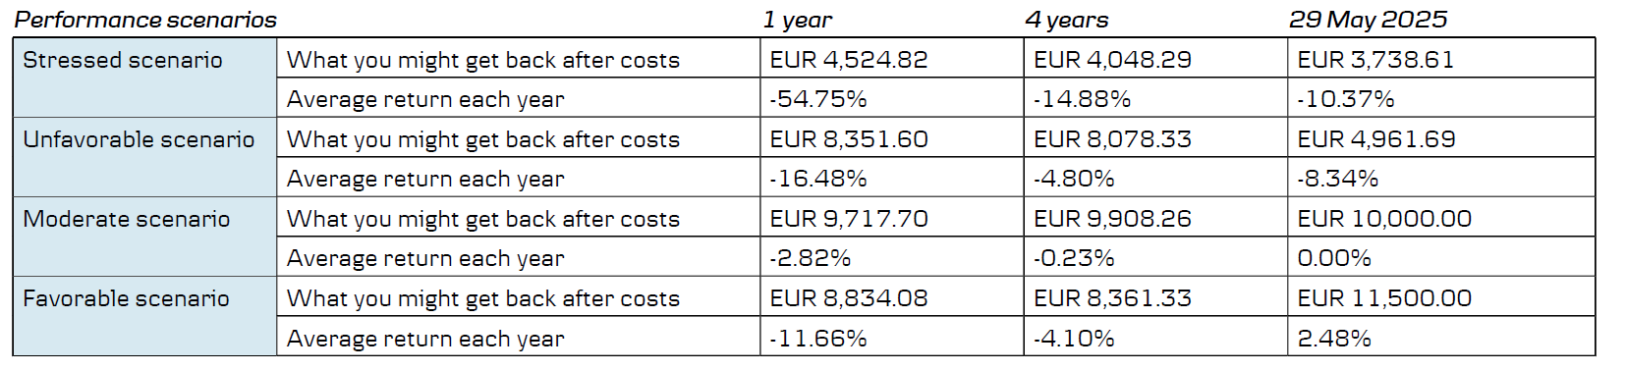
<ESA_QUESTION_PKID_7>

- : If a stress scenario is included in the presentation of future performance scenarios, should the methodology be modified? If so, how?
<ESA_QUESTION_PKID_8>
We understand that the current low interest rates and recent volatility has been abnormally low. However, a five year historic period is very short in the greater scheme of things. In comparison, the US equity premium is calculated using a period of over 100 years. If we could suggest an alternative approach for calculating volatility we would extend the length over a much longer period of time. Prior to the financial crisis in 2008 the observed volatility was also abnormally low (if we recall correctly). In retrospect, the short-term volatility was calm before the storm and turned out to have little predictive value of what happened next.

Finans Norge (Finance Norway), which is an interest organization for financial companies in Norway, have issued standard rates for the equity risk premium, equity volatility and interest rate risk premiums which the industry use in their forward looking performance scenarios. By using the same assumptions the industry avoids an unrealistic rat race where the winner is the most fanciful issuer who projects the highest expected return. This may be an alternative approach to only using five years historical data (noise) to predict the future.

This approach may not work on negative interest rates, but if the models does not permit negative growth rates maybe one could use zero growth as default under this circumstance.
<ESA_QUESTION_PKID_8>

- : Do you agree with how the reference rate is specified? If not, how should it be specified?
<ESA_QUESTION_PKID_9>
We agree that reference rates based on academic consensus and risk premiums based on long-term data series represent a reasonable approach. We may be more sceptical about using only five-year time frames for variance, skew and excess kurtosis of the return distribution. This time period seems too short to capture high volatility market conditions which in the past seems to occur with roughly 10 +/- year intervals.

To illustrate our point we enclose two volatility charts from two academic papers on volatility which illustrates how relatively long periods of low volatility erupts in sudden bursts of high volatility. In our opinion it may thus be worthwhile to use longer time series also for volatility measures.

https://www.policyuncertainty.com/media/Policy%20News%20and%20Stock%20Market%20Volatility.pdf

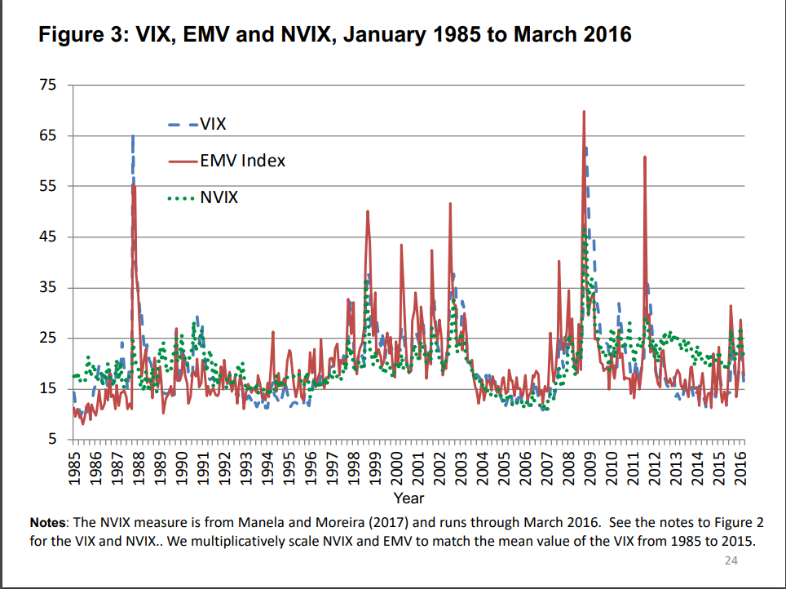

https://www.nber.org/papers/w16976.pdf
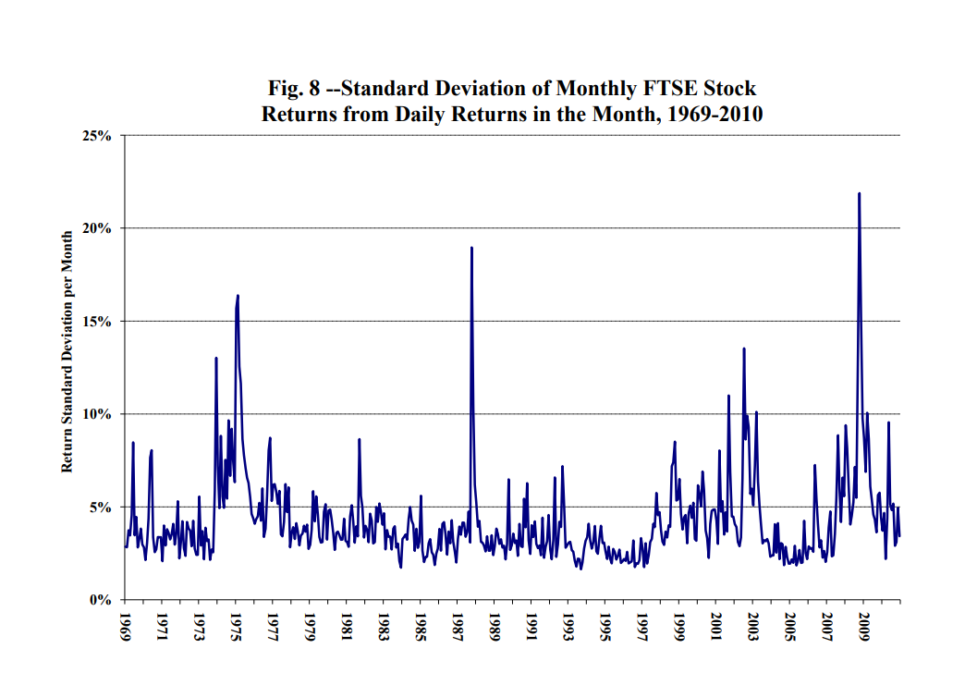

<ESA_QUESTION_PKID_9>

- : The revised methodology specifies that the risk premium is determined by future expected yields. The methodology further specifies that future expected yields should be determined by the composition of the PRIIP decomposed by asset class, country and sector or rating. Do you agree with this approach? If not, what approach would you favour?
<ESA_QUESTION_PKID_10>
Overall we agree with the revised methodology. It may be wise not to create a proliferation of different rates by creating too many sub segments. We may for instance question the need to break the rates into different sectors. One sector with an historical high yield need not deliver superior future yields to a sector with historic low yields. Rather the opposite tends to happen with mean reversion.
<ESA_QUESTION_PKID_10>

- : The ESAs are aware that historical dividend rates can be averaged over different time spans or that expected dividend rates can be read from market data providers or obtained from analyst reports. How should the expected dividend rates be determined?
<ESA_QUESTION_PKID_11>
In general, the longer the time series, the better.
<ESA_QUESTION_PKID_11>

- : How should share buyback rates be estimated?
<ESA_QUESTION_PKID_12>
NA
<ESA_QUESTION_PKID_12>

- : Do you agree with the approach for money-market funds? Are there other assets which may require a similar specific provisions?
<ESA_QUESTION_PKID_13>
We believe the probabilistic method represents a good approach for equity based products and options. Once we introduce interest rate based products it becomes trickier as we do not believe we can identify an empirical growth rate for the level of interest rates.

This also applies for hybrid funds which has gained much popularity among Norwegian consumers - particularly as an asset class in pension schemes.

The national experience on hybrid funds (UCITS fund combining stock and money-market funds) is that several of these funds are marketed with government bond benchmarks which do not reflect the actual credit or duration risk of the actual fund portfolios. As a result these funds typically show an over-performance which would vanish with a more representative benchmark. The inherent deficiency of the indexes are typically not communicated to the consumers. This has been pointed out by the Norwegian FSA, but hybrid fund providers have in general not changed their approach.

In 2019 the NCC has identified that there is still lack of compliance on this matter and published our results in https://fil.forbrukerradet.no/wp-content/uploads/2019/10/rapport-kombinasjonsfond-og-fondsprofiler.pdf (Norwegian only).
<ESA_QUESTION_PKID_13>

- : The methodology proposes that the future variance be estimated from the 5-year history of daily returns. Should the volatility implied by option prices be used instead? If so, what estimate should be used if option prices are not available for a particular asset (equities namely)?
<ESA_QUESTION_PKID_14>
See our answer on Q8. We believe that five-year time series are too short to capture expected average volatility. Otherwise we have no opinion on what is the best alternative of implied option price volatility or historic daily returns.
<ESA_QUESTION_PKID_14>

- : Do you think compensatory mechanisms for unforeseen methodological faults are needed? If yes, please explain why.
<ESA_QUESTION_PKID_15>
We are sceptical about accepting too much leeway for the suppliers to use other methods if they are unhappy with the forecast. The recent past has shown that a significant number of structured products sold to retail investors indeed have a negative expected return profile. If issuers can claim methodological faults and create alternative forecasting methods for their particular products, they will do so at the typical detriment of the retail investor. If there are methodological faults, this needs to be fixed by the regulator and not be left to the discretion of the suppliers.

Two of the proposals for compensatory mechanisms were based on adjusting expected returns if projected returns did not match minimum or maximum past returns. The efficacy of this approach depends on the definition of “past.” If the time series are sufficiently long, we believe there will be observations of both extreme highs and extreme lows for most products.
<ESA_QUESTION_PKID_15>

- : Do you favour any of the options above? If so, which ones? How would you ensure that the information in the KID remains comparable for all products?
<ESA_QUESTION_PKID_16>
We are uncertain whether it should be an absolute aim to maintain a 100 percent comparability between products. The return characteristics between a UCITS equity fund and an exotic structured product can be vast. While it can be sufficient to apply the MiFID II methodology for UCITS funds, a different approach is required for structured products with automatic redemptions such as autocalls.

In general, we think the proposed methodology would be a significant improvement over the current and pro-cyclical method. If the past is to be used as a prediction for the future, then the time-series need to be long enough to capture both ups and downs in the market.
<ESA_QUESTION_PKID_16>

- : Are there any other compensatory mechanisms that could address unforeseen methodological faults? If yes, please explain the mechanism; explain how it ensures that scenario information in the KID allows investors to compare PRIIPs, and explain how the information for similar products from different manufacturers remains sufficiently consistent.
<ESA_QUESTION_PKID_17>
NA
<ESA_QUESTION_PKID_17>

- : What are your views on the use of a simplified approach such as the one detailed above, instead of the use of probabilistic methodologies with more granular asset specific requirements?
<ESA_QUESTION_PKID_18>
We are open to a more simplified approach, as we also mentioned in Q10. Fewer sector or regional rates will simplify the comparison across borders and sectors and avoid a pro-cyclical focus on products that have done well in the recent past, which is not usually a good predictor of the future.

On the other hand, there are probably already a number of countries with universally accepted rates being applied across the industry. As mentioned, Finance Norway has established rates that are loyally being used by asset managers when making return projections. A simplified approach with one European rate to rule them all may not be an improvement on what is already being done in Norway.
<ESA_QUESTION_PKID_18>

- : Do you consider the use of a single table of growth rates appropriate? If no, how should the methodology be amended?
<ESA_QUESTION_PKID_19>
It makes sense to have one shared maximum growth rate for equities across countries. We assume the maximum growth rate will in effect also become the minimum growth rate for the issuers. The maximum rate should thus reflect the expected growth rate. The same also goes for property.

We are unsure how a maximum growth rate would apply to bonds and money market instruments with a predetermined interest rate. A plain vanilla bond typically has a fixed coupon rate and will not pay out more than the coupon and the invested amount if held until maturity. If anything, it will pay out less in case of a default. The same goes for money market funds. The interest rate is what it is and will most likely follow a random walk pattern.
<ESA_QUESTION_PKID_19>

- : More generally, do your views about the use of a probabilistic methodology vary depending on the type of product (e.g. structured products vs non-structured products, short-term vs long-term products)? For which type of products do you see more challenges to define a probabilistic methodology and to present the results to investors?
<ESA_QUESTION_PKID_20>
The probabilistic method is best suited for equity-based products where it is possible to distil an equity-risk premium based on long time-series. Property too, but probably to a lesser extent.

When it comes to bonds and money market funds we are not convinced that the probabilistic method is appropriate. The expected nominal yields will be defined by the coupon rates and default risk.
Structured products are difficult to pin down, but in our opinion they are often constructed in opaque ways in order to hide costs and obscure the actual payoff. However, the expected return can be modelled and predicted for various scenarios and the probabilistic method should work well. If the issuers complain about the complexity of modelling various outcomes, then they should probably not sell them to retail investors in the first place.
<ESA_QUESTION_PKID_20>

- : Do you think these alternative approaches should be further assessed? If yes, what evidence can you provide to support these approaches or aspects of them?
<ESA_QUESTION_PKID_21>
We think option C can be a viable approach for equities. It is the method deployed in Norway and is followed by the industry when making projections.

Empirical research does not show a significant correlation between beta and expected return. Since the beta does not have a proven impact on expected returns it would not be appropriate to include it in the KID methodology.
<ESA_QUESTION_PKID_21>

- : Are there any other approaches that should be considered? What evidence are you able to provide to support these other approaches?
<ESA_QUESTION_PKID_22>
NA
<ESA_QUESTION_PKID_22>

- : Do you think illustrative scenarios should be included in the KID as well as probabilistic scenarios for structured products?
<ESA_QUESTION_PKID_23>
We agree that the main disadvantage of an illustrative scenario is that it is left to the discretion of the manufacturer to select the scenarios. If history is a guide to the future, most manufacturer will predominantly choose scenarios that make the products look more appealing than they really are. In our experience, this kind of investment products are neither well understood nor particularly profitable for retail investors. It is hard to understand how the various cost elements in these financial constructions add up. By developing a robust probabilistic framework and presenting it in a meaningful way it will be more difficult for manufacturers to market products with a negative or low expected return to retail investors.

Yet our experience is also that providers of packaged retail investment products to a large degree use illustrative scenarios in their general marketing and sales efforts in order to make the products look more appealing. That suggest that the selection of illustrative scenarios should not be left to the discretion of the issuer, but needs to be subject to regulation in the KID*
<ESA_QUESTION_PKID_23>

- : If not, do you think illustrative scenarios should replace probabilistic scenarios for structured products?
<ESA_QUESTION_PKID_24>
No, this would likely become an exploitable loophole to cherry-pick outcomes.
<ESA_QUESTION_PKID_24>

- : Do you agree with this approach to define PRIIPs which would show illustrative performance scenarios using the existing definition of Category 3 PRIIPs? If not, why not? Where relevant, please explain why this approach would not be appropriate for certain types of Category 3 PRIIPs?
<ESA_QUESTION_PKID_25>
As mentioned earlier, we do not think that illustrative scenarios should replace probabilistic ones for Category III products. In the event that illustrative scenarios are included as an add-on option, it would be appropriate to limit this to category III products.
<ESA_QUESTION_PKID_25>

- : Would you be in favour of including information on past performance in the KID?
<ESA_QUESTION_PKID_26>
We strongly believe past performance information should be a crucial part of every KID. However, it is vital that the historical performance comes with a relevant benchmark which shows relative performance after costs. We see no reason to do this differently for UCITS funds than what is mandated for KIIDs in UCITS.
We agree with Better Finance’s position paper “ON CALCULATION AND PRESENTATION OF
COSTS AND PERFORMANCE SCENARIOS IN THE PRIIPs KID” on this subject.

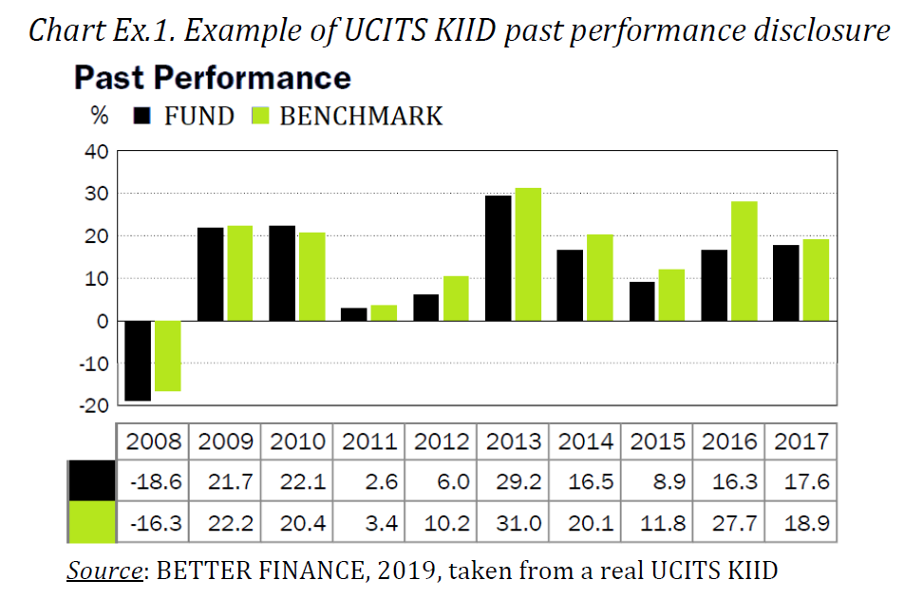

https://betterfinance.eu/publication/better-finance-position-paper-on-calculation-and-presentation-of-costs-and-performance-scenarios-in-the-priips-kid/

We would also want inclusion of past performance information for Category I and III products. While we understand that this can be difficult, we strongly believe that this burden of proof should be carried by the manufacturers that choose to market these products to retail investors. As we believe that many structured financial products are deliberately opaque and designed to conceal the true implicit and indirect costs. A retrospective look at how these products would have fared, had they been purchased five or ten years earlier, would probably have a disciplinary effect on the issuers.

The consultation paper states that it may create an “adverse incentive to design products that would have more favourable simulated past performance” (Page 32). We assume this is an objection raised by the suppliers It is illustrative of the kind of cynicism that permeates a number of manufacturers in the asset management sector. This is effectively a way of saying that if we are forced to show our products true performance we will stop selling them. We believe that most retails investors are not well served by the structured products on offer. If the manufacturers stop producing a large portion of them because of bad historical optics, this can be counted as a major victory for the KID and not something that needs to be corrected. However, even if the industry elects to tilt its product portfolio towards structured products with a positive historical record, the obligatory probabilistic projection will expose expensive and unsuited products. This will create an uphill marketing battle for the suppliers even if the structured combination of products happened to deliver positive past return. If the combination of past returns and future projections result in fewer structured products being marketed to retail investors this should be considered to be a positive rather than a negative.

In conclusion, we do not think Category I and III should get exemption from showing past results. We also think that the past results section should be prolonged to 10 years (or at least the duration of the product)in order to factor in a typical length of a business cycle. If the investment product has a shorter history than 10 years, then the past performance disclosure should start from the inception.
<ESA_QUESTION_PKID_26>

- : Would your answer to the previous question be different if it were possible to amend Article 6(4) of the PRIIPs Regulation?
<ESA_QUESTION_PKID_27>
NA
<ESA_QUESTION_PKID_27>

- : Do you think that it can be more appropriate to show past performance in the form of an average (as shown in the ESA proposal for consumer testing) for certain types of PRIIPs? If so, for exactly which types of PRIIPs?
<ESA_QUESTION_PKID_28>
We believe an average can be useful, but should be supplemented by showing yearly returns compared to a relevant benchmark. This level of detail gives a valuable and informative overview of the products volatility and consistency vs. the benchmark.

The average could be displayed as we have tried to illustrate below. The return can also be shown both gross and net, as shown in the Ex1 below. It would have looked less cluttered if we had managed to stack the annual cost on top of the net return with another colour, but Excel did not have this option. However, by stacking them, the retail investor may confuse net with gross return or the colour scheme could become blurred if printed in black and white.

We therefore recommend keeping the cost information out of the historical performance chart and go for Ex2.

We believe that this set-up should be used for as many types of PRIIPs as possible.

<ESA_QUESTION_PKID_28>

- : Do you have any comments on the statement that would supplement the display of past performance (e.g. with regard to the presentation of costs which are not included in the net asset value (NAV))?
<ESA_QUESTION_PKID_29>
The performance should be measured net of costs.
<ESA_QUESTION_PKID_29>

- : Are you of the opinion that an additional narrative is required to explain the relationship between past performance and future performance scenarios?
<ESA_QUESTION_PKID_30>
NA
<ESA_QUESTION_PKID_30>

- : Do you see merit in further specifying the cases where the UCITS/AIF should be considered as being managed in reference to a benchmark, taking into account the provisions of the ESMA Questions and Answers on the application of the UCITS Directive?
<ESA_QUESTION_PKID_31>
As mention in Q13: Hybrid funds has gained much popularity among Norwegian consumers - particularly as an asset class in pension schemes.

The national experience on hybrid funds is one where several for the hybrid funds are sold to consumers lacking a relevant reference index or lacking necessary, easy to understand information about the meaning of a proxy reference index or the consequences of comparing performance to an improper reference index. This has been pointed out of the Norwegian FSA, but yet hybrid fund providers does not live up to the instruction of the FSA.
We identified lack of compliance as late as in 2019 and published our results in https://fil.forbrukerradet.no/wp-content/uploads/2019/10/rapport-kombinasjonsfond-og-fondsprofiler.pdf (Norwegian only).
<ESA_QUESTION_PKID_31>

- : Do you see the need to add additional provisions for linear unit-linked insurance-based investment products or linear internal funds?
<ESA_QUESTION_PKID_32>
NA
<ESA_QUESTION_PKID_32>

- : Do you agree that a fixed intermediate time period / exit point should be used instead of the current half the recommended holding period to better facilitate comparability?
<ESA_QUESTION_PKID_33>
Yes. It would provide less alternative ways of presenting in a product in a favourable manner and makes it easier to compare equal products
<ESA_QUESTION_PKID_33>

- : In this case (of a fixed intermediate time period), do you agree to show costs if the investor would exit after 5 years for all PRIIPs with a recommended holding period of at least 8 years? Or do you prefer a different approach such as:
<ESA_QUESTION_PKID_34>
NA
<ESA_QUESTION_PKID_34>

- : Do you think it would be relevant to either (i) use an annual average cost figure at the recommended holding period, or (ii) to present both an annual average cost figure and a total (accumulated) costs figure?
<ESA_QUESTION_PKID_35>
We believe that both an average cost figure and a total accumulated should be presented.
<ESA_QUESTION_PKID_35>

- : Do you think that it would be helpful, in particular for MiFID products, to also include the total costs as a percentage of the investment amount?
<ESA_QUESTION_PKID_36>
We agree that a higher degree of cost detail is beneficial to understand the underlying cost structure of the product. A percentage cost of the investment should be obligatory.
<ESA_QUESTION_PKID_36>

- : In this context, are there PRIIPs for which both performance fees and carried interests are applied?
<ESA_QUESTION_PKID_37>
Since “carried interest” really is just a form of performance fee it does not make a lot of sense to separate them into two different entries in the cost table. Not many retail investors will understand the concept of carried interest anyway. A performance fee is more universally recognized.

It would be better to instead include a box for implicit costs such as over- or understated volatility figures in option-based investment products. Manufacturers must not be given the possibility to hide the true cost of the option.
<ESA_QUESTION_PKID_37>

- : Do you agree with this analysis from the ESAs? If yes, what are your views on the extent to which fees related to the management of the underlying real estate assets, i.e. the properties themselves, should be taken into account in the calculation of the cost indicators?
<ESA_QUESTION_PKID_38>
We agree that this would give a better picture of the true costs of private equity and real estate investment products. To our knowledge, it is not uncommon for PE managers to charge portfolio companies for management services and where the income does not flow into the fund, but to the management partnership. These types of costs should obviously be included in the cost indicators.

This is probably not easy to control, but the mere requirements to disclose them will probably incentivise the manufacturers to create more transparent fee structures or risk litigation if it turns out they did not disclose these types of fees.

However, it may be hard to distinguish between pure operational expenses in the portfolio companies/properties and cost of portfolio management.
<ESA_QUESTION_PKID_38>

- : Do you agree with the ESAs’ preferred option 3 to revise the cost tables?
<ESA_QUESTION_PKID_39>
We agree that option 3 is the best of the alternatives. We think simplifying Table 1 to only include RIY percentage figures will give the retail investor a relatively clutter free overview.
<ESA_QUESTION_PKID_39>

- : If not, which option do you prefer, and why?
<ESA_QUESTION_PKID_40>
NA
<ESA_QUESTION_PKID_40>

- : In particular, do you think that the proposed changes to the presentation of the impact of costs on the return in percentage terms (i.e. including reduction in return before and after costs) is an improvement on the current presentation?
<ESA_QUESTION_PKID_41>
Yes, we think the removal of the monetary figures to Table 2 will make the disclosure of the percentage terms more impactful.
<ESA_QUESTION_PKID_41>

- : Do you have other comments on the proposed changes to the cost tables?
<ESA_QUESTION_PKID_42>
NA
<ESA_QUESTION_PKID_42>

- : What are your views on the appropriate levels of these thresholds? Please provide a justification for your response.
<ESA_QUESTION_PKID_43>
We do not have sufficient knowledge to provide a meaningful answer to this question. However, we agree with ESA that it is important to include the impact of transactions costs in the overall cost figure. For active UCITS funds annual transaction costs can represent a sizeable chunk compared to the annual fees.
The below table is cut from an FT-article (https://www.ft.com/content/78918c88-fd13-11e7-a492-2c9be7f3120a) and shows how transaction costs add to the total cost of ownership.

The issue with the correctness of the slippage method is bigger than the KID. The MiFID II requires that fund providers disclose transactions costs, but partly due to different methodologies permitted it is difficult to compare. Once this larger issue is solved we assume the KID rules can be harmonized with the MiFID methodology, but in the meantime we agree with ESAs approach for the KID.

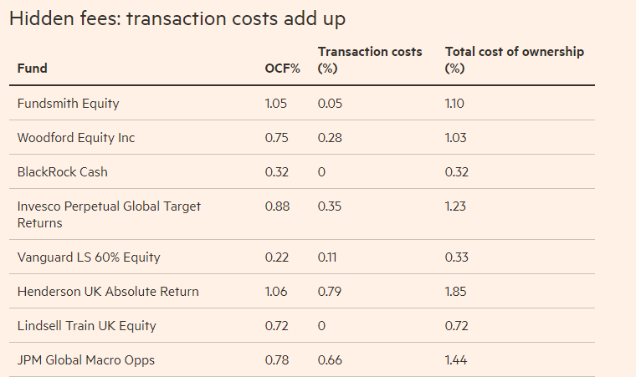

<ESA_QUESTION_PKID_43>

- : If UCITS would fall in the scope of the PRIIPs Regulation, do you agree that the coexistence of the UCITS KII (provided to professional investors under the UCITS Directive) and the PRIIPs KID (provided to retail investors under the PRIIPs Regulation) would be a negative outcome in terms of overall clarity and understandability of the EU disclosure requirements? Are you of the view that the co-legislators should therefore reconsider the need for professional investors to receive a UCITS KII, as the coexistence of a PRIIPs KID together with a UCITS KII (even if not targeted to the same types of investors) would indeed be confusing, given the differences in the way information on costs, risks and performance are presented in the documents? Alternatively, are you of the view that professional investors under the UCITS Directive should receive a PRIIPs KID (if UCITS would fall in the scope of the PRIIPs Regulation)?
<ESA_QUESTION_PKID_44>
NA
<ESA_QUESTION_PKID_44>

- : What are your views on the issue mentioned above for regular savings plans and the potential ways to address this issue?
<ESA_QUESTION_PKID_45>
NA
<ESA_QUESTION_PKID_45>

- : Do you agree that these requirements from Article 4 should be extended to all types of PRIIPs, or would you consider that it should be restricted to Management Company of UCITS or AIFs?
<ESA_QUESTION_PKID_46>
NA
<ESA_QUESTION_PKID_46>

- : Do you agree that this requirement should be extended to all types of PRIIPs, or would you consider that it should be restricted to Management Company of UCITS or AIF?
<ESA_QUESTION_PKID_47>
In general NCC prefer a minimum of different standards or regulations for different types of providers of products on that appear to serve the purpose for consumers. It would simplify the process of comparing products with many similar features for consumers
<ESA_QUESTION_PKID_47>

- : Do you agree that these requirements should be extended to all types of PRIIPs, or would you consider that they should be restricted to the Management Company of the UCITS or AIF?
<ESA_QUESTION_PKID_48>
NA
<ESA_QUESTION_PKID_48>

- : Do you have any comments on the proposed approaches in relation to the analysis and proposals in this Section, and in particular on the extent to which some of the abovementioned requirements should be extended to other types of PRIIPs?
<ESA_QUESTION_PKID_49>
No
<ESA_QUESTION_PKID_49>

- : Do you think this proposal would be an improvement on the current approach?
<ESA_QUESTION_PKID_50>
We agree that KIDs with a large cost range does not provide particularly useful information to the retail investor. We would advise to create PRIIP KIDs for each investment product. We also need to consider that this type of products typically are speculative in nature and not well-suited for long-term saving purposes.

While it may be cumbersome for manufacturers to create KIDs for these types of products, we also think that transparency and specificity is especially important for these types of financial products. We believe that products such as baskets of CFDs or binary options or autocalls especially requires specific disclosure and do not believe that making the lives of the manufacturers of these products easier is the right way forward.

<ESA_QUESTION_PKID_50>

- : Do you envisage significant practical challenges to apply this approach, for example for products which allow the investor to choose between a wide range or large number of options?
<ESA_QUESTION_PKID_51>
Se our answer on Q50
<ESA_QUESTION_PKID_51>

- : Do you see any risks or issues arising from this approach in relation to consumer understanding, for instance whether the consumer will understand that other combinations of investment options are also possible?
<ESA_QUESTION_PKID_52>
We see the risk of a manufacturer making a relatively investor-friendly generic auto call product KID which will not be marketed. Then they create other bundles with less investor-friendly characteristics and market them instead. The consumer may understand or not understand that other combinations are possible, but we believe that the distinction will be easily obfuscated in the fog of the sale.
<ESA_QUESTION_PKID_52>

- : Do you think this proposal would be an improvement on the current approach?
<ESA_QUESTION_PKID_53>
NA
<ESA_QUESTION_PKID_53>

- : Are there other approaches or revisions to the requirements for MOPs that should be considered?
<ESA_QUESTION_PKID_54>
NA
<ESA_QUESTION_PKID_54>

- : Do you have any comments on the preliminary assessment of costs and benefits?
<ESA_QUESTION_PKID_55>
We disagree with the proposal not to include past performance in the KID. We believe there is an important place for both past performance (10 years) and future projections in the document. In the event that past performance tells a positive story we are convinced that the manufacturers will provide this information in the marketing material even if it is not disclosed in the KID.

For illustrative scenarios we believe there is a significant risk of manufacturers cherry-picking the examples to make the investment proposals more enticing. The KID needs to stay neutral and comparable.
<ESA_QUESTION_PKID_55>

- : Are you able to provide information on the implementation costs of the proposed changes, in particular regarding, (1) the proposed revised methodology for performance scenarios (using a reference rate and asset specific risk premia), and (2) the overall changes to the KID template?
<ESA_QUESTION_PKID_56>
Consumers cost on mis-selling practices should ideally be held up against those implementation costs that falls on providers. The European consumer – BEUC- has provided a map on such cost on https://www.beuc.eu/press-media/news-events/price-bad-advice-launches.

This overview lacks costs regarding the Roeggen-case which represented the settlement of the before mentioned mis-selling of structured products done by DNB in Norway. Through media coverage we have learned that the cost of the settlements in DNB alone amounted to roughly € 50 million. DNB had an estimated market share of 25% for the market for structured products I 2013 in Norway. As sales of complex structured products came to a halt in Norway, DNB continued its sales of the same products abroad e.g. Lithuania resulting in a similar scandal there.
<ESA_QUESTION_PKID_56>

- : Are there significant benefits or costs you are aware of that have not been addressed?
<ESA_QUESTION_PKID_57>
When it comes to option pricing we have not seen attempts to identify unrealistic assumptions for volatility as a cost element. For a vertically integrated company that for instance sit on both sides of option trades there may be opportunities to hide costs, for instance by assuming unrealistically high volatility when pricing the options. One legal entity in the company can manufacture and sell the options at a high price to another legal entity, which then distributes either single options or baskets of them to retail investors. While the distributing entity charges the cost specified in the KID, the other part of the cost equation may be hidden for retail investors.
<ESA_QUESTION_PKID_57>

COMMISSION DELEGATED REGULATION (EU) 2017/653 of 8 March 2017 supplementing Regulation (EU) No 1286/2014 of the European Parliament and of the Council on key information documents for packaged retail and insurance-based investment products (PRIIPs) by laying down regulatory technical standards with regard to the presentation, content, review and revision of key information documents and the conditions for fulfilling the requirement to provide such documents
Regulation (EU) No 1286/2014 of the European Parliament and of the Council of 26 November 2014 on key information documents for packaged retail and insurance-based investment products (PRIIPs), OJ L 352, 9.12.2014, p. 1.
Regulation (EU) 2018/1725 OF THE EUROPEAN PARLIAMENT AND OF THE COUNCIL of 23 October 2018 on the protection of natural persons with regard to the processing of personal data by the Union institutions, bodies, offices and agencies and on the free movement of such data, and repealing Regulation (EC) No 45/2001 and Decision No 1247/2002/EC, OJ L 295, 21.11.2018, p. 39.
See “Section II – Key Investor Information Document (KIID) for UCITS” (in particular, Q&A 8) of the Q&A document available at: https://www.esma.europa.eu/sites/default/files/library/esma34-43-392_qa_ucits_directive.pdf

