|  |
| --- |
| 16 October 2019 |

|  |
| --- |
| Response form for the Joint Consultation Paper concerning amendments to the PRIIPs KID |
|  |

|  |
| --- |
| Date: 16 October 2019  ESMA 30-201-535 |

Responding to this paper

The European Supervisory Authorities (ESAs) welcome comments on this consultation paper setting out proposed amendments to Commission Delegated Regulation (EU) 2017/653 of 8 March 2017[1] (hereinafter “PRIIPs Delegated Regulation”).

The consultation package includes:

• The consultation paper

• Template for comments

The ESAs invite comments on any aspect of this paper. Comments are most helpful if they:

• contain a clear rationale; and

• describe any alternatives the ESAs should consider.

When describing alternative approaches the ESAs encourage stakeholders to consider how the approach would achieve the aims of Regulation (EU) No 1286/2014[2] (hereinafter “PRIIPs Regulation”).

Instructions

In order to facilitate analysis of responses to the Consultation Paper, respondents are requested to follow the below steps when preparing and submitting their response:

1. Insert your responses to the questions in the Consultation Paper in the present response form.
2. Please do not remove tags of the type <ESA_QUESTION_PKID_1>. Your response to each question has to be framed by the two tags corresponding to the question.
3. If you do not wish to respond to a given question, please do not delete it but simply leave the text “TYPE YOUR TEXT HERE” between the tags.
4. When you have drafted your response, name your response form according to the following convention: ESA_PKID_nameofrespondent_RESPONSEFORM. For example, for a respondent named ABCD, the response form would be entitled ESA_PKID_ABCD_RESPONSEFORM.
5. The consultation paper is available on the websites of the three ESAs and the Joint Committee. Comments on this consultation paper can be sent using the response form, via the [ESMA website](https://www.esma.europa.eu/press-news/consultations) under the heading ‘Your input - Consultations’ by 13 January 2020.
6. Contributions not provided in the template for comments, or after the deadline will not be processed.

Publication of responses

All contributions received will be published following the close of the consultation, unless you request otherwise in the respective field in the template for comments. A standard confidentiality statement in an email message will not be treated as a request for non-disclosure. A confidential response may be requested from us in accordance with ESAs rules on public access to documents. We may consult you if we receive such a request. Any decision we make not to disclose the response is reviewable by ESAs Board of Appeal and the European Ombudsman.

Data protection

The protection of individuals with regard to the processing of personal data by the ESAs is based on Regulation (EU) 2018/1725[3]. Further information on data protection can be found under the [Legal notice](http://www.eba.europa.eu/legal-notice) section of the EBA website and under the [Legal notice](https://eiopa.europa.eu/Pages/Links/Legal-notice.aspx) section of the EIOPA website and under the [Legal notice](https://www.esma.europa.eu/legal-notice) section of the ESMA website.

# General information about respondent

|  |  |
| --- | --- |
| Name of the company / organisation | ASSOGESTIONI |
| Activity | Investment Services |
| Are you representing an association? |  |
| Country/Region | Italy |

# Introduction

Please make your introductory comments below, if any:

<ESA_COMMENT_PKID_1>

Assogestioni[4] welcomes this new opportunity to express views about the future of PRIIPs regulation. We fully appreciate the huge effort undertaken by ESAs to address very complex topics and revise a document that is meant, first, to enhance retail investors’ understanding of a particular product and, second, to allow investors to compare different products and different types of products.

We very much welcome the proposals to include the presentation of costs and past performance used in the UCITS KIID in the PRIIPs KIID and which may feasible to meet MiFID disclosure obligations. However, let us mention that we have also strong concerns about the ESAs favourite solution regarding the key elements of the PRIIPs KID related to performance scenarios and costs as we consider it would not be beneficial for all actors, especially if UCITS KIID is phased-out.

We fully understand the timing constraints placed on the ESAs, nevertheless we caution against a too rushed process that could lead to unworkable or not appropriate proposals. As regards the scenario proposal, the ESAs appear to be aware that the methodology based on the dividend yield approach is onerous and complex and not been fully back-tested across different types of products. On the costs side, four type of presentations, that increase the number of cost points, from the current 12 up to 32, should give investors an appropriate presentation of costs, but the final results may become incomprehensible for the average investor. On the transaction costs calculation, the slippage method is still maintained, but its more flawed effect is removed to avoid transaction costs becoming negative and therefore not understandable by investor (as they would become a revenue and not a cost any longer). This is simply masking the conceptual flaw and practical implications.

In addition, the proposed amendment to the PRIIPs KID should be tested with the consumer, to understand if the revised document is fit for purpose. Consumer testing is key here to understand the preferences and interpretation of the retail investor, but the current consumer testing, being undertaken in parallel by the European Commission, deals only with the illustration of the performance scenarios and not the whole (revised) PRIIPs KID.

A potentially unsuitable PRIIPs KID is a source of deep concern for us as we have an extremely positive experience with the very simple, but fair pre-contractual information given to investors through the UCITS KIID, a document that it is expected to be dismissed at the end of 2021.

In this context, we would like to insist on the fact that technical choices should be based on proved, tested, well understood and clear techniques. Indeed, even if the discussion is intellectually interesting, PRIIPs is not the place for experimentation. Focusing too much on providing comparable information between widely different investment products, the information presented is in same case irrelevant at best and misleading at worst. We strongly believe that in the face of such a challenge, the objective cannot be to get the “perfect solution”, but a solution which is “understandable, not misleading, not increasing asymmetry” for investors and that is cost effective for all PRIIPs manufactures, included asset managers.

A more comprehensive review of the PRIIPs should start with the appropriate review of the PRIIPs Regulation (in the light also of the MiFID II experience) by the European Commission.

Therefore, please find here below our recommendations.

With specific regards to the review of level 1 legislation that ESAs should consider requesting, we recommend the ESAs the following.

* + review the “concept” of the appropriate performance scenario, since future estimation are always challenging (art. 8(3)(d)(iii) PRIIPs);
  + exclude from the “total aggregate cost” indicator the type of costs coming from (also) actively managed investment funds that cannot be precisely calculated neither ex-ante (transaction costs and performance fees) nor ex-post (implicit transactions costs) and ask for a separate disclosure (in line with performance fee disclosure under the UCITS KIID) (art. 8(3)(f) PRIIPs);
  + provide, if necessary, the legal basis for the regular updating by the ESAs of common reference parameters for example a spread table for transaction costs calculation and the standard growth rates, if the dividend methodology would be requested;
  + **align the obligation to provide PRIIP KIDs in the context of regular saving plans with the current supervisory practice under the UCITS framework** (art. 13(4) PRIIPs).

With specific regards to the Delegated Regulation, we recommend the ESAs the following:

* (continue) to keep the illustration of the historical returns (where appropriate): experience with the UCITS KIID shows that investors wish to see the product’s history of returns;
* should a performance quantitative scenario still be required, extend the historical return series used in the actual method from 5 to, at least, 10 years. Further improvements of estimation may simply require an adjustment to reflect the current risk-free rate. Supplementary alternatives are included in our response: scenario based on historical observations, volatility based Sharpe risk premia and - as a last resort -standardised growth rate provided by ESAs.
* keep the illustration of costs as simple as possible, and in line with MiFID II disclosure: present aggregate cost figures, without RIY approach, together with the relevant costs of the product in percentage of the value of the subscription/redemption or the net asset. This approach would lead also to firms distributing investment products to rely on the disclosure of product costs provided in the PRIIPs KID for the purpose of computing their aggregated cost figure comprising charges of both product and service;
* as regard the methodology for calculating transaction costs, provide two options:
  + use standardised transaction costs figures, improving the proposed methodology applied for new PRIIPs. In line with a proportional regulatory approach, a “simplified” method where the ESAs provide the relevant figures, would require cheaper, less time consuming, more reliable systems, given the challenge of what has to be measured. The above would be in line also with the systems already applied by asset managers to provide transaction costs figures for the purpose of MiFID II disclosure;
  + use a more empirical calculation that avoids the slippage drawdown i.e. compare the execution price against the mid-market price when a trade takes place, rather than against the arrival price. This aspect is of specific relevance for the treatment of costs resulting from the market impact of transactions which shall be disregarded for the purpose of MiFID II disclosure.
* **review/clarify the scenario and cost presentations:**
  + **for closed-ended fund.** The information presented in the PRIIP KID should reflect the PRIIP’s lifetime (RHP) and be based on the business forecast given for these highly individualised funds (e.g. ELTIF, EUVECA, EUSEF, real estate and other private equity or debt funds). This would facilitate retail investors’ understanding of the financial characteristic of these PRIIPs and encourage long-term investments in line with the CMU objectives;
  + **for funds that provides single investment or regular investments**: only the information based on single investment should be reflected in the PRIIP KID since it is potentially the most unfavourable one as it does not take into account the mitigations offered by a regular investment (market timing).

Last, but not least, a review of the disclosure regime for UCITS should be applied, since it would be inappropriate and costly to make the UCITS KIID (only) for professional investors (which are not in the scope of PRIIPs) who are capable of analysing more complex information beyond UCITS KIID or PRIIP KID.

<ESA_COMMENT_PKID_1>

* : Are there provisions in the PRIIPs Regulation or Delegated Regulation that hinder the use of digital solutions for the KID?

<ESA_QUESTION_PKID_1>

We generally support rules that enable digital solutions, however, in order to provide digital solutions, the whole PRIIPs framework should be reviewed. For time being, many provisions refer to “paper” or “hardcopy” documents.

In this specific regard, for example, art. 13 of the PRIIP Regulation, while acknowledging the possibility of using a durable medium or a website for the supply of the KID, allows these methods only if pre-established conditions are met and art. 17 of the Delegated Regulation provides for the "delivery" of the KID.

<ESA_QUESTION_PKID_1>

* : Do you agree that it would be helpful if KIDs were published in a form that would allow for the information to be readily extracted using an IT tool?

<ESA_QUESTION_PKID_2>

Even if we generally agree with the idea of foreseeing digital solution in order to provide information to the investors through the PRIIPs KID, we believe that it should be coordinated and aligned to the PRIIPs KID underlying ratio and so the need of providing accurate, fair, clear and not misleading information in order to provide the retail investors for an understandable document.

We wonder what the ESAs would consider an “IT tool” and we believe the creation of data standards is no trivial task and should be fully thought through by the ESAs.

<ESA_QUESTION_PKID_2>

* : Do you think that the amendments proposed in the consultation paper should be implemented for existing PRIIPs as soon as possible before the end of 2021, or only at the beginning of 2022?

<ESA_QUESTION_PKID_3>

We do believe that it should be better **to postpone the implementation of the amendments** recommended in the CP **to the beginning of January 2022,** in line with the UCITS possible phase-out.

From an operational perspective, one must also consider that the proposed amendments to the Level 2 Regulation will not be approved before the second half of 2020 (at the earliest). Thus, January 2022 may leave market participants with little more than one year to implement all changes. It is essential that they are given enough time for implementation, which will include, among other things, fundamental changes to the underlying IT infrastructures as well as training of financial advisers.

<ESA_QUESTION_PKID_3>

* : Do you think that a graduated approach should be considered, whereby some of the requirements would be applied in a first step, followed by a second step at the beginning of 2022?

<ESA_QUESTION_PKID_4>

A gradual approach to introducing amendments is not helpful. As in the replied to Q3, our preference is that all changes should be implemented at the beginning of 2022.

<ESA_QUESTION_PKID_4>

* : Are there material issues that are not addressed in this consultation paper that you think should be part of this review of the PRIIPs Delegated Regulation? If so, please explain the issue and how it should be addressed.

<ESA_QUESTION_PKID_5>

As regards the PRIIPs Delegate Regulation, we would like to raise the following issues:

* ***Scenario and cost presentations for closed-ended fund only at RHP***. With specific regards to closed-ended fund that are not tradable or redeemable before the RHP we believe that nor the 1 year period neither the intermediate one is valuable for them. In such case the scenario should be given only at RHP. Similar considerations can be made for ELTIF which minor redemptions would be possible before the end of its life or for Category 1 closed-end funds admitted to trading on the secondary market whose value is linked to the NAV or have a relevant liquidity risk (please see our response to Q7).
* ***Scenario and cost presentations for funds that provides single investment or regular investments*** *(Delegated Regulation Annex IV, par. 32, Annex V, part. II, Annex VI, par. 90, Annex VII).* There may be also a need for a clarification where two different subscription methods, at the option of the investor, are offered by the same fund: single investment or regular investments. In such a case, it should be clarified that the information based on single investment should be reflected in the PRIIP KID only since it is potentially the most unfavourable one as it does not take into account the mitigations offered by a regular investment (market timing). This also in line with the combined provision of the contents of par. 32 of Annex IV of the PRIIP Delegated Regulation 2017/653 and Annex VI, point 90, which refer, except for insurance products, to the sole method of payment in a single investment. Furthermore, also in the representation of the costs referred to in Annex VII, reference is made exclusively to the regular “premium” (not regular investment), therefore with exclusive regard to insurance products. In line with above, the presentation of the template named ”Regular investment paid” in Annex V, Part II, Template B should be eliminated. Should the ESAs require both presentations (single and regular investments) for PRIIPs different from regular premium insurance-based investment products, a coordination is needed between Annexes IV, V, VI and VII.

On a technical level, further clarity must also be provided with regards to the following:

* Minimum data requirement (Delegated Regulation, Annex II, para. 10, flow chart - 4. Flow Diagrams, A. SRI, Section 2, Part 2 on page 6, Q&A #11[5] ). Para. 10 of Annex II of the Delegated Regulation states that “*where data on daily pricing covering a period of 5 years are not available, a shorter period may be used. For daily observations of a PRIIP’s or its benchmark or proxy’s price, there shall be at least 2 years of observed returns*.” It is not clear what the minimum data requirement is where a benchmark/proxy is available for 5 years: 2 years or 5 years? It appears that the use of 5 years historical return is possible but not mandatory and that the historical 2 years can also be used (as “the minimum”). This could create level playing field problems. For example, if in the last 5 years, the more recent 2 are been characterised by a lower market volatility, funds that haven’t got 5 (or not concatenate up to 5) years historical data would have a lower MRM than already operating funds that have 5 years of price (NAV). Therefore, to prevent the MRM of similar funds from differing, it should be clarified that the minimum requirement period is always 5 years (and not 2 years) when 5 years data would be available with appropriate benchmarks or available proxies. We suggest updating para. 10 as follow: “*where data on daily pricing covering a period of 5 years are not available (including concatenation with representative benchmark or available proxy data) …”*
* MRM update (Delegated Regulation, Annex II, para. 53). The provisions in relation to the MRM “risk bucket” updates are different between the UCITS KIID and the PRIIP KID. In the UCITS KIID, the update has to be carried out when the MRM falls outside its bucket on each weekly or monthly data reference point over the preceding four months. In the PRIIP KID, the update is driven by the majority of evidence of the last four months, regardless of the time pattern of the series. This could lead to a more frequent risk class update for funds that fall in between two MRM class. We believe that RTS should be updated in line with UCITS rules.
* Cost of acquiring or disposing of units in UCITS or AIF (Delegate Regulation, Annex VI, para. 5, lit. l and m). The provisions should exclude the reference to the summary cost indicator to avoid an overestimation of the costs to be presented to investors, especially if entry fee are calculated as their maximum values, even if not paid by an asset manager (please see also our response to Q39. In addition, such figure currently include a time horizon and a yield assumption (moderate performance scenarios).

<ESA_QUESTION_PKID_5>

* : Do you have comments on the modifications to the presentation of future performance scenarios being considered? Should other factors or changes be considered?

<ESA_QUESTION_PKID_6>

In general, consumer testing is a cornerstone for “Better Regulation”. Regulatory changes should be based on thorough and in-depth consumer testing processes.

With that in mind, we consider the value of this consumer testing exercise highly questionable. The ESAs themselves explain that “within the timeframe of the current review of the PRIIPs Delegated Regulation, it will not be possible to test all aspects of the KID”[6]. However, a proper full-scale consumer testing exercise by the European Commission would have allowed insight into the functioning of the current PRIIP KID and provide important understandings for both this technical review and the more fundamental Level 1 review.

We understand that only (certain) performance scenarios are being consumer tested. Unfortunately, none of the substantial changes to the presentation of costs is subject to any consumer testing.

With specific regards to disclosing probabilities in the performance scenarios, pending the outcome of the consumer testing, we would like to raise our concerns on the suggested addition of a new column entitled “estimated chance the scenario occurs”. In our views this figures (probabilities) may again provide investors with unrealistic expectations about the future outcome of their investments. We, therefore, suggest not to include such information in the PRIIP KID.

In any case, the KID should clearly state that future scenarios are for illustrative purposes only, so that potential investors have a better understanding of the expected return (and risk) of the PRIIP.

<ESA_QUESTION_PKID_6>

* : If intermediate scenarios are to be included, how should they be calculated for Category 3 PRIIPs (e.g. structured products)? If intermediate scenarios are not shown in the performance section, which performance assumption should be used for the ‘What are the costs?’ section?

<ESA_QUESTION_PKID_7>

We agree with removing the intermediate performance scenarios from the future performance scenarios for all types of PRIIPs not just for Category 3 PRIIPs.

In general, two holding periods, i.e. 1-year and the recommended holding period (RHP), should be sufficient. We believe that the 1-year holding period already provides sufficient information to retail investors about the implications of ending the investment before the end of RHP.

In addition, we believe a derogation in the presentation of performance scenario (and costs) should be introduced for **closed-ended fund not traded on secondary markets** where investors may not step out until the natural end of the fund (contractual nature)**.**

The investment activity, trading behaviour and cost structures in these funds differ very substantially from a UCITS fund. These funds are by definition aimed at illiquid investments attracting patient capital and where the valuation may vary considerably over time (so the impact of costs). The raising capital, especially when there are retail investors, usually takes some time and the drawn commitment is driven by the target investment; the base of calculation of costs differ over time (usually total commitment over the investment period – NAV afterwards). The information presented in the PRIIPs KID should reflect all the PRIIP lifetime and be based on the business forecast given the highly individualised nature of these funds (ELTIF, EUVECA, EUSEF, real estate and other private equity or debt funds). This would facilitate retail investors in understanding the financial characteristic of the PRIIP and it could incentivize long-term investments in line with the objectives of the CMU. A KID PRIIPs with a presentation that does not deal with these factors could make the fund unattractive to investors.

Therefore, we believe that it makes no sense to take a presentation of performance (and costs) at the end of the first year and at the half of the recommended holding period (if the latter would be kept) and we ask for a revision of the relevant provision to clarify that such presentation in these circumstances are not applicable. For example, illustrative tables could be the same but the column header at 1y (or ½ RHP) states “not applicable”.

In addition, we also believe that the forward-looking principle should be used even if the fund will reopen subscription at some point in its life: using historical value instead of a business forecast could be misleading.

Finally, **similar considerations can be made even for ELTIF** **which minor redemptions would be possible before the end of life and closed-ended fund admitted to trading on the secondary market where one of the following characteristics is present**:

* the PRIIP is in Category 1 (c), i.e. when the underlying investments of PRIIPs are priced on a less regular basis than monthly;
* trading value linked to the NAV;
* relevant liquidity risk.

**As regard the interaction between performance scenario and the cost section**, i.e. the figure coming from the moderate performance should be used for the calculation of the reduction in yield (RIY), we believe that in the revised Delegated regulation the following solution could be possible if the illustration of costs at the ½ RHP would not be eliminated:

* the disclosure of the aggregate costs in a RIY format should be replaced by a total cost indicator over time: the return used would be equal to the PRIIP’s costs i.e. using a net return assumption of zero assuming that the investors get back their original investment.

With this approach figures coming from performance scenarios are no longer needed. Such assumptions would align the cost disclosures in the 1-year column with the ex-ante cost disclosures under MiFID II, thus creating a crucial link for retail investors.

Please see also our response to Q40.

<ESA_QUESTION_PKID_7>

* : If a stress scenario is included in the presentation of future performance scenarios, should the methodology be modified? If so, how?

<ESA_QUESTION_PKID_8>

With an improved methodology for the calculation of performance scenario, we believe that stress scenario should not be necessary anymore. A short disclaimer may be added to emphasise, once more, to investors that the unfavourable scenario does not reflect the worst possible outcome

The unfavourable, moderate and favourable scenarios presentation should be sufficient.

<ESA_QUESTION_PKID_8>

* : Do you agree with how the reference rate is specified? If not, how should it be specified?

<ESA_QUESTION_PKID_9>

*General remarks on future performance scenarios*

“*Appropriate performance scenarios, and the assumptions made to produce them”* should be included, in the PRIIPs KID according to the Level 1 text under the section titled ‘What are the risks and what could I get in return?’ (art. 8(3)(d)(iii) PRIIPs Regulation).

Since future estimates are always challenging, we believe that focusing too much on providing comparable information between widely different investment products would lead in same case too irrelevant and in other cases misleading information.

We strongly believe that in front of such a challenge, the objective cannot be to get the “perfect solution”, but a solution which is “understandable, not misleading, not increasing asymmetry” to investors and which provides the relevant information and the features of the product that should enable the investor to make an informed decision before purchasing a PRIIP.

Such solution should also be cost effective for all PRIIPs manufactures, included asset managers: the benefit to the investor of this approach must outweigh the costs incurred to deliver the new methodology. The approach taken should be pragmatic, simple as possible and avoid an unequal burden among PRIIPs manufacturers (small vs large number of underlying investments), or among the same PRIIP manufactures. This burden will be disproportionately larger for small and medium-size players and will further accelerate the trend to outsource the KID production.

We, therefore, believe it essential to revisit the theoretical concept behind the current methodology and go beyond the technical modifications. Simply put, comparability should not come at the cost of inappropriate or misleading information or less competition. Each type of PRIIP provides a different value proposition and thus necessitates slightly different disclosures in a pre-contractual document.

For example, for non-structured open-ended funds, historical performance through the fluctuation of the results over an appropriate time period is sufficient to show the effects of various market drivers and the role of the active asset management, if any, and costs; while for structured funds, where the presentation of past information would be misleading, the explanation on how the structure will work in the future is valuable and, therefore, a “what if scenario” would be preferable. For closed-end funds a forward-looking principle based approach on business forecast might be appropriate.

Indeed, we share the point made by the ESAs in the letter sent to the European Commission on May 23rd, 2019 on the proposed performance scenario options for consumer testing where they states “*we consider Level 1 text to be drafted in a sufficiently open manner and the PRIIPs Level 2 text already provides for some product-specific approach, for example in relation to the pay-off graphs used for exchange-trade-derivatives*”.

However, due constrains and time pressure, should a quantitative future performance scenario be kept, we believe that the ESAs preferred option, based on the dividend yield methodology, has many shortcomings and it should not be used for the presentation of the performance scenarios.

Broadly speaking we do not support the dividend yield methodology for the following reasons:

* the methodology is too complex, which could lead to misunderstanding or mistakes o, in any case, to incomparable results between PRIIPs manufactures;
* it does not reflect the active management of funds;
* it still presents misleading information to the investor:
  + to tackle the issue of procyclicality, it strongly smoothens its results, thus generating scenarios that may remain very constant over time;
* it will give rise to significant market data costs:
  + very substantial amount of additional data points to be collected for each individual sector and country or even at individual instrument level;
  + daily dividend yields (and share buyback) are currently not collected and/or stored by fund managers as part of their daily business activities and regulatory requirements. Even in cases where they are being collected, the current licence requirements do not allow these data to be used for the purpose of calculating and disclosing performance scenarios;
* it is still based on historical data (compensation mechanism), which had to be removed from the model;
* we see no way meaningfully to explain to retail investors how the disclosed performance scenarios have been arrived at.

The above comments show that a much simpler and streamlined approach is needed. As even a more complex methodology will not be able to predict the future more accurately, a balance must be struck between the overall complexity and the usefulness of the resulting disclosures to retail investors. We believe that a solution that drastically reduces the complexity and costs of the current proposal is needed. This approach should not require a look-through to the underlying assets and should not disadvantage fund managers that have fewer resources or are less able to incur additional data costs

Please see our responses to Q18-22 for more details.

*Specific comments on ESAs preferred option: dividend yield methodology for probabilistic performance scenarios*

It is a fact that any type of future projections will always remain educated guesses – no matter how complex the underlying methodologies would be, each will have its distinct advantages and disadvantages. Therefore, the performance scenario chosen should strike a balance between simplicity and meaningfulness for retail investors.

While from a theoretical point of view it may seem appropriate to consider an estimator to determine the expected yield or risk premia of the asset class or product, we understand that the revised methodology is creating an even more complex and resource-intensive exercise (in comparison to the current one).

Applying best efforts to verify the ESAs’ assumptions and proposals, in our understanding, the proposed methodology requires a very substantial amount of additional data points to be collected for each individual sector and country or even at single instrument level. A look-through approach seems to be requested, thus heavily impacting investment funds in particular (especially funds of funds). A daily look-through approach could not be feasible for underlying third party funds: this does not reflect reality, as this information is not always available nor feasible in terms of competition (asset managers should share with third parties their daily portfolio composition). In any case, this does not reflect the fund exposure/strategy.

The methodology does not take into account a fund manager’s management style (used to achieve the mandate stated in the fund investment policy) as it assumes a static portfolio composition. In addition, the proposed method deals only with certain instruments and does not say how to deal with currency exposures, derivatives, shorts, etc…. Due to this, the following fundamental issues arise:

* an estimator based on the market does not reflect the active management of funds: differences between actively and passively-managed funds are not reflected in the scenarios. In addition, the scenarios are net of costs. Thus, active funds will always present worse performance scenarios than index-tracking funds with a similar market exposure[7].
* funds with a dynamic investment strategy change their asset allocation over time. Their holdings would be different depending on the point in time used for the calculation (equities vs bonds or strategies based on risk controls). Along the same lines, the appraisal of derivatives can also have profound effects on a fund’s allocation over time. Derivatives may change the fund’s exposure and taking into account the portfolio would be an issue, for example funds invested in (governments) bonds which swap it (all or part of it) with an equity exposure would base scenarios on a bond risk premium rather than an equity one. Therefore, we wonder how ex-ante information that could consistently change throughout the recommended holding period would be of any value to the investor in choosing the PRIIP. The change of portfolio composition also leads to another important issue, the (continuous) data feed required and the monitoring of the asset allocation in order to verify whether the portfolio’s change triggers the threshold that requires updating the KID PRIIPs.
* for sectors that pays lower dividend, the methodology seems to be inappropriate:

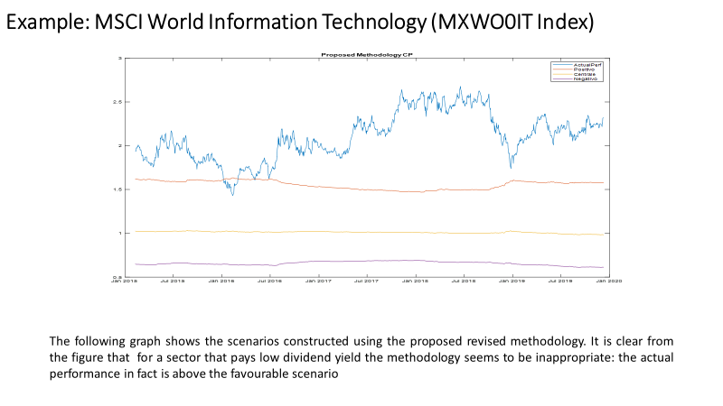

* In some cases, reference markets cannot always be correctly determined or ascertained in terms of investment policy (market neutral, long-short strategies, multi-manager funds, funds of hedge funds). Would a risk-free rate be the fall-back solution in such cases? But this would lead to inappropriate or even misleading information being disclosed to investors.

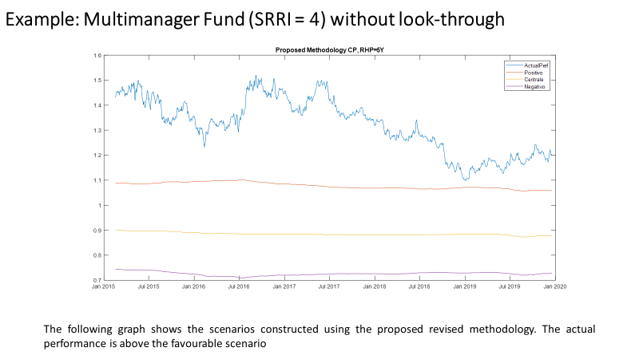

The ESAs seem to overlook the very real costs attached to collecting even more market data necessary for the underlying calculations. Some of the data needed, such as daily dividend yields (and share buyback), are currently not collected and/or stored by fund managers as part of their daily business activities and regulatory requirements. Even in cases where they are being collected, the current licence requirements do not allow these data to be used for the purpose of calculating and disclosing performance scenarios. Thus, the new requirements will significantly increase fund managers’ cost burden. This burden will be disproportionately larger for small and medium-sized players. This is a questionable direction of travel, given the huge increase in fees over the past years being paid by fund managers for market data.

Finally, the results of this complex mechanism could not be used if a compensatory mechanism apply i.e. when the output of the scenario will be not in line with the return observed in the past (which would be removed from the model) or with the asset manager evaluation. This effectively makes the expensive exercise to be carried out useless and, in any case, less comparable because each manufacturer should adjust the scenario.

So, we see no way meaningfully to explain to retail investors how the disclosed performance scenarios have been arrived at.

*Specific comments on the reference rate*

The reference rate has to be calculated on an asset-weighted basis. The consultation paper does not go into detail on the maturity of the sovereign bond. It may be fixed, for example using sovereign bonds with a 5-year maturity or it may depend on the recommend holding period. This causes uncertainty for a correct testing. In addition, the reference rate is based on currency and country of the assets specific and issues comes for funds with certain geographical and or credit exposures, such as funds investing in emerging markets or for funds that use currency hedging strategies. The reference rate would be optimistic as it does not reflect the sovereign credit risk.

<ESA_QUESTION_PKID_9>

* : The revised methodology specifies that the risk premium is determined by future expected yields. The methodology further specifies that future expected yields should be determined by the composition of the PRIIP decomposed by asset class, country and sector or rating. Do you agree with this approach? If not, what approach would you favour?

<ESA_QUESTION_PKID_10>

As already explained in our reply to Q9, the proposed requirement for calculating the dividend yield of the equity is very complicated. The proposed methodology expects to use the average dividend yield for each country and sector represented, weighted by its representation. Furthermore, government bonds, corporate bonds and foreign exchange instruments would all be treated in a similar manner as equities.

In reality, such an approach would be especially onerous for fund managers. A globally diversified fund, with a reasonable spread of shares by sector, would end up requiring a complex calculation on an asset, country, currency and sector-weighted basis. The comparability of scenarios between PRIIPs would not be guaranteed in any case, given that the value of the estimators may be different depending on the source used.

Furthermore, the consultation paper lacks clarity on a number of crucial issues:

* It is not clear how to determine the country of origin of the asset, (i.e. primary listing, country of incorporation, country of headquarters, etc.). We understand that the ESAs are using the primary listing to determine the country of the asset in their own testing. Although the primary listing is often a key determinant of the country of the asset, this may diverge from the approach used by some investment managers and the data vendors.
* There is also no clarity on how the sector of the asset should be determined. Data vendors allocate assets to a sector but, there is no industry standard for assigning a sector.

<ESA_QUESTION_PKID_10>

* : The ESAs are aware that historical dividend rates can be averaged over different time spans or that expected dividend rates can be read from market data providers or obtained from analyst reports. How should the expected dividend rates be determined?

<ESA_QUESTION_PKID_11>

Given the highly relevant concerns around the access and pricing of market data, we are adamant that - if the dividend yield methodology is prescribed by the ESAs - these rates should be determined and made publicly available by the ESAs or the NCAs. Such standardised rate tables would be essential, and they would help lower the very real costs of obtaining such market data from data providers and avoid all single European manufacturers, especially the medium-little one, to afford data licenses costs for the feeding process.

Such standard table should be granular enough to be applied for different types of PRIIPs and should be consistent with asset classes that might be used for the calculation of transactions costs (please see our response to Q43.

We believe that no prescriptive rule for the estimation/calibration of the parameters should be included in the RTS, but only some general principle. Such as “The ESAs shall issue guidelines with common reference parameters for the methodology for performance scenarios. The guidelines shall be updated at least every year taking into account the latest market developments”. It is worth noting that it could be also valuable in the context of PRIIPs the exercise done by ESMA in defining and updating the common calibration to be used for MMF stress tests[8] .

<ESA_QUESTION_PKID_11>

* : How should share buyback rates be estimated?

<ESA_QUESTION_PKID_12>

TYPE YOUR TEXT HERE

<ESA_QUESTION_PKID_12>

* : Do you agree with the approach for money-market funds? Are there other assets which may require a similar specific provisions?

<ESA_QUESTION_PKID_13>

While the approach on money market funds seems plausible, at first glance, it also contains an additional data points that needs to be properly sourced to be included in the overall methodology. This further exacerbates the problems already described above.

<ESA_QUESTION_PKID_13>

* : The methodology proposes that the future variance be estimated from the 5-year history of daily returns. Should the volatility implied by option prices be used instead? If so, what estimate should be used if option prices are not available for a particular asset (equities namely)?

<ESA_QUESTION_PKID_14>

We are against the use of option prices to determine volatility. Options prices are not always available for equities. More importantly, though, this would require all PRIIPs manufacturers to have access to options data, which is not the case. Receiving access to option prices will again represent a significant additional cost.

<ESA_QUESTION_PKID_14>

* : Do you think compensatory mechanisms for unforeseen methodological faults are needed? If yes, please explain why.

<ESA_QUESTION_PKID_15>

The ESAs’ proposal to include “compensatory mechanisms” highlights that there are fundamental issues in trying to project future outcomes with any sort of accuracy. This essential flaw cannot be masked by making the underlying methodology more and more complicated.

Thus, having to consider additional “compensatory mechanisms for unforeseen methodological faults”, such as past performance, would simply be overkill, as it would make an already extremely complicated methodology even more complex and daunting. The original aim of this exercise (i.e. the disclosure of performance scenarios) was to strike a reasonable balance between retail investors being able to understand potential return outcomes while at the same time not making calculation too resource-intensive. The suggested approach risks becoming more and more academic in nature and losing sight of this all-important balance.

<ESA_QUESTION_PKID_15>

* : Do you favour any of the options above? If so, which ones? How would you ensure that the information in the KID remains comparable for all products?

<ESA_QUESTION_PKID_16>

We have issues with all options suggested by the ESAs. In terms of using past performance data, this may not be of relevance for all types of PRIIPs. Also, who would be in charge of their definition and keeping them updated to reflect prevailing market conditions?

Using past performance data will not only make the calculation much more complicated, but the results would also be more difficult to explain to the investor due to the underlying assumptions used which may differ depending on the “compensatory mechanism” being applied or not.

Furthermore, there could be significant confusion, particularly where the best and worst historical figures are calculated over a different time period than that on which the scenarios are based (i.e. 5 years). Moreover, there could still be a danger that the best and worst historical performances remain pro-cyclical, particularly where products do not have a long enough track record.

Please see our suggested alternatives approaches laid out in our responses to Q18-22.

<ESA_QUESTION_PKID_16>

* : Are there any other compensatory mechanisms that could address unforeseen methodological faults? If yes, please explain the mechanism; explain how it ensures that scenario information in the KID allows investors to compare PRIIPs, and explain how the information for similar products from different manufacturers remains sufficiently consistent.

<ESA_QUESTION_PKID_17>

As explained in our response to Q15, no additional compensatory mechanism should be introduced.

<ESA_QUESTION_PKID_17>

* : What are your views on the use of a simplified approach such as the one detailed above, instead of the use of probabilistic methodologies with more granular asset specific requirements?

<ESA_QUESTION_PKID_18>

Due to the numerous shortcomings of the dividend yield methodology, we are strongly in favour of a **thoroughly simplified approach.**

**We ask ESAs to look and consider the following alternatives (in order of preference).**

1. Actual method, but extending the historical period and rate adjustment
2. Scenario based on historical observations of the PRIIP over a period of two times the RHP
3. Volatility based Sharpe risk premia
4. Standardised growth rates

**1. Actual method, but extending the historical period and rate adjustment**

We believe that the actual method, based on historical return could be improved extending the historical period used to measure performance from 5 years to 10 years (or 15 years to extend the market cycle). This would entail a change to the time periods specified in various points in Annex II of the Delegated Regulation.

Where the return time period extension might not be sufficient in improving the results, we propose also an adjustment of the growth rate to reflect the current market as follow: the growth rate (g) of all PRIIPs would be estimated as a historical average annual return of the PRIIPs over a longer reference period (10y), reduced by the average risk-free rate recorded over the same reference period (10y) and increased by the current risk-free rate.

Extending the historical period of the PRIIP price, some evidence on a large stock index and a government index show a reduction in the estimated performance level and amplitude. In the following table the estimates are based on rolling return at 5, 10 and 15 years. To obtain sufficiently stable performance, the simulation should be done over at least 15 years. For funds which data are not available for the whole period, proxies could be used. Also in this case there could be an issue with data feeding costs, but we believe that the cost of these data are lower than those incurred with the dividend yield methodology.

The simulations below do not reflect the rate adjustment.



The results are improved if rate adjustments are considered. Here below some evidences.

The recommended holding period is assumed to be 5 years (except for the Money Market fund that is 1 year). The below plot shows the money you could get back at the end of the RHP, under different scenarios, favourable, moderate and unfavourable scenario (red, yellow, violet line respectively) assuming that you invest EUR 1,0. An additional blue line, representing the actual cumulative return over the same RHP, allows to compare generated scenarios against actual returns. It is clear from the figures that pro-cyclicality is better addressed.

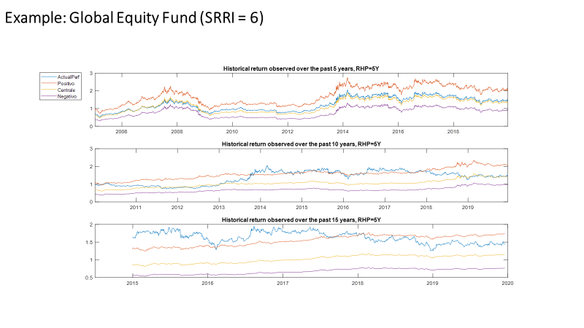

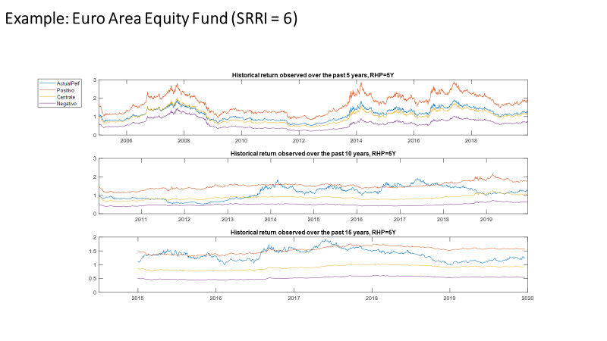

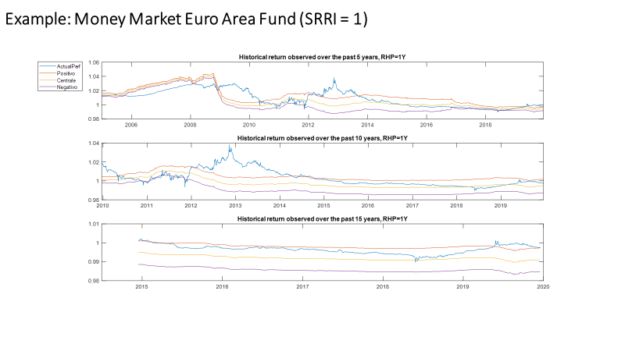

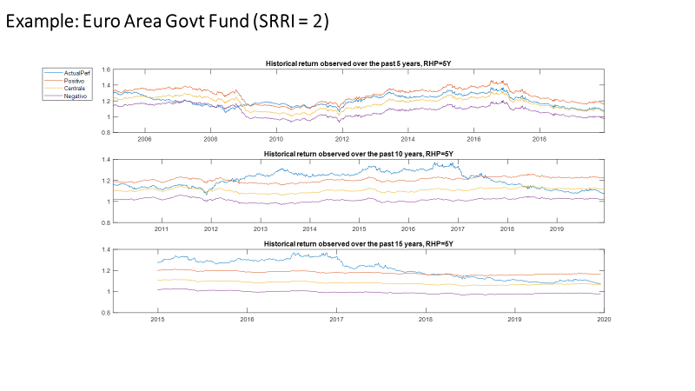

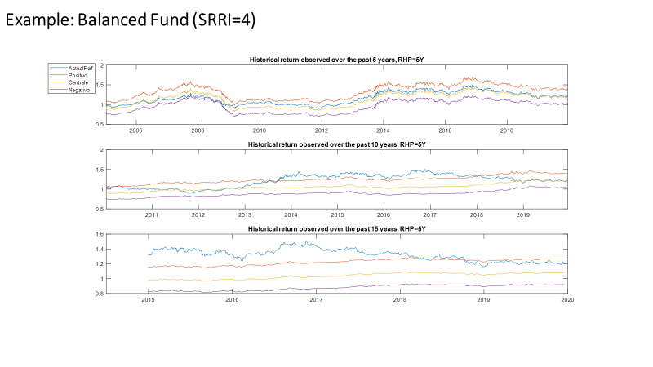

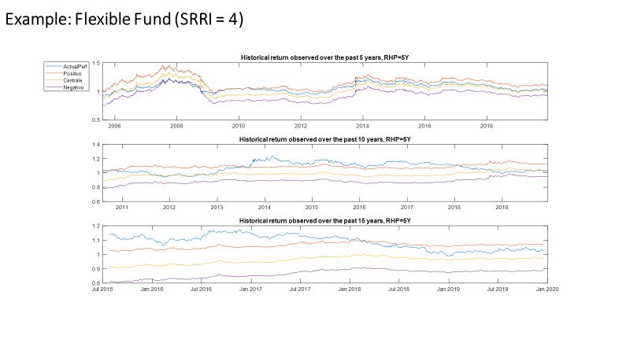

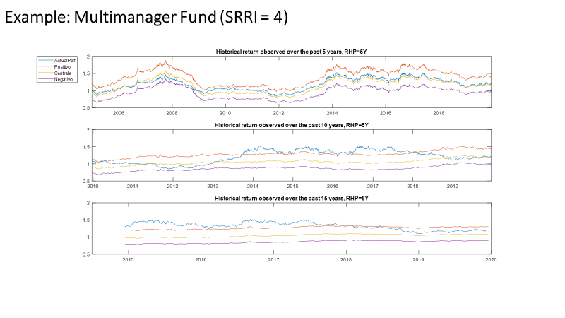

We are aware that also this method is not perfect and has some positive and negative. But we believe that, in the end, in a cost/benefit analysis the positive aspects exceed the negative ones:

* simple and objective method
* reflecting (also) the active management and the management style net of costs (based on NAV)
* no look through approach
* clear assumption for investors
* reduced compliance costs (impact on implementation, procedure, data feed)
* less expensive for data supply (cost of data vendor)
* longer period reduces pro-cyclicality
* no figures provided by ESAs or other independent third party
* method already implemented by PRIIPs

Negative:

* past projected in the future
* proxy to be used for funds which data are not available for the whole period
* not fully eliminate pro-cyclicality

**2. Scenario based on historical observations of the PRIIP over a period of two times the RHP**

The scenarios are based on historical observations of the PRIIP over a period of two times the RHP.

The performance scenarios for a fund with a recommended holding period of 5 years could look as follows:

|  |  |  |  |
| --- | --- | --- | --- |
| **Example scenarios based on historical observations of the last 10 years (i.e. twice the recommended holding period)** | **If you had invested € 10.000 for 5 years (i.e. the recommended holding period)** | **Observed results (i.e. over the recommended holding period)** | **Results observed over a 5-year recommended holding period, based on the last 10 years of the product’s life** |
| Best performance | What you might have gotten back after costs after 5 years | XX XXX.XX EUR | Worst [5] year performance observed over the last [10] years |
| Average yearly return | XX.XX% |
| Average performance | What you might have gotten back after costs after 5 years | XX XXX.XX EUR | Average [5] year performance observed over the last [10] years |
| Average yearly return | XX.XX% |
| Worst performance | What you might have gotten back after costs after 5 years | XX XXX.XX EUR | Best [5] year performance observed over the last [10] years |
| Average yearly return | XX.XX% |

The observations to be used are derived from all the rolling five-year periods (in rolling monthly terms) observable over a 10-year period, twice the RHP. This method would have the benefit of being more likely understandable to an average retail investor. For funds with no sufficient history, proxies could be used as an example.

**Positive:**

* allow retail investors to better understand how a certain product will function given certain market conditions
* simple to explain to investor, without any probabilistic approach

**Negative:**

* work only for funds and other products with past performance data.

However, we believe that if such scenarios do not provide meaningful results for other types of PRIIPs then different – more suitable – performance scenarios must be chosen for these types of PRIIPs.

**3. Volatility based Sharpe risk premia**

As reported by the ESAs on page 28, JC 2019 63, Joint Consultation Paper concerning amendments to the PRIIPs KID, between the alternative option raised so far: “*b) A proposal to use volatility-based risk premia. The risk premium would depend on the Sharpe ratio for each asset class or fund class and the asset or fund specific volatility. The Sharpe ratio for each asset class or fund class could be derived using historic averages.”*

The risk premia together with an appropriate reference rate results in the expected growth rate.

Of course, the correct estimation of the risk premium is challenging. In principle, the excess return over the risk-free rate (“excess return”) can be generated using the investment in risky asset classes and/or Alpha strategy, i.e. strategies that, by definition, have a negligible expected correlation with the returns of the risky asset classes.

Differences between PRIIPs with declared active management could be addressed in two different fields: one of them to estimate the potentialities arising from the only use of an investment in risky asset class (Beta), and the other to estimate the additional contribution resulting from the use of an active management (Alpha). In both cases, the goal would be to represent the estimate of a frontier of expected Sharpe ratios, a low boundary one arising from only the use of Beta strategies and a higher boundary arising from Beta plus Alpha strategies, for each level of SRI of the PRIIP.

As an example, the low level of Sharpe Ratio could be estimated over a long-term horizon, for which the historical series for a diversified set of risky asset classes are available (US government bonds, EMU government bonds, Investment Grade corporate bonds, High Yield corporate bonds, Emerging Markets government bonds, all country equities). By weighting differently those asset classes with respect to the SRI (or VEV), it is possible to calibrate the β Sharpe Ratio for each SRI (or VEV) level from the long-term historical return distribution of those balanced portfolios.

The high level of Sharpe Ratio (β+α) could instead be inferred directly from the evidence of the PRIIP or, for new PRIIP with no history, with the analysis of the actual long period Sharpe Ratios made by a sample set of similar PRIIPs.

The expected growth rate could be based on the sum of the Sharpe Ratio (β+α) (for PRIIPs actively managed) or the Sharpe Ratio (β) (for PRIIPs non actively managed), differently calibrated for each SRI (or VEV) bucket, multiplied by the volatility of the SRI plus the risk free component, equal for all SRI (or VEV) buckets.

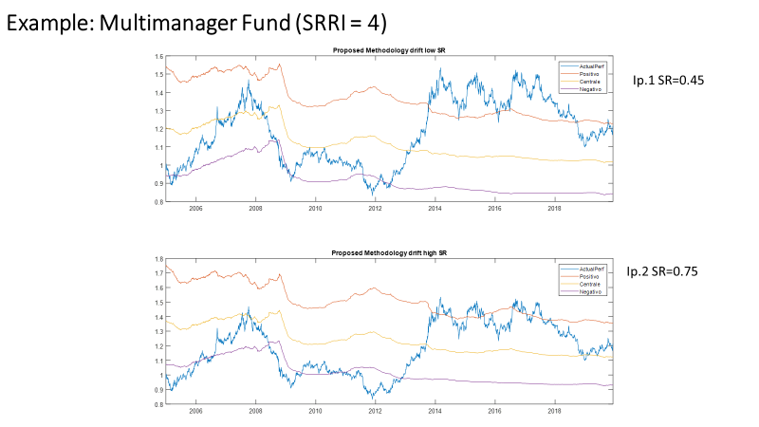

**4. Standardised growth rates**

If the ESAs maintain the dividend yield approach, at the very least, we ask these **future performance scenarios** to be **based** **on standardised growth rates**.

These standardised rates, however, would need to have the following features to make them workable for PRIIPs manufacturers:

* They must be **provided by an independent third party (such as the ESAs) free of charge**. This will avoid diverging growth rates being put forward by data providers and significantly reduce the costs of this individual data collection by PRIIPs manufacturers. These tables would have to be revised at regular intervals to properly reflect changing market conditions. The Delegate regulation should only contain high-level principles. Further details of such data should form the part of ESAs guidelines that will allow timely (at least annual) updates. Such as “*The ESAs shall issue guidelines with common reference parameters for the methodology for performance scenarios (transaction costs). The guidelines shall be updated at least every year taking into account the latest market developments*”. It is worth noting that it could be also valuable in the context of PRIIPs the exercise done by ESMA in defining and updating the common calibration to be used for MMF stress tests[9].
* The standardised rates should provide growth rates for the unfavourable, moderate and favourable scenarios.
* Sufficient granularity with regards to each asset class and sub-class should be provided. To achieve the right level of granularity these growth tables should contain the same asset classes as the transaction cost tables for new PRIIPs (see also our response to Q43).
* The growth rates should be net of all charges or the performance scenario should be produced before charges (gross of costs). This is necessary as actively-managed funds tend to have higher gross returns but also higher costs than passively-managed funds (this has been confirmed by ESMA’s latest cost and performance study). This is important because it would create an inherent bias towards actively-managed funds if PRIIPs costs have to be deducted from the standard growth rate in order to calculate the performance scenario net of costs. This should be avoided. We believe that sufficient comparability of costs is still ensured, as investors will have the dedicated cost tables for comparison.
* PRIIPs manufacturers should have no flexibility in applying the standard rates, i.e. they should not be allowed to lower them if they feel this is necessary. This will remove a great deal of complexity from the calculation and increase comparability between similar types of PRIIPs.
* Applied to the fund, according to its main investment policy (no look-through).

Should the standardised growth rates be gross, some clarification on the expected steps to get from the performance scenarios (gross return) to the average annual return net of costs should be welcomed. The scenario flow diagrams provided so far with worked examples don’t include any costs calculation useful for the industry to confirm their understanding of how to get to the final numbers.

<ESA_QUESTION_PKID_18>

* : Do you consider the use of a single table of growth rates appropriate? If no, how should the methodology be amended?

<ESA_QUESTION_PKID_19>

Please consider our response to Q18.

<ESA_QUESTION_PKID_19>

* : More generally, do your views about the use of a probabilistic methodology vary depending on the type of product (e.g. structured products vs non-structured products, short-term vs long-term products)? For which type of products do you see more challenges to define a probabilistic methodology and to present the results to investors?

<ESA_QUESTION_PKID_20>

Probabilistic methodologies should not vary depending on the type of product. The ESAs should rather consider entirely different types of performance scenarios for the type of product. The UCITS KIID differentiates between ‘linear’ and ‘structured’ funds to provide performance information. The same logic should be followed in the PRIIP KID.

<ESA_QUESTION_PKID_20>

* : Do you think these alternative approaches should be further assessed? If yes, what evidence can you provide to support these approaches or aspects of them?

<ESA_QUESTION_PKID_21>

Please consider our response to Q18 with regards to our proposals for alternative approaches

<ESA_QUESTION_PKID_21>

* : Are there any other approaches that should be considered? What evidence are you able to provide to support these other approaches?

<ESA_QUESTION_PKID_22>

Please consider our response to Q18 with regards to our proposals for alternative approaches.

<ESA_QUESTION_PKID_22>

* : Do you think illustrative scenarios should be included in the KID as well as probabilistic scenarios for structured products?

<ESA_QUESTION_PKID_23>

It is odd that the inclusion of illustrative scenarios (as well as probabilistic scenarios) is considered only for structured products. Furthermore, illustrative scenarios should replace the existing probabilistic scenarios rather than be added to the existing performance disclosures. Providing different types of performance scenarios for the same product will be confusing and likely misleading.

In line with our response to Q20, we therefore urge the ESAs to reconsider their approach towards performance scenarios entirely. The current experiences with the PRIIP KID has shown that it is impossible to provide meaningful comparisons between all types of PRIIPs. The ESAs must also consider that different types of performance scenarios are relevant for different types of products. This conclusion forms the basis of the UCITS KIID, in which there are different disclosures for structured UCITS.

<ESA_QUESTION_PKID_23>

* : If not, do you think illustrative scenarios should replace probabilistic scenarios for structured products?

<ESA_QUESTION_PKID_24>

See our response to Q23.

<ESA_QUESTION_PKID_24>

* : Do you agree with this approach to define PRIIPs which would show illustrative performance scenarios using the existing definition of Category 3 PRIIPs? If not, why not? Where relevant, please explain why this approach would not be appropriate for certain types of Category 3 PRIIPs?

<ESA_QUESTION_PKID_25>

See our response to Q23.

<ESA_QUESTION_PKID_25>

* : Would you be in favour of including information on past performance in the KID?

<ESA_QUESTION_PKID_26>

Yes, we strongly appreciate the ESAs proposal leveraging the positive experience of the UCITS KIID, where past performance information is presented where relevant for the investor to take an informed decision. Its inclusion is of paramount importance and, as far as we know, it is well appreciated by investors.

As regard the scope of the application, we share the ESAs proposal which does not seems to require the inclusion of past performance for AIFs classified under Category 1 PRIIPs (for example some closed-ended real estate funds). Much clarification should be welcomed to clearly include also closed-ended fund which, at some point in time of their life, reopen the subscriptions.

<ESA_QUESTION_PKID_26>

* : Would your answer to the previous question be different if it were possible to amend Article 6(4) of the PRIIPs Regulation?

<ESA_QUESTION_PKID_27>

No, our answer to the previous question would remain unchanged.

However, the three-page limit set in Article 6(4) of the PRIIPs Regulation is an important issue where more information should be included in the KIID. We refer to the transposition of many UCITS KIID-specific disclosures or the upcoming pre-contractual disclosures mandated in sustainable finance regulation.

<ESA_QUESTION_PKID_27>

* : Do you think that it can be more appropriate to show past performance in the form of an average (as shown in the ESA proposal for consumer testing) for certain types of PRIIPs? If so, for exactly which types of PRIIPs?

<ESA_QUESTION_PKID_28>

One of the essential benefits of a yearly representation of a past performance is to showcase the PRIIP’s past volatility in order to highlight the importance of different results that could be obtained in a long-term horizon.

If some comparison between PRIIPs would be maintained, and we believe it essential to have it in the presentation of the historical results, we believe that showing past performance in the form of an average should not substitute the graph with the 10y past performance, even if it would be limited only to PRIIPs with a RHP over a specific minimum duration.

Additional information made in the form of an average could also be included in the PRIIPs KID, where they are considered valuable for investors.

<ESA_QUESTION_PKID_28>

* : Do you have any comments on the statement that would supplement the display of past performance (e.g. with regard to the presentation of costs which are not included in the net asset value (NAV))?

<ESA_QUESTION_PKID_29>

The only costs that are not included in the past performance presentation (based on NAV) are the entry or exit costs that an investor may pay. If a statement is necessary, it should address this issue since a generic statement could be misleading.

<ESA_QUESTION_PKID_29>

* : Are you of the opinion that an additional narrative is required to explain the relationship between past performance and future performance scenarios?

<ESA_QUESTION_PKID_30>

No, we believe that there should be no explanation in the PRIIPs KID on the relationship between past performance and future scenarios. A clear distinction should be made between the two representation, but an additional narrative could confuse investors, especially if it should reflect the methodologies.

<ESA_QUESTION_PKID_30>

* : Do you see merit in further specifying the cases where the UCITS/AIF should be considered as being managed in reference to a benchmark, taking into account the provisions of the ESMA Questions and Answers on the application of the UCITS Directive[10]?

<ESA_QUESTION_PKID_31>

As regard disclosure of benchmark, we support the transparency requested in Article 7(1) letter d. and 18 of the KIID Regulation, but we would suggest further effort in terms of clarity of the updated UCITS Q&A documents (ESMA34-43-392) with the answer to Q&A 8b where there are controversial interpretations.

It seems sufficient for a benchmark index “to play a role in the management of the UCITS” for the management company to disclose it in the KIID (including in past performance) and a non-exhaustive example provides cases where ESMA believes this to be the case.

However, we believe that is always onus of the asset manager to determine whether a UCITS is in practice managed according to a benchmark, as stated also in the 8b answer “*Ultimately, the onus is on the UCITS management company to identify whether the UCITS is in practice managed in reference to a benchmark index.* *However, the following are … examples of where an approach may include or imply reference to a benchmark […]”.*

The list of non-exhaustive examples provided in the Q&A, in our understanding, do not automatically trigger for a disclosure in the UCITS KIID (or in the PRIIPs KID). The use of “may” in the ESMA response put in evidence that it might be a case - neither it should nor it must be a case - that an example included in the list trigger for the disclosure. This interpretation permits a disclosure of only the benchmarks that are relevant to the implementation of a given investment strategy. For example, if a UCITS references an index for the sole purpose of measuring its performance fees against it (example EURIBOR + x%), that UCITS should not be necessarily understood as being managed according to that same index. Thus, it would depend on the investment objective and the strategies pursued and these features could not simply derive from the provision of a performance fee (please see also our reply to consultation paper on Guidelines on performance fee in UCITS),

We, therefore, believe that the transition from a UCITS KIID to a PRIIP KID will be another opportunity, other than the consultation paper on Guidelines on performance fee in UCITS, to better clarify such Q&A.

<ESA_QUESTION_PKID_31>

* : Do you see the need to add additional provisions for linear unit-linked insurance-based investment products or linear internal funds?

<ESA_QUESTION_PKID_32>

TYPE YOUR TEXT HERE

<ESA_QUESTION_PKID_32>

* : Do you agree that a fixed intermediate time period / exit point should be used instead of the current half the recommended holding period to better facilitate comparability?

<ESA_QUESTION_PKID_33>

No, we believe that only a one-year and recommended holding period (RHP) should be used in the cost disclosures. The current ½ RHP should be deleted. This would reduce the amount of information being presented to retail investors by one third without depriving investors from essential new insights. The costs of investment in many PRIIPs are very high at the beginning (over one year) and are smoothed over the recommended holding period. Investors should be able to deduce the effect of early exit between those dates from the remaining bits of information.

Furthermore, RHPs vary substantially between different types of PRIIPs, so there is little sense in striving for complete comparability. It is more important to provide meaningful information.

Should the ESAs decide to keep the intermediate time period in the cost tables, a fixed holding period of 5 years should be used for all PRIIPs in order to facilitate comparability.

With regards to closed-ended fund, that could take different forms (ELTIF, EUVECA, ESUEF, real estate funds or other private equity/debt fund) we believe that appropriate information on costs should be given only at RHP.

Should the ESAs require also a presentation at the ½ RHP/5years for an ELTIF for which redemptions would be possible before the end of life of the ELTIF (beginning from a date specified in the fund rule), the treatment of the exit costs, if any, should be clarified. For example, if a limited redemption may be possible at the 3rd or 7th year of the ELTIF’s life, and the costs should be displayed at the 5th year, exit costs should not be considered as they would not apply at the 5th year. To avoid misunderstanding by investors and for a better level playing field further clarity is welcomed.

<ESA_QUESTION_PKID_33>

* : In this case (of a fixed intermediate time period), do you agree to show costs if the investor would exit after 5 years for all PRIIPs with a recommended holding period of at least 8 years? Or do you prefer a different approach such as:

<ESA_QUESTION_PKID_34>

Please see our comments to Q33 above.

<ESA_QUESTION_PKID_34>

* : Do you think it would be relevant to either (i) use an annual average cost figure at the recommended holding period, or (ii) to present both an annual average cost figure and a total (accumulated) costs figure?

<ESA_QUESTION_PKID_35>

The use of an annual average cost figure ensures a better comparability between PRIIPs. A total cumulated figure depends on the RHP and this may vary immensely between different types of PRIIPs, so there is little sense in comparing the accumulated cost figures across PRIIPs with different RHP, for example 5, 10, 15 years.

<ESA_QUESTION_PKID_35>

* : Do you think that it would be helpful, in particular for MiFID products, to also include the total costs as a percentage of the investment amount?

<ESA_QUESTION_PKID_36>

Yes, it would be very helpful with the MiFID II disclosures. It is absolutely crucial that investors receive the same cost disclosures through the PRIIP KID and MiFID ex-ante disclosures at the point of sale:

* such representation would lead also to firms distributing investment products to rely on the disclosure of product costs provided in the PRIIPs KID for the purpose of computing their aggregated cost figure comprising charges of both, product and service;
* assumptions on performance are not relevant for MiFID II. Where an illustration of the impact of costs on returns is made, this is generally based on the assumption that the annual return each year will cover the relevant costs (meaning that the value of the investment at the end of each year is equal to the initial investment amount). Therefore, we believe that options 1 to 4 that require that all or some cost elements be calculated as a RIY on the basis of the moderate performance scenario do not permit to align the disclosure with MiFID. It is worth noting, that the alignment with MiFID II should not only be with Table 2, but also with Table 1.

This presentation has further merits:

* it represents the potential cost of the investor and of the PRIIP, regardless its RHP. Therefore, it could not be misunderstood the impact of an entry or exit fee/penalties, whenever it takes.
* It interacts better with figures disclosed in the prospectus/fund rule.

<ESA_QUESTION_PKID_36>

* : In this context, are there PRIIPs for which both performance fees and carried interests are applied?

<ESA_QUESTION_PKID_37>

We are not aware of PRIIPs applying both performance fees and carried interests.

<ESA_QUESTION_PKID_37>

* : Do you agree with this analysis from the ESAs? If yes, what are your views on the extent to which fees related to the management of the underlying real estate assets, i.e. the properties themselves, should be taken into account in the calculation of the cost indicators?

<ESA_QUESTION_PKID_38>

As regard the performance fee narrative, we agree with the ESAs’ previous assessment with regards to how to extend the existing narrative to all type of performance fee models.

<ESA_QUESTION_PKID_38>

* : Do you agree with the ESAs’ preferred option 3 to revise the cost tables?

<ESA_QUESTION_PKID_39>

We agree that the cost tables need to be revised. However, all options presented by the ESAs expand the cost presentation with even more data points than are currently present. The ESAs’ preferred Option 3 has 32 cost figures/percentages compared 12 require at the moment. The second table also mixes calculated information (RIY) with information displayed in the prospectus/fund rules.

In the interest of retail investors, the ESAs should aim at reducing the number of specific cost elements being disclosed by focusing on the most relevant figures from their viewpoint.

Herewith some specific comments on the different proposals.

We disagree with the presentation in the table of cost of the return per year before and after the costs proposed across the 4 options. The concept of disclosing a “return per year before costs” is conceptually and fundamentally flawed. This figure is pure fiction, as it requires PRIIPs manufacturers to re-include all costs into the PRIIP, resulting in a “super gross” figure (i.e. net returns without any costs) that assumes that there are no opportunity costs for investors. This would even include implicit transaction costs. This would clearly mislead retail investors into believing that returns are for free.

In addition, investor would see figures on return also in the cost section, not only in the performance scenario and in the historical performance. Thus, would include another complexity in their understanding of the figures.

**The ‘return per year before/after costs’ disclosure therefore should be outright deleted.**

We make specific suggestions for a simplified solution, which can be found in our response to Q40.

<ESA_QUESTION_PKID_39>

* : If not, which option do you prefer, and why?

<ESA_QUESTION_PKID_40>

*Misleading nature of the RIY presentation*

We still believe that the concept of RIY currently used to disclose product costs to retail investors is too complex for many PRIIPs. The fact that the costs include a time horizon and a yield assumption represents a new type of theoretical disclosure that clients, especially fund investors, have not generally been familiar with.

Also, MiFID II (and IDD) does not require the disclosure of costs in an RIY format, which leads to the unacceptable situation that a PRIIP being sold through advisory channels will lead to two different product cost disclosures being presented to the investors. The RIY concept could be dropped outright for other alternative disclosure types such as UCITS KIID style disclosures. These would have the key advantage of providing cost figures not based on assumptions (i.e. return). This data can then be used for other purposes such as online calculators.

Therefore, we propose the following two different table, that could be also combined in one cost table.

In both table, costs are presented in monetary as well as percentage terms on a total cost basis and no assumption of the return is made. In other terms, the performance is assumed to offset all costs for the relevant period of calculation (meaning that the value of the investment at the end of each year is equal to the initial investment amount). In line with our response to Q36, this assumption it essential to make the crucial alignment with the MiFID ex-ante cost disclosures.

*Table 1 (Changes to ESAs option 1)*

|  |  |  |
| --- | --- | --- |
| **When you invest [10.000 / 1.000 EUR per year]** | **If you end/exit/surrender/terminate/lapse/ after 1 year** | **If you exit after [recommended holding period] years** |
| Total costs over time per year in € | € | € |
| Total costs over time per year in % | % | % |

*Table 2 (Changes to ESAs option 2)*

|  |  |  |  |
| --- | --- | --- | --- |
| **Type of costs** | | **Description of costs** | **Example** |
| ***One-off costs*** | ***Entry costs*** | |  | | --- | | **[X% of the amount invested / premium paid] or [x% of the first Y premiums / investments]**  *Where the costs are embedded in the price or premium:*  **These costs are already included in the [price / premium] you pay.**  *[Where distribution costs are included in entry costs] This includes [monetary value] EUR costs of distribution of your product. ~~[Where the manufacturer only knows the maximum distribution cost]~~* **~~This is the maximum you could pay. The person selling you the product will inform you of the exact charge.~~**  ***[Where distribution costs are not included in the entry costs]****.*  **The person selling or advising you may require you an additional entry fee up to a level of y% of the amount invested.** | | 0% of the amount invested is kept/embedded in the fund.  The person selling or advising you the product may require you additional fees up to a level **of 5%** of the amount invested. |
| ***Exit costs*** | **X% of the value of your investment at that time.**  *Where the costs are embedded in the price:*  These costs will be included in the price you get.  *Where they apply only for disinvestment prior to the recommended holding period.*  **These costs only apply in case of** *(explain circumstances or an example in max 100 characters)***:**  **exit before maturity/termination of the product / [months/years]/ exit out of the (monthly/….) / liquidity windows).**  For details, refer to section “How long should I hold it and can I take my money out early?” | **3%** of the value of your investment at that time. These costs only apply in case if you exit before 5 years. |
| ***Ongoing costs*** | ***Management fees and other costs*** | |  | | --- | | **X%** of (value of the investment / other basis) [per year / other time period] [where applicable] **(of which % are management fees)** | | **1.25%** of the value of the investment per year (of which 1.10% are management fees). |
| ***Transaction costs*** | **X% of (value of the investment per year)**  This is an estimate of the costs of us buying and selling underlying investments for the product calculated [with/without] the use of a standard costs table. | **0.2%** of the value of the investment per year. This is an estimate of the costs of us buying and selling underlying investments for the product. |
| ***Incidental costs*** | ***~~[~~Performance fees / carried interest / other~~]~~*** | **X% of** (value of the investment / other basis) *(…describe in max 100 characters). Where applicable [cross-reference to prospectus/fund rules]*  *~~[Only include row where applicable]~~* | **0,30**% of the value of the investment; **20%** if the fund outperforms … |

In addition, in order to deliver the most accurate information to the investor, any entry/exit fees that are not known by the manufacturer should only be disclosed in the second cost table. The PRIIPs manufacturer knows the maximum amount that can be applied and discounted by the distributor, but it does not know the actual amount applied to the investor. Integrating the maximum entry cost into the total cost figure is not accurate, as it is a common practice for distributors to negotiate with client an entry cost reduction. Disclosing the maximum is therefore inexact and misleading. The total and precise entry costs paid are disclosed by the distributor under MIFID and IDD requirements.

In line with above, we would suggest the following amendments:

* Point 3(a) of Annex VI should be modified as follows: “Distribution fee, to the extent that the amount is known to the management company. If the actual amount is not known to the management company, the maximum of the possible known distribution costs for the specific PRIIP shall be shown **in the composition of the costs in the Table 2 (Annex VII).“**
* Point 62 of Annex VI: “For the calculation of the summary cost indicator the costs to be disclosed referred to in point 72 of this Annex shall be the total costs. This shall equal for investment funds to the sum of the costs as referred to in points 1 and 2 of this Annex, **to the extent that the actual amount of one-off costs paid by the investor is known to the management company,** plus the sum of the costs as referred to in points 4 and 6 of this Annex;”

Should ESAs insist with the RIY, based on the results of the moderato scenario, in table 1 could be added a separate row with the RIY information as follows

|  |  |  |
| --- | --- | --- |
| **When you invest [10.000 / 1.000 EUR per year]** | **If you end/exit/surrender/terminate/lapse/ after 1 year** | **If you exit after [recommended holding period] years** |
| Total costs over time per year in € | € | € |
| Total costs over time per year in % | % | % |
| Reduction in return each year due to costs in %* | % | % |

*\* We have assumed the product perform as shown in the moderate performance scenario*

Finally, in any case, we would suggest providing concrete examples to calculate the costs. These could be useful for the industry to confirm the understanding of how to get to the final numbers required.

<ESA_QUESTION_PKID_40>

* : In particular, do you think that the proposed changes to the presentation of the impact of costs on the return in percentage terms (i.e. including reduction in return before and after costs) is an improvement on the current presentation?

<ESA_QUESTION_PKID_41>

No, as highlighted in our response to Q40, we are strongly against the proposed changes to the presentation of the impact of costs on the return in percentage terms (i.e. including a reduction in return before and after costs).

Firstly, in an effort to better explain the concept of reduction in yield/return, even more information is suggested to be presented to retail investors. We strongly doubt that this additional information (three lines instead of one) will be understood by retail investors.

Secondly, the concept of disclosing a “return per year before costs” is conceptually and fundamentally flawed. This figure is pure fiction, as it requires PRIIPs manufacturers to re-include all costs into the PRIIP, resulting in a “super gross” figure (i.e. net returns without any costs) that assumes that there are no opportunity costs for investors. This would clearly mislead retail investors into believing that returns are for free. This disclosure therefore should be deleted altogether.

<ESA_QUESTION_PKID_41>

* : Do you have other comments on the proposed changes to the cost tables?

<ESA_QUESTION_PKID_42>

Please see our answers to Q39-42 above

<ESA_QUESTION_PKID_42>

* : What are your views on the appropriate levels of these thresholds? Please provide a justification for your response.

<ESA_QUESTION_PKID_43>

*Broad consideration on transaction costs*

Transaction costs are incurred by the managers to gain exposure to the market or to change exposure in order to deliver performance. These costs result from the buying or selling financial instruments, securities, or real assets. These buying and selling actions are necessary because of investor flow, rebalancing, new type of investment or ongoing risk management.

Implicit in any decision to give evidence of transaction costs is a view that asset managers benefit from incurring transaction costs and are not sufficiently incentivised to control them. This is not the case. High transaction costs that do not result in better outcomes will harm returns and returns are what managers are remunerated and judged upon.

Therefore the objective of asset managers is to minimise transaction costs for in the implementation of their investment decisions.

There are two major issues with transaction costs:

* + - total cashflow vs discretionary trading activity: any PRIIP with strong positive/negative cashflows, will experience significant transaction costs as it seeks to invest/disinvest. In markets with significant transaction taxes (taxes, not brokerage) would be the main component of transaction costs. In addition, delegated Regulation introduces some compensatory mechanism where anti-dilution mechanism apply, but it is worth noting that such mechanism may be not available in all jurisdiction. Therefore, competition issues may arise.
    - operational challenges in calculating and quantify transaction costs. Although explicit transaction costs can, at least ex-post, be precisely accounted, implicit costs can only ever be estimated. As a result, there would be a real risk of introducing distortions into investor decision-making, where the choice of the products would depend of the amount of such figure.

In consideration of the above, transaction costs should be illustrated to the investors in the pre-contractual document but not included in the total aggregate cost indicator. The illustration of such costs should be under the line, in coherence with performance fee disclosure under the UCITS KIID. Therefore, we strongly support an amendment of the relevant Level 1 provision both for PRIIPs and MiFID).

*Specific consideration on transaction costs*

We see some value when the ESAs proposed in the consultation paper some derogations to the methodologies for the calculation of transaction cost, especially in Option 2. However, we invite to move a step forward and clearly provide two methodologies for their calculation. Whatever the fallback option may be the derogation would not still be workable for most asset managers.

It should be possible to calculate transaction costs as either of the following:

* + use standardised transaction costs figures for implicit transactions costs, improving the proposed methodology applied for new PRIIPs (please see our proposal below). In line with a proportional regulatory approach, a “simplified” method where the ESAs or a third independent party provide the relevant figures free of charge, would require cheaper, less time consuming, more reliable systems, given the challenge of what has to be measured. The above would be in line also with the systems already applied by asset managers to provide transaction cost figures for the purpose of MiFID II disclosure. Furthermore, a single European provider will also ensure that there are no divergences between EU Member States. It is worth noting that the figures might be provided directly by ESAs. European authorities could provide relevant figures in line with the work already done in other fields[11].
  + use a more empirical calculation that avoids the slippage drawdown i.e. compare the execution price against the mid-market price when a trade takes place, rather than against the arrival price. This aspect is of specific relevance for the treatment of costs resulting from the market impact of transactions which shall be disregarded for the purpose of MiFID II disclosure.

For a well-informed disclosure to investor, the PRIIPs should disclose the method used to calculate transaction costs i.e. standard table or actual costs. Please see our suggestions for the presentation of costs - table 2 in our response to Q39.

We would also highlight that if a standardised spread table could not be possible to use, except for funds, UCITS and AIF benefitting from the “UCITS exemption” should start to collect historical data (up to three years). We ask therefore to keep a derogation: until the end of the exemption period (currently 31 December 2021) exempted funds may calculate transaction costs for that period using costs coming from a standard spread table. It would also be very welcomed if asset manager could rely on data relating to “historical transaction costs” used in the context of the MiFID disclosure. Asset managers have indeed provided to third distributors the relevant data and this derogation will ensure continuity in the evidence provided to investors.

***

**Points 7 to 23 of Annex VI to be replaced by the following:**

**Transaction costs - General**

7. The information about all costs and charges, including transaction costs incurred by the PRIIP, which are not caused by the occurrence of underlying market risk, shall be calculated and disclosed to the client. Transactions costs shall include explicit charges and where applicable implicit charges.

8. Transaction costs shall be calculated using the methodology described in points ~~10 to 18~~ 9b to 18b of this Annex for investments in the following instruments:

(a) transferable securities as defined by Article 2 of Commission Directive 2007/16/EC (1);

(b) other instruments for which there are frequent opportunities to dispose, redeem or otherwise realise at prices that are publicly available to market participants and that are either market prices or prices made available or validated by valuation systems independent of the issuer.

9. Transaction costs shall be calculated using the methodology described in points 9b and 22 to 24 of this Annex for investments in other instruments or assets.

9a. Where the PRIIP has been operating for less than three years, transactions costs shall be calculated using the methodology set out in points 19 to 21 of this Annex

**Treatment of anti-dilution mechanisms**

9b. Where a PRIIP has a pricing mechanism that offsets the impact of dilution from transactions in the PRIIP itself, the amount of benefit accruing to the ongoing holders of the PRIIP from anti-dilution mechanisms may be deducted from the transaction costs incurred within the PRIIP using the following methodology: (a) the monetary amount of any anti-dilution levy, or other payment in connection with a transaction in the PRIIP itself, that is paid to the PRIIP may be subtracted from the total transaction costs (b) the benefit to the PRIIP of issuing units (or otherwise enabling investment in the PRIIP) at a price other than the mid price, or of cancelling units (or otherwise enabling redemption of funds from the PRIIP) at a price other than the mid price, provided that the PRIIP itself receives the benefit, shall be calculated as follows and may be subtracted from the total transaction costs: (i) the difference between the price of units issued and the mid price, multiplied by the net number of units issued; (ii) the difference between the price of units cancelled and the mid-price, multiplied by the net number of units cancelled.

**Transaction costs for instruments defined under point 8 a) and b)**

Explicit transaction costs

10. Explicit costs include costs and charges incurred by the PRIIP, and paid out of investor’s financial investment in the PRIIP, in order to acquire or dispose of the underlying assets of the PRIIP, such as but not limited to commissions paid to brokers or other intermediaries, stamp duty or market taxes, contract fees and execution fees for OTC derivatives, legal advisers for real estate transactions, ~~clearing fees and booking fees charged by the custodian for other assets~~, where relevant.

11. Explicit costs shall be calculated as the average yearly transaction costs (sum of costs incurred by the PRIIP during the year divided by average net asset over the year) over the previous three years, for all individual transactions undertaken by the PRIIP and in the base currency of the PRIIP~~, averaged over one year. This sum shall be converted into a percentage by dividing by the average net assets of the PRIIP over the same period.~~

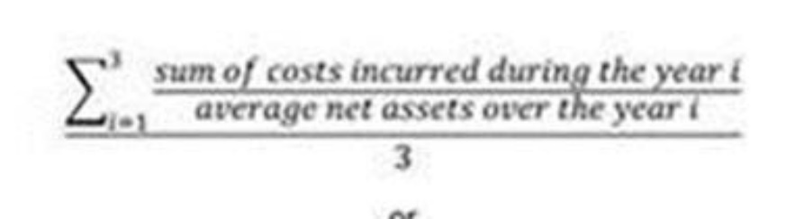

Implicit transaction costs

12. In addition, other charges, which are not explicit costs, impact the overall performance of the PRIIP when acquiring or disposing of underlying assets. These are deemed implicit costs ~~and shall be disclosed by the manufacturer of the PRIIP to demonstrate how transactions are executed on terms that are most favourable to the client~~.

13. Implicit costs shall be calculated as the average yearly transaction costs (sum of such individual charges incurred by the PRIIP during the year divided by average net asset over the year) over the previous three years for all individual transactions undertaken by the PRIIP~~. They shall be calculated~~ in the base currency of the PRIIP~~, and averaged over one year. This average annual sum shall also be converted into a percentage by dividing by the average net assets of the PRIIP over the same three year period. Where these figures are negative, implicit costs shall be deemed to be zero such that the level of transaction costs cannot be less than the amount of explicit costs.~~

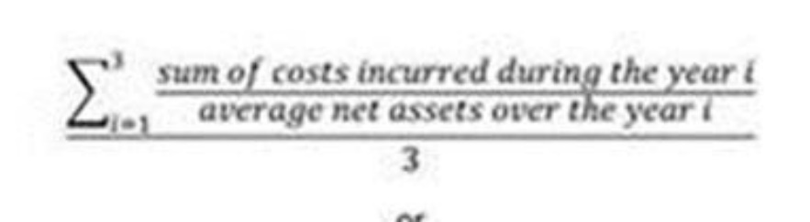

14. Any and all processes developed by the PRIIP manufacturer to manage, mitigate and measure implicit costs shall be fit for purpose and documented in a clear and sufficiently detailed manner.

It should be possible to calculate implicit transaction costs as either of the following:

* Implicit costs shall be identified by comparing the execution price recorded for a specific transaction with a suitable reference price. The identification of a suitable reference price shall be duly recorded and follow the approaches set out in points 15 to 17 of this Annex ~~(a) and (b)~~ in a manner that is consistent with documented internal procedures of the PRIIP manufacturer to manage, mitigate and measure implicit costs, applied consistently across transaction types.
* Implicit costs shall be measured by reference to data provided by ESAs or - as a fall-back option - an independent third party (included association). The calculation of implicit transaction costs shall follow the approaches set out in points 18 and 18a of this Annex.

OTC transactions

~~15. Where the manufacturer has obtained executable prices from multiple counterparties or where live executable prices are available, implicit transaction costs shall be measured by reference to such prices. In any such case, the number of units traded shall be multiplied by either the reference price of the instrument subtracted from the execution price for each purchase undertaken by the PRIIP or the execution price subtracted from the reference price of the instrument for each sale undertaken by the PRIIP;~~

~~16. By way of derogation from point 15, where the manufacturer is able to demonstrate that the transaction data used is statistically meaningful, sufficiently granular and proper governance and controls are in place to ensure that the data is sufficiently representative of the actual trade, implicit transaction costs shall be measured by reference to. prices obtained for previous transactions in assets bearing similar characteristics (e.g. duration, maturity, coupon, call- / put-ability) and liquidity, using transactions previously executed by the manufacturer or a third party or using available indexes or This derogation shall apply in all cases where a manufacturer undertakes fewer than [250] transactions in a three-year period for an individual PRIIP, or where the total consideration for all transactions undertaken over 3 years is less than [25%] of the net asset value of the product~~.

15. For OTC transactions,

a. where a transaction is executed after bid prices and offer prices have been obtained from more than one potential counterparty, the arrival price shall be taken to be:

i. If the best bid price is below the best offer price, the mid-point between the best bid price and best offer price;

ii. If the best bid price is higher than the best offer price, the best bid price in the case of a sale or the best offer price in the case of a purchase.

b. Where a transaction is executed without both bid prices and offer prices having been obtained, the implicit transaction cost shall be calculated according to points 18 and 18a.

*For transactions negotiated on platform,*

16. For transactions negotiated on platform implicit transaction costs shall be measured by reference to the mid-market price of the instrument, at the time the order is executed ~~transmitted by the portfolio manager or the trader~~ or, if justified by the manufacturer on the basis of the asset type or liquidity or availability of market data, by reference to a relevant intraday mid-market price available for the day of the transaction~~, or by reference to the opening or previous closing price for that security where relevant.~~ In any such case, the number of units traded shall be multiplied by either the reference price of the instrument subtracted from the execution price for each purchase undertaken by the PRIIP or the execution price subtracted from the reference price of the instrument for each sale undertaken by the PRIIP.

16a. For orders executed in several transactions, the transaction costs may be calculated either for each individual execution, or using the volume weighted average mid-market price of the instrument during the period of execution as the arrival price, or by calculating the transaction cost of the first or last execution, as appropriate given the characteristics of the order and of the instrument and the timeframe of execution of the order.

17. Where information about the time when the order is executed is not available (or not available to a sufficient level of accuracy), or where information about the mid-market price at that time is not available, it is permissible to calculate the transaction cost as described in point 18 and 18a.

~~18. By way of derogation, where the manufacturer is able to demonstrate that the transaction data used is statistically meaningful, sufficiently granular and proper governance and controls are in place to ensure that the data is sufficiently representative of the actual trade, implicit transaction costs shall be measured by reference to prices obtained for previous transactions in the same or similar securities presenting similar characteristics (e.g. size, industry) and liquidity, deriving from transactions executed by the manufacturer or a third party or using available indexes. This derogation shall apply in all cases where a manufacturer undertakes fewer than [250] transactions in a three-year period for an individual PRIIP, or where the total consideration for all transactions undertaken over 3 years is less than [25%] of the net asset value of the product.~~

18. For the asset classes indicated in table below, implicit transactions costs shall be calculated by multiplying the portfolio turnover by the reference cost of the asset class.

18a. The ESAs shall issue guidelines with common reference parameters [for the table below]. The guidelines shall be updated at least every year taking into account the latest market developments. PRIIPs manufactures should make any changes to the KID in order to incorporate this additional guidance as soon as practicable, or by the next KID update following the publication of the guidelines

Example of a standard table

|  |  |  |  |  |
| --- | --- | --- | --- | --- |
| Asset Classes: Implicit transaction costs | |  |  |  |
| Government bonds | Government bonds and similar instruments developed market rating AAA-A | Maturity Buckets 1-3 yrs, 3-5 yrs, 5-7 yrs, 7-10 yrs, 10+yrs | US, Euro, UK, Japan, Pacific ex Japan* |  |
| Government bonds and similar instruments developed market different rating below A | Italy, ex Italy* |  |
| Government bonds emerging markets (hard ~~and soft~~ currency) | Government bonds emerging markets (hard ~~and soft~~ currency) | Maturity Buckets 1-3 yrs, 3-5 yrs, 5-7 yrs, 7-10 yrs, 10+yrs* |  |  |
| Government bonds emerging markets (soft currency) | Government bonds emerging markets (soft currency) | Maturity Buckets 1-3 yrs, 3-5 yrs, 5-7 yrs, 7-10 yrs, 10+yrs* |  |  |
| Investment grade corporate bonds | Investment grade corporate bonds | Maturity Buckets 1-3 yrs, 3-5 yrs, 5-7 yrs, 7-10 yrs, 10+yrs* | US, Euro, UK, Japan, Pacific ex Japan* |  |
| Other corporate bonds | High yield corporate bonds | Maturity Buckets 1-3 yrs, 3-5 yrs, 5-7 yrs, 7-10 yrs, 10+yrs* | US, Euro, UK, Japan, Pacific ex Japan* |  |
| Liquidity | Money market instruments (for the sake of clarity, money markets funds not included) |  | US~~$~~, Euro, Yen |  |
| Shares developed markets | Large-cap shares (developed markets) |  | US, Euro, UK, Japan, Pacific ex Japan* |  |
| Mid-cap shares (developed markets) |  | US, Euro, UK, Japan, Pacific ex Japan* |  |
| Small-cap shares (developed markets) |  | US, Euro, UK, Japan, Pacific ex Japan* |  |
| Shares emerging markets | Large-cap shares (emerging markets) |  | Asia ex China, Latin America, China* |  |
| Mid-cap shares (emerging markets) |  | Asia ex China, Latin* **America, China |  |
| Small-cap shares (emerging markets) |  | Asia ex China, Latin* America, China |  |
| Listed derivatives | Listed derivatives |  | Developed, Emerging* | Future, Option* |
| OTC | OTC Exotic options |  |  |  |
| OTC Plain vanilla options |  |  |  |
| OTC IRS, CDS and similar |  |  |  |
| OTC Swaps and similar instruments (different from IRS, CDS and similar) |  |  |  |
| OTC FX Forwards developed markets |  |  |  |
| OTC FX Forwards emerging markets |  |  |  |
| Securitized | ABS, MBS, CMBS, CLO …* |  |  |  |
| Commodity |  |  |  |  |

*Detailed figures may be used.

**Historical data**

18b. When calculating transaction costs using data prior to [end date of the UCITS exemption], it is permissible to calculate the transaction costs as described in point 18 and 18a or to rely on data viable to comply with Article 24 (4) Directive 2014/65/EU.

**Transaction costs for new PRIIPs**

19. For PRIIPs that have been operating for less than 3 years, transaction costs shall be estimated according to the following:

a. estimating the total costs incurred from the costs calculated under the method described under points 10 to 18b ~~14~~ for a period representing the highest multiple of one year that the PRIIP has been operating, averaged over one year;

b. for a PRIIP that has been operating for less than one year, by estimating the portfolio turnover in each asset class with the costs estimated according to the methodology referred to in points 10, 18 to 18b ~~to 14 a (ii) and 14 b (ii)~~ of this Annex.

20. Estimates of portfolio turnover for a PRIIP that has been operating for less than one year must be made on a consistent basis with the investment policy disclosed in the offering documents. Estimates of portfolio turnover for a PRIIP that has been operating for more than one year must be consistent with actual portfolio turnover.

21. For PRIIPs that have been operating for less than three years and that invest predominantly in assets other than assets as referred to in point 8~~9~~ of this Annex, the PRIIP manufacturer shall estimate the explicit transaction costs only ~~on the basis of the fair value method~~ using comparable assets or be based on the business forecast.

Transaction costs for assets defined under point 9

22. When estimating transaction costs for assets other than assets as referred to in point 8 of this Annex, transaction costs shall be deemed to consist of explicit costs only and shall be calculated as the annual average of the aggregate of the costs directly associated with the transaction including all charges, commissions, taxes and other payments (such as anti-dilution levies), where those assets are made from the payments ~~assets~~ of the PRIIP. ~~Where the asset has been bought or sold at a price that is materially different from its fair value, implicit costs shall be calculated as follows : (execution price – fair value price)*number of transactions.~~

~~19.~~ 23.For assets that are not measured at fair value, transaction costs are incremental costs determined in accordance with the product's accounting policies.

~~23. The transaction cost estimate must not be less than the amount of actual identifiable costs directly associated with the transaction.~~

24. By way of derogation from points 22 and 23 for closed-ended PRIIPs, transactions costs may be based also on an approved business plan.

***

Where ESAs insist with Option 1, please take into account these further suggestions:

* Para. 9 “*Where implicit transaction costs are negative, a minimum of explicit transaction costs shall be disclosed*” and paragraph 26 “*The transaction cost estimate must not be less than the amount of actual identifiable costs, if any, directly associated with the transaction*”. The arrival price methodology, in theory, produces both positive and negative trade-per-trade transaction costs and should, theoretically, “average out to approximately zero”. However, in many cases it does not do so. These paragraphs should be deleted as they confirm that negative could arise. Put them to zero only hides the problem. In addition, this would introduce a bias since negative costs would not arise, but overstated costs are deemed acceptable. Furthermore, the zero floor for aggregate implicit costs would apply only to equities but not to OTC instruments, which could make use of the derogation in point 20 of Option 1.
* Para. 13 “… *clearing fees and booking fees charged by the custodian*” This is not a transaction cost because it is not a cost necessarily incurred as a result of transacting (it is incurred as a consequence of employing a custodian). It is included in ongoing costs as per point 5(a)(iv) of annex VI of the RTS.
* Have a derogation for UCITS and AIF benefitting from the “UCITS exemption” until the end of the exemption period (currently 31 December 2021). The New PRIIPs approach or data used in the MiFID context could be used. See our comments above.
* Para. 20 and followings “*The actual transaction costs for each transaction shall be calculated on the following basis: for each purchase undertaken by the PRIIP, the mid-market price of the instrument at the time the purchase order is executed ~~transmitted to another person for execution~~ (the purchase ‘arrival price’) shall be subtracted from the net realised execution price of the transaction. The resulting value shall be multiplied by the number of units purchased*”. We believe essential to remove the market movement for the cost calculation. This can be achieved by using the mid-market price.
* Para 20 “*By way of derogation from points 13-19 […]Where live market quotes are not available by reference, to spreads obtained for either previous* ***relevant*** *transactions in assets bearing similar characteristics (e.g. duration, maturity, coupon, call-/ put-ability) and liquidity, using transactions previously executed by the manufacturer or ~~data verified by an independent third-party, or from an independent third-party to value the asset~~ data provided by*independent third party (included association)~~or following the methodology defined in point 27 [Transaction costs for new PRIIPs.~~ “Independent third-party validation should be avoided.
* Para. 22 *“By way of derogation from points 13-21 of this Annex, where a product undertakes fewer than [250] transactions in a three-year period, or where the total consideration for all transactions undertaken over 3 years is less than [25%] of the net asset value of the product, the manager may calculate transaction costs using the methodology described in point 20.”* We do not agree with this threshold because it is inoperable by the large extend of asset managers and potentially creates an uneven playing field.
* Para. 23. “*In calculating the costs associated with foreign exchange, the arrival price must reflect a reasonable estimate of the consolidated price, and must not simply be the price available from a single counterparty or foreign exchange platform, even if an agreement exists to undertake all foreign exchange transactions with a single counterparty*”. This paragraph should be deleted/revised as it is not compatible with the current practices, i.e. contracts and systems. The cost of changing the practices, contracts and systems would be disproportionate compared to the resulting differences of a small number of basis points. Such a new device is not necessary for the manager for evaluating the quality of its counterparty. Should the prices not be good enough, the manager will simply change its counterparty.
* Para. 27 and followings. The methodology of transaction costs for new PRIIPs should be revised. The Delegate regulation states two different methodologies for the estimation of transaction costs, one for existing funds and one for new funds. The presence of two different methods should be avoided, where these are not complementary to each other because they would imply double operational costs. In addition, the methodology for new funds requests information on the underlying of one or more reference indices. This may generate fees payable to index or data providers to collect also data on bid-ask spread. Finally, the cost of producing such information should be assessed also considering proportionality with regards to characteristics of different market players. PRIIPs manufactures should rely on spreads obtained for either previous relevant transactions in asset bearing similar characteristics other than data provided by an independent third-party.

<ESA_QUESTION_PKID_43>

* : If UCITS would fall in the scope of the PRIIPs Regulation, do you agree that the coexistence of the UCITS KII (provided to professional investors under the UCITS Directive) and the PRIIPs KID (provided to retail investors under the PRIIPs Regulation) would be a negative outcome in terms of overall clarity and understandability of the EU disclosure requirements? Are you of the view that the co-legislators should therefore reconsider the need for professional investors to receive a UCITS KII, as the coexistence of a PRIIPs KID together with a UCITS KII (even if not targeted to the same types of investors) would indeed be confusing, given the differences in the way information on costs, risks and performance are presented in the documents? Alternatively, are you of the view that professional investors under the UCITS Directive should receive a PRIIPs KID (if UCITS would fall in the scope of the PRIIPs Regulation)?

<ESA_QUESTION_PKID_44>

We do not agree with continuing to provide a UCITS KIID to professional investors. Because of the experience and competences of professional investors – that are able to process complex information - we do believe that providing UCITS KIID will entail an increase of unjustified costs.

Furthermore, we believe that PRIIP KID should not be delivered to professional investors and this, both on the basis of the considerations, made above and because such an obligation does not derive from the PRIIPS regulatory framework, which is focused on the retail investor.

**We, therefore, insist that the UCITS Directive is amended accordingly and the UCITS KIID Regulation repealed in order to have only one Key Information Document for retail investors from 01 January 2022.**

<ESA_QUESTION_PKID_44>

* : What are your views on the issue mentioned above for regular savings plans and the potential ways to address this issue?

<ESA_QUESTION_PKID_45>

We very much welcome the fact that the ESAs envisage re-examining the treatment of saving plans under Article 13(4) of the PRIIPs Regulation. This is essential as a savings plan enjoys great popularity among retail investors in a number of EU member states, as Italy.

We believe that, although the wording of the provision in the art. 13, par. 4 of the PRIIPS Regulation is not prima facie easy to read, however the substantial analysis of the same would seem to go in the direction of Q&A UCITS KIID (i.e 2a) regarding regular savings plans. Article 13, par.4, provides that where successive transactions regarding the same PRIIP are carried out on behalf of a retail investors in accordance with instructions given by that retail investors to the person selling the PRIIP prior to the first transaction, the obligation to provide a key information document under paragraph 1 shall apply only to the first transaction, and to the first transaction after the key information document has been revised in accordance with Article 10 of PRIIPS Regulation. In accordance with the provision of the PRIIP Delegated Regulation (articles 15-16), the review is different from the annual update because the first assume that there are some amendments that significantly affects the information included in the key information document. Therefore, we believe that even in the PRIIPS framework, as well as in the UCITS KIID, in case of saving plans it should be provided a KID at the beginning of the plan and every time there is a change that significantly affect the initial subscription agreement.

In case this interpretation would not be considered, we believe that it fundamental to maintain – even in the PRIIPS framework - the UCITS Q&A (cf. 2a) provision about the regular saving plan. Therefore, **we strongly support the amendment of Art. 13 (4) of the PRIIPS Regulation in accordance with the current market practice under the UCITS Q&As.**

<ESA_QUESTION_PKID_45>

* : Do you agree that these requirements from Article 4 should be extended to all types of PRIIPs, or would you consider that it should be restricted to Management Company of UCITS or AIFs?

<ESA_QUESTION_PKID_46>

TYPE YOUR TEXT HERE

<ESA_QUESTION_PKID_46>

* : Do you agree that this requirement should be extended to all types of PRIIPs, or would you consider that it should be restricted to Management Company of UCITS or AIF?

<ESA_QUESTION_PKID_47>

TYPE YOUR TEXT HERE

<ESA_QUESTION_PKID_47>

* : Do you agree that these requirements should be extended to all types of PRIIPs, or would you consider that they should be restricted to the Management Company of the UCITS or AIF?

<ESA_QUESTION_PKID_48>

TYPE YOUR TEXT HERE

<ESA_QUESTION_PKID_48>

* : Do you have any comments on the proposed approaches in relation to the analysis and proposals in this Section, and in particular on the extent to which some of the abovementioned requirements should be extended to other types of PRIIPs?

<ESA_QUESTION_PKID_49>

We agree with ESAs to take into account particular UCITS structures, with particular reference to share classes (i.e. art. 26 of the UCITS KIID regulation and the related ESMA Q&A).

<ESA_QUESTION_PKID_49>

* : Do you think this proposal would be an improvement on the current approach?

<ESA_QUESTION_PKID_50>

We have not specific comments. However, it worth saying that for the preparation of the PRIIPs KID for a MOP, the data on the underlying options (funds) should be based on the figures disclosed in the PRIIP KID as much as possible. Any further information could actually have an impact on PRIIPs manufactures both terms of financial resources and operational efforts to afford in providing/colleting relevant information.

<ESA_QUESTION_PKID_50>

* : Do you envisage significant practical challenges to apply this approach, for example for products which allow the investor to choose between a wide range or large number of options?

<ESA_QUESTION_PKID_51>

We have not specific comments. However, it worth saying that for the preparation of the PRIIPs KID for a MOP, the data on the underlying options (funds) should be based on the figures disclosed in the PRIIP KID as much as possible. Any further information could actually have an impact on PRIIPs manufactures both terms of financial resources and operational efforts to afford in providing/colleting relevant information.

<ESA_QUESTION_PKID_51>

* : Do you see any risks or issues arising from this approach in relation to consumer understanding, for instance whether the consumer will understand that other combinations of investment options are also possible?

<ESA_QUESTION_PKID_52>

TYPE YOUR TEXT HERE

<ESA_QUESTION_PKID_52>

* : Do you think this proposal would be an improvement on the current approach?

<ESA_QUESTION_PKID_53>

TYPE YOUR TEXT HERE

<ESA_QUESTION_PKID_53>

* : Are there other approaches or revisions to the requirements for MOPs that should be considered?

<ESA_QUESTION_PKID_54>

TYPE YOUR TEXT HERE

<ESA_QUESTION_PKID_54>

* : Do you have any comments on the preliminary assessment of costs and benefits?

<ESA_QUESTION_PKID_55>

There is a high risk that if the flaws of the PRIIPs Regulation are not adequately addressed prior to the implementation of the amended Level 2 Regulation, PRIIP KIDs will not serve their purpose of providing investors with the information they need to make an informed decision. Instead, investors will be overwhelmed by information which may, in the worst case, not be applicable and/or helpful.

The cost and benefit within the industry to become compliant, which may involve a number of stages of amendment, is not sensible. We strongly recommend taking further time and consultation with the industry to ensure that the changes made are adequate for the expansion of the PRIIPs regime to UCITS. If necessary, an additional deadline to the extension, rather than implementing unsuitable changes, should be considered.

We would also favour a grandfathering period, which would permit firms to review and amend their PRIIPs KIDs as part of their annual review, rather than having to be compliant with the amended Level 2 Regulation by a fixed date. This would significantly reduce the cost and effort within the market, and the amount of documents foisted on investors.

<ESA_QUESTION_PKID_55>

* : Are you able to provide information on the implementation costs of the proposed changes, in particular regarding, (1) the proposed revised methodology for performance scenarios (using a reference rate and asset specific risk premia), and (2) the overall changes to the KID template?

<ESA_QUESTION_PKID_56>

It is not easy to assess implementation costs for the performance and cost methodology changes. We do not currently believe that the suggested change to the performance methodology provides a reasonable improvement considering the additional costs and uncertainty.

<ESA_QUESTION_PKID_56>

* : Are there significant benefits or costs you are aware of that have not been addressed?

<ESA_QUESTION_PKID_57>

TYPE YOUR TEXT HERE

<ESA_QUESTION_PKID_57>

1. COMMISSION DELEGATED REGULATION (EU) 2017/653 of 8 March 2017 supplementing Regulation (EU) No 1286/2014 of the European Parliament and of the Council on key information documents for packaged retail and insurance-based investment products (PRIIPs) by laying down regulatory technical standards with regard to the presentation, content, review and revision of key information documents and the conditions for fulfilling the requirement to provide such documents
2. Regulation (EU) No 1286/2014 of the European Parliament and of the Council of 26 November 2014 on key information documents for packaged retail and insurance-based investment products (PRIIPs), OJ L 352, 9.12.2014, p. 1.
3. Regulation (EU) 2018/1725 OF THE EUROPEAN PARLIAMENT AND OF THE COUNCIL of 23 October 2018 on the protection of natural persons with regard to the processing of personal data by the Union institutions, bodies, offices and agencies and on the free movement of such data, and repealing Regulation (EC) No 45/2001 and Decision No 1247/2002/EC, OJ L 295, 21.11.2018, p. 39.
4. Assogestioni is the trade body for Italian asset management industry and represents the interests of members who manage funds and discretionary mandates around € 2,283 billion (as of September 2019).
5. Questions and answers (Q&A) on the PRIIPs KID- 11. Can an appropriate benchmark or proxy continue to be used once sufficient data becomes available? It is not possible to use an appropriate benchmark or proxy where sufficient market data is available for the PRIIP. However, where market data is available only for a part of the period used for the calculation, the available market data should be concatenated with the relevant price data of an appropriate benchmark or proxy (for example where monthly market data of the PRIIP is available, it should be concatenated with monthly market data of the benchmark or proxy). Once sufficient market data of the PRIIP becomes available to complete the data series, that data should be used in its entirety rather than the data of the benchmark or proxy.
6. ESAs consultation paper, page 12
7. ESMA’s recent report on cost and performance agreed that active funds, in general, outperformed passively-managed funds in gross returns. While passively-managed funds achieved better overall net returns, active funds only provided slightly lower net returns (5.8% versus 5.5% at 10-year horizon).
8. Guidelines on stress test scenarios under the MMF Regulation (ESM34-49-164). Part. 4.8 Guidelines on the establishment of additional common reference stress test scenarios.
9. Guidelines on stress test scenarios under the MMF Regulation (ESM34-49-164). Part. 4.8 Guidelines on the establishment of additional common reference stress test scenarios.
10. See “Section II – Key Investor Information Document (KIID) for UCITS” (in particular, Q&A 8) of the Q&A document available at: https://www.esma.europa.eu/sites/default/files/library/esma34-43-392_qa_ucits_directive.pdf
11. For example, please see the guidelines on stress test scenarios under the MMF Regulation (ESM34-49-164). Part. 4.8 Guidelines on the establishment of additional common reference stress test scenarios.