|  |
| --- |
| 16 October 2019 |

|  |
| --- |
| Response form for the Joint Consultation Paper concerning amendments to the PRIIPs KID |
|  |

|  |
| --- |
| Date: 16 October 2019  ESMA 30-201-535 |

Responding to this paper

The European Supervisory Authorities (ESAs) welcome comments on this consultation paper setting out proposed amendments to Commission Delegated Regulation (EU) 2017/653 of 8 March 2017[1] (hereinafter “PRIIPs Delegated Regulation”).

The consultation package includes:

• The consultation paper

• Template for comments

The ESAs invite comments on any aspect of this paper. Comments are most helpful if they:

• contain a clear rationale; and

• describe any alternatives the ESAs should consider.

When describing alternative approaches the ESAs encourage stakeholders to consider how the approach would achieve the aims of Regulation (EU) No 1286/2014[2] (hereinafter “PRIIPs Regulation”).

Instructions

In order to facilitate analysis of responses to the Consultation Paper, respondents are requested to follow the below steps when preparing and submitting their response:

1. Insert your responses to the questions in the Consultation Paper in the present response form.
2. Please do not remove tags of the type <ESA_QUESTION_PKID_1>. Your response to each question has to be framed by the two tags corresponding to the question.
3. If you do not wish to respond to a given question, please do not delete it but simply leave the text “TYPE YOUR TEXT HERE” between the tags.
4. When you have drafted your response, name your response form according to the following convention: ESA_PKID_nameofrespondent_RESPONSEFORM. For example, for a respondent named ABCD, the response form would be entitled ESA_PKID_ABCD_RESPONSEFORM.
5. The consultation paper is available on the websites of the three ESAs and the Joint Committee. Comments on this consultation paper can be sent using the response form, via the [ESMA website](https://www.esma.europa.eu/press-news/consultations) under the heading ‘Your input - Consultations’ by 13 January 2020.
6. Contributions not provided in the template for comments, or after the deadline will not be processed.

Publication of responses

All contributions received will be published following the close of the consultation, unless you request otherwise in the respective field in the template for comments. A standard confidentiality statement in an email message will not be treated as a request for non-disclosure. A confidential response may be requested from us in accordance with ESAs rules on public access to documents. We may consult you if we receive such a request. Any decision we make not to disclose the response is reviewable by ESAs Board of Appeal and the European Ombudsman.

Data protection

The protection of individuals with regard to the processing of personal data by the ESAs is based on Regulation (EU) 2018/1725[3]. Further information on data protection can be found under the [Legal notice](http://www.eba.europa.eu/legal-notice) section of the EBA website and under the [Legal notice](https://eiopa.europa.eu/Pages/Links/Legal-notice.aspx) section of the EIOPA website and under the [Legal notice](https://www.esma.europa.eu/legal-notice) section of the ESMA website.

# General information about respondent

|  |  |
| --- | --- |
| Name of the company / organisation | The Investment Association |
| Activity | Investment Services |
| Are you representing an association? |  |
| Country/Region | UK |

# Introduction

Please make your introductory comments below, if any:

<ESA_COMMENT_PKID_1>

**Introduction**

It is essential both for customer confidence and flow of reliable information through the distribution chain that regulators, industry and other stakeholders work together to ensure that European disclosure frameworks deliver meaningful information. As the front line point-of-sale document that will be extended to cover investment funds directly alongside other retail investment and insurance products, getting the PRIIP Key Information Document (KID) right must remain a central priority.

The Investment Association welcomes the ESAs willingness to consider amendments to the PRIIPs framework and the constructive approach to engaging with stakeholders that has been taken by the ESAs and national regulators during the course of the development of the proposals and during the consultation period itself. We look forward to this continuing as the proposals are finalised.

A principled and pragmatic approach

The common theme in our response to the consultation paper is an attempt to provide principled, pragmatic solutions to technical challenges that are inherently problematic. The wide range of forecasting tools and cost measurement methodologies used across the investment market is in itself an important indication of the challenges and uncertainties associated with the key issues under consultation. Areas such as performance prediction and measurement of implicit costs cannot be approached by one-size-fits all, technically complex solutions. Instead of helping customers, the risk of misleading information leading to poor decision-making in the retail market rises significantly.

Our approach to analysing the methodologies underpinning both the performance scenarios and transaction costs calculations proposed in the consultation paper has been guided by five core principles:

- The information provided to investors must be meaningful and the methodology should not produce results that are misleading to investors

- Comparability between products should not be more important than providing meaningful information to investors

- The approach taken should be pragmatic and as simple as possible to calculate (without producing misleading results)

- Firms that have fewer resources or are less able to incur additional data costs should not be put at a disadvantage by the chosen methodology

- The benefit of the approach to investors must outweigh the costs incurred to deliver the new methodology as ultimately costs are borne by the end investor

With these principles in mind, we would make the following key recommendations that can still deliver better customer information about potential returns and full transparency of charges and costs:

**- The PRIIP KID needs a simplified approach to illustrating performance scenarios** that is based on historical observations and that is cost effective to apply. The dividend yield approach, as currently framed, is a step forward in some respects, but will not resolve the fundamental problems with performance scenarios.

**- Past performance must be presented alongside future projected performance**. To continue to exclude past performance denies investors an essential way to understand how a product has behaved, which can provide important insights, including on volatility of return.

**- Placing the probability of the scenario occurring alongside the performance scenarios** is misleading and should be avoided. It further highlights the inherent challenges in predicting the future. All data that tends towards an accuracy that is illusory should be avoided.

**- The presentation of costs should include the data required by MiFID and IDD intermediaries expressed as percentages relative to the value invested.** This will help to move the PRIIP KID away from an approach to cost presentation heavily dependent upon a set of wider assumptions and towards a more direct approach to cost transparency.

**- The slippage methodology for calculating transaction costs should be amended further** in order to eliminate distortions to cost data caused by market noise. Simplified alternatives to communicating market costs can be put in place that do not lead to results that fund managers know to be an incomplete and potentially misleading indicator of the investment process.

**Performance scenarios**

If the future could be accurately predicted, the financial services industry and its customers would operate in a very different way. Sound principles of diversification and risk management are a recognition of the profound uncertainty that characterises economic and market forecasting.

At the same time, we do know a lot about the characteristics of different asset classes according to historical observations, particularly around volatility, which should enable better communication with investors and potential investors about the potential returns available and the likely associated risks.

The industry recognises that more should be done to help customers understand potential future performance, particularly in the context of individual saving that is increasingly focused on pension needs, where contribution levels are often highly discretionary. Getting a stronger foundation in place will help both communications by the long-term savings and pensions industry and by all of those involved in serving customers – intermediaries, information services, and so on.

These three considerations – inherent uncertainty, a strong basis of knowledge about asset class characteristics and a responsibility to help customers – shape the basis for our response on performance scenarios. Equally, our response is determined by five principles around disclosure set out in our opening comments above, which apply both to performance scenarios and areas such as transaction costs. These incline us towards simplicity from both a presentation and operability perspective and a major emphasis on meaningful information as well as comparability. More broadly, we maintain the need for accountability, which means that past performance should always be available.

Taken together, all of this means that we are extremely cautious about complex technical approaches to performance scenarios which may give a superficial reassurance of predictability, while in fact being based on highly questionable underlying assumptions. It was this combination of factors that led to what are recognised almost universally as being a totally flawed approach in the original PRIIP KID, particularly in the context of the removal of past performance.

The new proposed approach – the dividend yield methodology – has tried to learn from the mistakes of the past in identifying a methodology that can draw on knowledge about market characteristics, without being a prisoner of past performance in a way that bakes in pro-cyclicality. In this regard, we welcome attempts by regulators to provide an alternative solution. The consideration of inclusion of past performance alongside scenarios is also welcome.

Our modelling suggests that the dividend yield methodology can help provide a better set of performance scenarios in parts of the equity market. There are, however, two fundamental problems. First, the utility and reliability of the methodology rapidly diminishes outside mainstream equities. Second, the complexity of the methodology as currently framed means that it is likely to be inoperable. Combined with the first point, this means that only a simplified version of the methodology should be considered and only for those parts of the market where it can be shown to be reliable. In effect, this means we need to consider an alternative since funds are increasingly investing on a highly diversified basis across a wide range of asset classes and financial instruments.

We support EFAMA and other European trade bodies putting forward alternative approaches based in essence on historical observations, whether calculated at fund or asset class level, whether produced by firms or based on standardised assumptions set out by regulators. This is the right starting point and represents a pragmatic recognition of the challenges set out in our opening paragraph above. We urge regulators to take note of the proposals being put forward by the fund management industry, as well as the evidence base presented in our response in support of a more pragmatic approach.

Our response is informed by the results of an empirical study of the methodology proposed in the consultation paper. The analysis presented on the dividend yield methodology is informed by research conducted by Andrew Clare, Professor of Asset Management at Cass Business School and an independent expert in asset management. This research was instrumental in showing that a simplified approach, based on the principles of the dividend yield methodology, could be used to calculate ‘M1’ in the performance scenario formula and give broadly the same results. Professor Clare also explored the viability of approaches based on the Sharpe Ratio and CAPM. The overarching argument and the conclusions drawn in the response to this consultation paper are those of The Investment Association.

**Comments on the dividend yield methodology**

We acknowledge that the proposed methodology is an improvement on the current methodology. It does not produce pro-cyclical results and so achieves the central aim of the proposed amendments. The correlation between the actual performance of the fund and the scenarios is also improved compared with the original methodology. Beyond this, we have significant concerns about the dividend yield methodology proposed. We understand that the ESAs have undertaken an extensive programme of testing across different types of funds and we would urge the ESAs to publish the results of this testing so that we can compare the results of this modelling exercise against our own and the modelling of other stakeholders.

We believe that there are three major issues with the dividend yield methodology as it is currently proposed:

- The **formula is too complex**, which could lead to errors and data is difficult to extract.

- It still presents **misleading information** to the investor.

- It will give rise to **significant market data costs.**

*Overly complex and open to interpretation*

Broadly, the methodology is very complex. Complexity could increase the likelihood of error in calculating the performance scenarios and some of the data inputs could be open to a wide variety of interpretation. This may lead to a significant variation in results between different groups running the calculations on similar profiles of funds and would run counter to one of the central aims of PRIIPs to present comparable information across different types of products.

If a retail investor, or indeed an intermediary, wanted to know how the scenarios are calculated, it would be not be possible to explain it to them.

Our testing has shown that this level of granularity and complexity makes no significant difference to the scenarios generated. Simplifying the inputs to use fund level dividend yields and single reference rates returns very similar results. Even more simply, growth rates set by the ESAs could also return very similar results which would be easier to implement and removes the reliance on external data providers.

*Risk of misleading information*

We identify a range of areas where the risk of misleading information is evident:

*Presentation of tracker fund performance*

Based on our testing of actual performance for a tracker fund and an active fund over a twenty-year market cycle, tracker fund performance was almost always higher in the unfavourable and moderate scenarios despite consistently higher net returns delivered by the active fund. If the PRIIPS KID had been produced in 2008 or 2014 using the dividend yield methodology for a representative UK equity active fund and UK equity tracker, the favourable scenario for the tracker fund and the active fund is almost identical. When we compared this with the actual performance of both funds in 2008 and again in 2014, we found that the favourable scenario would have understated the performance of the active fund which in fact outperformed the favourable scenario. The tracker fund’s performance was actually aligned to the moderate scenario but both showed a similar favourable scenario outcome. We believe that investors could make decisions based on misleading information about the performance of active funds relative to tracker funds by making performance data for tracker funds and active funds look the same. (See Part I of our Technical Commentary in Annex One for more detail.)

*Accounting for changing portfolio composition*

The proposed methodology does not take account of the change in the composition of a fund’s holdings through the year, which could have a significant impact on the expected growth rate. Balanced or mixed asset funds in particular may change their underlying holdings through the year but this will not be reflected in the future performance scenarios. It would not be practical to make funds re-calculate scenarios throughout the year when there is a change to the portfolio weighting in addition to the requirement to re-calculate when performance falls by 5% or more. Mixed asset and allocation funds are the most affected by this issue, and it highlights the drawbacks of a fund-specific approach.

*Assigning non-distributing assets a weight of 0%*

We have concerns that assigning non-distributing assets a weight of 0% will lead to presenting misleading information for certain types of funds. We have carried out testing on a concentrated portfolio of rapid growth stocks. About three quarters of the holdings are non-distributing and we find that the methodology fails here. The dividend yield methodology generates scenarios that significantly underestimate performance with actual performance falling above the favourable scenario 46% of the time over the ten-year period we tested. Excluding non-distributing shares from the calculation rather than assigning a value of 0% marginally improves the scenarios but not significantly. There is an inherent limitation in using the dividend yields of a small proportion of the portfolio to estimate the performance of the fund.

*The assigned probability to the moderate scenario is often incorrect*

Our testing shows that the statement in the KID presentation table that there is a 50 in 100 chance you do worse than the moderate scenario is typically incorrect. Suggesting that there is a 50/50 chance that the investor could do worse than the moderate scenario is not borne out by our testing. Actual performance bears very little relation to the moderate scenario and whilst we believe it is useful to include a moderate scenario, it is extremely misleading to assign it an “estimated chance that the scenario occurs” of “50 in 100 chance you do worse.” (See Annex One).

*Fixed income fund performance*

The early results of our modelling suggest that the methodology is less effective in fixed income (although it does address the pro-cyclicality of the current methodology). At times, the performance scenarios for fixed income funds that we tested diverge notably from actual performance. We have seen the scenarios fail to capture the range within which actual performance lies for a number of the bond funds we tested ranging from 20%- 40% of the time. It has been difficult to get data going back far enough to test this over longer market cycles. We think further testing is required.

**Market data costs**

The data required for the inputs in the dividend yield methodology is significant and our data request to firms confirms that some of this data is not readily available to them. The daily data requirement compounds this issue and firms have struggled to supply us with data in the format required for our modelling.

It has been suggested by the ESAs that the use of commercial data vendors to provide a feed in the required format could solve this issue but it is likely to add significant costs for firms. As a result of MiFID II, rising market data costs have been highlighted as an area of concern in a recent ESMA study (MiFID II/MiFIR Review Report No.1, on the development in prices for pre- and post-trade data and on the consolidated tape for equity instruments, December 2019). Our smallest member firm by AUM is £100m, and the impact of rising market data costs on firms of this scale will be felt disproportionately. It could limit the competitiveness of smaller firms.

Data licences often restrict the usage of data to a particular activity and we have been told that the PRIIPs KID is unlikely to be covered by current licences. This is likely to mean that firms must obtain new PRIIP-specific licences: these could come at a significant additional cost. Whilst equity analysts and fund managers undoubtedly know the yields and income distribution of the holdings they invest in, they are not likely to be actively involved in the production of a PRIIPs KID. Indeed, many firms outsource the production of KIDs/KIIDs to third parties such as FEFundinfo and Kneip.

A few of the larger firms who were able to share data with us were only able to do so as a result of access to sophisticated third-party databases (for example Aladdin, Charles River or SIMCorp’s Dimension). The teams responsible for producing the KIDs did not have direct access to the databases required to produce the scenarios, and in some cases, were reliant on the previous coding experience of their colleagues to extract the data required. We are very concerned about the burden placed on smaller firms who do not have these licences, the resource to access these databases and the expertise required to use them. We would urge the ESAs to consider the cost of generating performance scenario versus the benefit to investors.

**Given the limitations of the methodology that are likely to persist even with a simplified dividend yield methodology, we prefer a simplified approach to illustrating performance scenarios** that is based in essence on historical observations, whether calculated at fund or asset class level, whether produced by firms or based on standardised assumptions set out by regulators (as set out in our General Comments and our response to question 18).

Given the previous difficulties in developing a fully-evidenced methodology, we would also stress our concern about the limited evidence presented in the ESAs’ paper, particularly given the short timeframes available to consider this complex proposal.

We are aware that our own modelling to date is incomplete in several respects, notably we have not yet been able to test multi-asset / solution funds. We would also like to see more extensive testing of fixed income funds over longer time periods to evaluate whether the limitations of the dividend yield methodology identified in our testing are generalised. We understand that the ESAs are testing an extensive range of funds and we would urge the ESAs to publish the results of their testing so that the industry can evaluate how the methodology performs for funds across a range of asset classes and strategies.

**Consumer testing**

It is unfortunate that the consumer testing was not completed prior to the publication of the consultation paper as the results of the testing would have helped inform our position, and would have likely informed the ESAs proposals in the consultation paper.

In our view a robust consumer testing process would test:

- The current UCITS KIID with past performance only

- The PRIIP KID with performance scenarios based on the proposed dividend yield methodology

- THE PRIIP KID with performance scenarios based on the proposed dividend yield methodology plus past performance.

The ESAs did not propose the testing of the first of these options on the basis that this has been tested previously when testing the UCITS KIID. However, there has been no consumer testing that has compared how consumers react to seeing future performance scenarios on their own with the presentation of past performance on its own to ascertain which option is more clearly understandable to them. There has also been no assessment of how investors understand and interpret the information presented in future performance scenarios compared with how they understand and interpret past performance when these are presented side by side. Consumer testing here would be extremely valuable.

The consumer testing should not be limited to preferences about the presentation of the information but rather should test the level of engagement and understanding of the information presented. It would be useful to determine whether investors understand that future performance cannot be accurately predicted and that the future performance scenarios are purely indicative. Consumer testing should assess how the inclusion of future performance scenarios might impact investment decisions. If the dividend yield methodology remains as outlined in the consultation paper it can present misleading information. If, as it appears, the Commission is testing the performance scenarios on the basis of the current methodology rather than any of the methodologies proposed in the consultation paper, then this will be of limited to no value as there is a general consensus that the current methodology for future performance is untenable owing to its pro-cyclicality.

We are concerned that given the substantial level of changes being proposed in the cost section, none of this will be consumer tested as the Commission has limited the testing to performance scenarios only. A valuable opportunity to really understand consumer preferences and to determine how we can drive better consumer outcomes has been missed.

**Understanding transaction costs**

We continue to support full transparency of transaction costs in the interests of accountability. Nevertheless, when considering transaction costs, it is essential to understand the complex relationship they have with investor outcomes. Transactions are necessary in order to build and manage a portfolio and transaction costs are necessarily incurred as part of transacting. Investors’ returns arise directly as a result of the growth of the portfolio constituents. The magnitude of transaction costs relative to the value traded is indicative of the efficiency of implementing transactions. Ensuring such costs per trade are minimised is a core part of any firm’s execution policies and sophisticated transaction cost analysis (TCA) techniques are used to monitor the effectiveness of such policies.

In contrast, the PRIIPs KID cost disclosures are expressed relative to the amount invested. It is tempting, but misleading, to draw conclusions about transaction costs expressed in this way. Faced with disclosures setting out transaction costs of €600 for product A and €500 for product B, an investor is likely to conclude that product B is cheaper. However, looking behind these figures reveals the opposite could be true. It might be that product A incurred transaction costs of 3bps on €2m traded and product B incurred 5bps on €1m traded. Clearly product A’s trading activity is considerably cheaper but the investor would have been misled by the fact that product A traded twice as much. The impact on investors’ returns of this higher level of trading can be assessed only by reference to the growth of the resultant portfolio constituents.

In summary, transaction costs are in no way indicative of investor outcomes. This can be clearly seen in **Exhibit 1** which shows the relationship between transaction costs and returns, based on Morningstar data for European equity funds during 2018-19. It demonstrates that whilst transaction costs may be high or low, and returns may be high or low, there is no correlation or causation between the level of transaction costs and outcome for investors in terms of the return delivered.

**EXHIBIT 1: RETURNS V TRANSACTION COSTS FOR EUROPEAN EQUITY FUNDS**

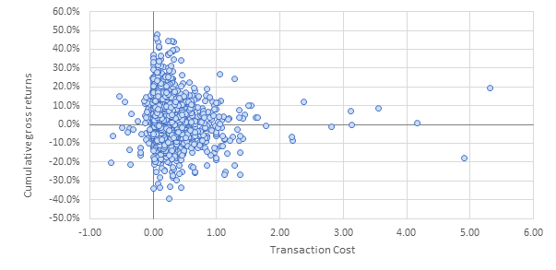

Furthermore, transaction costs as expressed in terms of the amount invested is not useful decision-making information in a pre-sale context. This can be seen clearly in **Exhibit 2** which shows the returns (gross and net of fees), charges and transaction costs of four funds that have been selected from the sample illustrated in Exhibit 1. The four funds have been selected on the basis of having delivered the same gross return in order to better demonstrate the differing effects of charges and transaction costs. The return after transaction costs is the relevant figure since it is the outcome of implementing the investment strategy employed by each fund – without incurring these transaction costs, there would be no return. Fund A has the highest transaction costs and aggregated total costs of 1.87% (ongoing charges plus transaction costs), but delivers the best return after fees. Conversely, Fund D has the lowest transaction costs and the same aggregated total costs of 1.87%. However, it delivers the worst return because it has the highest charges. In our view, Fund D is unequivocally more expensive than Fund A because the higher charge has reduced the share of the return going to the investor.

**EXHIBIT 2: Examples from European Equity Funds 2018-2019**

|  |  |  |  |  |  |
| --- | --- | --- | --- | --- | --- |
| **Jan. 2018 – Sept 2019 (21 months)** | **Transaction costs (annual)** | **Ongoing charges (annual)** | **Investment Return before charges (after transaction costs)** | **Ongoing charges (21 months)** | **Cumulative (net) return to investor after charges** |
| FUND A | 0.77% | 1.10% | 5.2% | 1.93% | **3.2%** |
| FUND B | 0.13% | 1.44% | 5.2% | 2.52% | **2.6%** |
| FUND C | 0.29% | 1.59% | 5.2% | 2.78% | **2.3%** |
| FUND D | 0.00% | 1.87% | 5.2% | 3.27% | **2.0%** |

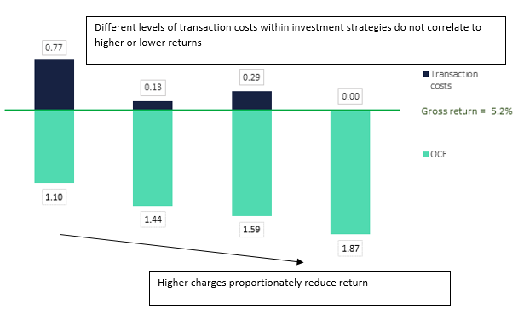

We are very concerned that this relationship between transaction costs and investor outcomes has not been properly reflected in the formulation of the ESAs proposals. Parts of the consultation paper indicate that interpretation of trading efficiency and investor disclosures have become muddled and the significance of the denominator has been overlooked. In particular, it is suggested at the top of page 42 of the consultation paper that trading less in order to minimise transaction costs is in investors’ best interests: *“This [the ESAs approach to providing transparency on implicit transaction costs to investors] should also promote effective competition within the market in order to encourage manufacturers to trade in a way that is in their investors’ best interests, and in particular to minimise such costs.”* The example above clearly demonstrates this may not be the case. This sentiment is also reflected in point 12 on page 101 of the consultation paper which incorrectly links KID cost disclosures to best execution policies: *“[Implicit costs] shall be disclosed by the manufacturer of the PRIIP to demonstrate how transactions are executed on terms that are most favourable to the client.”*

These misunderstandings have profound consequences for the coherence of aggregated cost disclosures. We suggest that further consideration takes place of how transaction costs are communicated through the delivery chain to ensure that unintended consequences – investment decisions based on information that has been misinterpreted – are avoided. This may include the industry’s own narrative around transaction costs and we are working further on this.

Overall, we support the rationale for amending the presentation of costs and our response to this section of the consultation paper focuses on fine tuning the options put forward by the ESAs. Our aim is to balance a preference for simplicity with the need to show sufficient granularity to enable a proper understanding of the cost structure. The current RIY approach is a significant obstacle to this. To this end we have drafted an enhanced option presented in Annex Two, building on elements of the options presented in the consultation paper.

# Annex one: IA technical commentary on the proposed methodology in the PRIIPS consultation paper

## Part I: Initial Results of IA modelling

We have carried out initial testing on the proposed methodology. Given the time constraints, in addition to the difficulties in obtaining the data, this testing is limited. We are concerned that we have not seen any extensive testing results from the ESAs other than a single chart in the consultation paper. We urge the ESAs to publish a report of the testing of the methodology prior to any policy recommendations.

In our testing we have made an attempt to stick to the methodology as prescribed in the consultation paper but it has not been possible for us to get all the data in the required format from any of our member firms. We have instead relied on third-party databases (Morningstar and Refinitiv Datastream) to carry out the testing. The testing was carried out as follows:

-We looked through to the underlying holdings by country and sector and applied a dividend yield of zero to non-dividend paying shares.

-The methodology prescribes using daily data but we have used monthly data. We have carried out some testing on daily data and found that this makes little difference.

-We have tested the methodology using simplified inputs and discuss the implications in our response to question 18 and Part III of this annex.

While an improvement on the current methodology, the dividend yield methodology is ultimately still producing results that are not reflective of actual investor outcomes.

-At times, scenarios do not change much year on year - they do not reflect the level of volatility of returns.

-Scenarios do not distinguish between investment strategies - a tracker fund can often produce higher scenario projections while also generating lower net of fees returns than a comparable active fund.

-Data required to produce scenarios for funds with high US exposures will be difficult to obtain.

-The methodology does not appear to work consistently for bond funds.

The consumer testing should focus not only on presentation, but the impact that inclusion of scenarios has on investor decisions. Will an investor presented with KIDs for two funds, an active and tracker fund, engage with the narrative text around the limitations of the scenarios and understand that in reality the two funds can produce materially different returns? Given that we have seen that scenarios do not reflect actual experience, what information are investors able to meaningfully extract from the scenarios?

### 1. UK Equity: Active Fund

Under the current methodology, the growth rate, which we will refer to as M1 in this paper, is estimated based on average five year returns. The left hand side of Figure 1 illustrates how the performance scenarios would look under M1.

-Under M1 the fund exhibits pro-cyclical performance scenarios. Scenario estimates in 2008, for example, hugely underestimated actual performance.

-20% of the time, the funds actual performance is above or below the favourable and unfavourable scenario.

The right hand side of Figure 1 illustrates the performance scenarios based on the dividend yield methodology proposed in the consultation paper.

-The methodology removes the pro-cyclicality observed under M1.

-It better captures the range between unfavourable and favourable within which actual performance should generally lie with actual performance falling outside of this range only 7% of the time (compared with 20% under M1).

-Since 2008, the actual performance of the fund has been consistently higher than the moderate scenario.

-There is almost no correlation between the moderate scenario and actual performance.

**Figure 1: Active equity fund scenarios under current methodology (left) and proposed dividend yield methodology (right)**

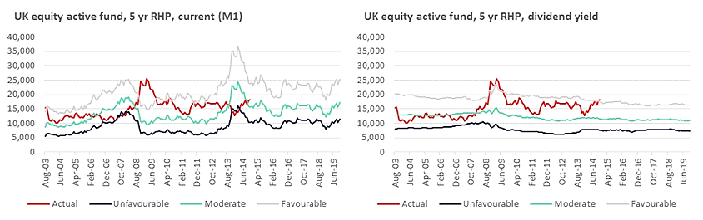

The metrics are summarised in Table 4 below.

**Table 4: Comparison of dividend yield (DY) methodology and M1 against actual performance**

|  |  |  |
| --- | --- | --- |
|  | **M1 vs. Actual** | **DY vs. Actual** |
| % below than unfavourable | 8% | 0% |
| % below/above the moderate | 28%/72% | 34%/66% |
| % above the favourable | 13% | 7% |
| Corr (actual, moderate) | -7% | 9% |

### 2. UK Equity: Tracker fund

Similarly, the dividend yield methodology better captures the range of outcomes over time for a UK equity tracker fund (see Figure 2 below).

* Like the active fund, the M1 exhibits the same level of pro-cyclicality when applied to a tracker fund.
* Using the dividend yield methodology, actual performance fell above the favourable/ below the unfavourable scenario only 2% of the time.
* The tracker fund also exhibits a slight negative correlation with the moderate scenario under the dividend yield methodology.
* The data displayed on the right hand side of Figure 2 show that until 2009, actual performance was consistently below the moderate scenario and has been almost consistently above the moderate scenario since then. The moderate scenario is not reflective of actual performance, however actual performance does remain within the 10th and 90th percentiles of the favourable and unfavourable scenarios.

**Figure 2: Equity tracker fund scenarios under current methodology (left) and proposed dividend yield methodology (right)**

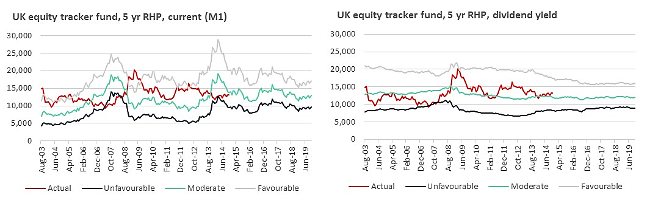

### 3. UK Equity: Active vs. Tracker fund

The principal concern here is that the methodology produces similar scenarios for both active and tracker funds (see left hand side of Figure 3). In fact, 80%, 87% and 52% of the time respectively, tracker funds had higher unfavourable, moderate and favourable scenarios when compared with the active fund when using the dividend yield methodology. The actual net of fees returns for the active fund were consistently higher since 2005.

**Figure 3: Active vs. Tracker scenarios under dividend yield methodology (left) and Active vs. Tracker actual realised performance (right)**

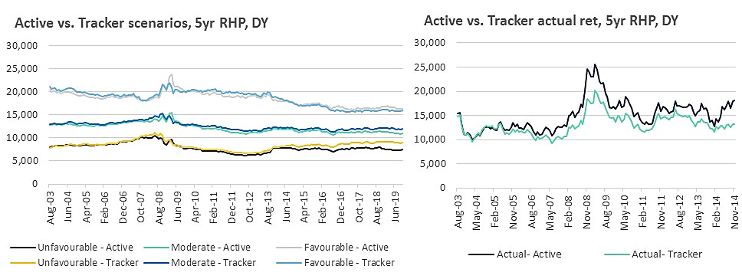

We have also tested the methodology by comparing the scenarios of the tracker against an active fund that performs consistently in the top quartile (see Figure 4). In this case, the methodology more clearly favours the tracker with unfavourable and moderate scenarios above the high performing active fund almost 100% of the time.

**Figure 4: High performing active vs. Tracker scenarios under dividend yield methodology (left) and High performing active vs. Tracker actual realised performance (right)**

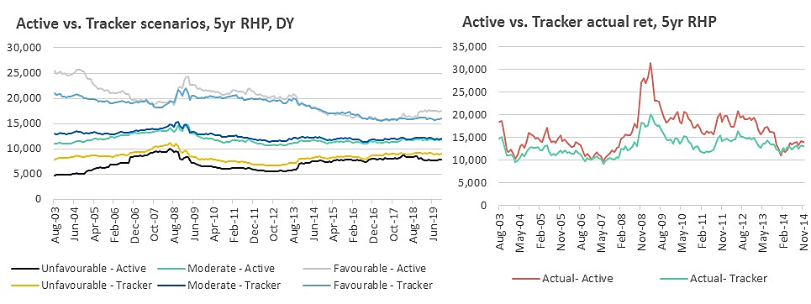

The charts we have presented are for testing purposes only. In reality investors will not be able to see how the scenarios have compared to actual performance over time. Instead they will be presented with a table. We have included the actual outcome in red for the purposes of comparison. Figure 5 shows what investors would have seen in two PRIIP KIDs if they had been generated in November 2008. The first table shows the scenarios for an active fund and the second tables shows the performance scenarios for a tracker fund. An investor comparing the two KIDs could quite easily conclude that the tracker fund is likely to generate higher net returns over the next 5 years based on the information presented. In this case, the investor would have lost out on over £6,000 of returns. We urge the ESAs to consider if the inclusion of scenarios could lead to suboptimal investment decisions.

**Figure 5: Example of KID presentation in November 2008 – UK Active v Tracker**

|  |  |  |  |
| --- | --- | --- | --- |
| **FIGURES AS THEY WOULD HAVE APPEARED IN KIDs IN NOVEMBER 2008 – ACTIVE FUND** | | | |
|  | | | |
| **Investment €10,000** | | | |
| **Scenarios** | **What you might get back after costs** | **Average return [per year/over RHP]** | **Estimated chance this scenario occurs** |
| **Minimum** | **There is no minimum guaranteed return. You could lose some or all of your investment** | | |
|
| **Unfavourable** | 8,883 | -2.30% | 10 in 100 chance you do worse |
| **Moderate** | 14,080 | 7.10% | 50 in 100 chance you do worse |
| **Favourable** | 21,305 | 16.30% | 90 in 100 chance you do worse |
| **Actual outcome** | 24,649 | 19.80% |  |

|  |  |  |  |
| --- | --- | --- | --- |
| **FIGURES AS THEY WOULD HAVE APPEARED IN KIDs IN NOVEMBER 2008 – TRACKER FUND** | | | |
|  | | | |
| **Investment €10,000** | | | |
| **Scenarios** | **What you might get back after costs** | **Average return [per year/over RHP]** | **Estimated chance this scenario occurs** |
| **Minimum** | **There is no minimum guaranteed return. You could lose some or all of your investment** | | |
|
| **Unfavourable** | 9,534 | -0.90% | 10 in 100 chance you do worse |
| **Moderate** | 14,568 | 7.80% | 50 in 100 chance you do worse |
| **Favourable** | 21,303 | 16.30% | 90 in 100 chance you do worse |
| **Actual outcome** | 18,383 | 12.90% |  |

### 4. Global Equity Fund

Our testing so far has focused on markets where share buybacks are not prevalent and so can be reasonably ignored as important data inputs. However, we have seen evidence that share buybacks are an important phenomenon in the US. Despite this, we have still been unable to obtain buyback data from firms for the purposes of testing. This has meant that we have been unable to factor in share buybacks in our testing of a global equity fund with steadily increasing exposure to US equities. The global equity fund that we tested, has steadily increased its exposure to US equities from just over one third (36%) at the start of the testing period to three-fifths (60%) as of 2019.

Figure 6 once again shows that the methodology addresses the pro-cyclicality issue. However, as US exposure increased, the scenarios generated do not reflect actual performance because of the absence of share buyback data. Realised returns were almost consistently above the favourable scenario from 2011-2014. There are indices that can be used as a proxy for the share buyback data but this would come at a significant cost that would disproportionately affect smaller firms.

We also found the reference rate calculations required for the global equity fund very onerous. Our testing required reference rate data for each of the countries represented in the fund (36 countries over the testing period) as well as the dividend yield and sector data of the underlying holdings.

For funds like this, the methodology is overly complex to no significant advantage. We were able to obtain fund level dividend yield data and the scenarios generated were almost identical.

**Figure 6: Active global equity fund scenarios under current methodology (left) and proposed dividend yield methodology (right)**

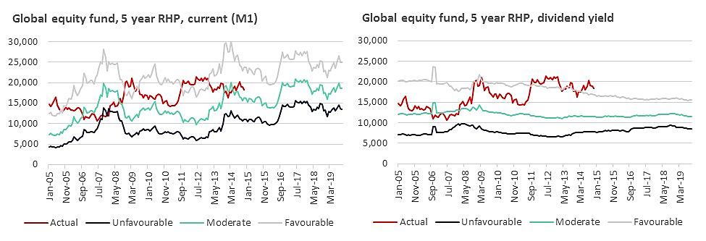

### 5. Sterling Strategic Bond Fund

We are concerned about the viability of the methodology for non-equity asset classes. Figure 7 below shows the dividend yield methodology tested on a strategic bond fund. As with equity funds, the methodology does address the issue of pro-cyclicality but the proposed methodology still fails to correctly estimate the scenarios meaning that the actual scenario at times of market stress, falls significantly outside the favourable scenario tram line in Figure 7. Under M1, actual performance is above/below the favourable/unfavourable scenarios 55% of the time compared with 25% of the time under the dividend yield methodology. PRIIP KIDs produced anytime between February 2008 and August 2010 would have shown scenarios that grossly underestimated the performance of the fund.

**Figure 7: Sterling strategic bond fund scenarios under current methodology (left) and proposed dividend yield methodology (right)**

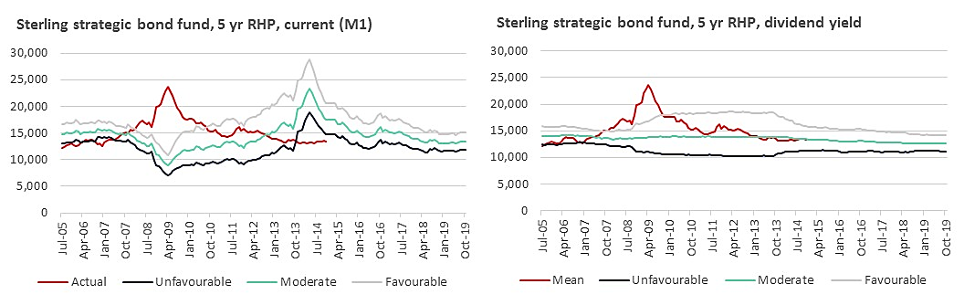

The results of our testing on bond funds has been mixed, with the methodology occasionally working well in the way we have seen it work for equities. For the fixed income funds where the methodology does not work as well, we see actual performance falling outside of the unfavourable/favourable bounds 20-40% of the time. Figure 8 below shows the results of a High Yield bond fund generated using fund level coupon rates. Actual performance falls above/below the favourable/unfavourable scenario 36% of the time compared with 33% of the time under the current methodology.

**Figure 8: High yield bond fund scenarios under current methodology (left) and proposed DY methodology (right)** 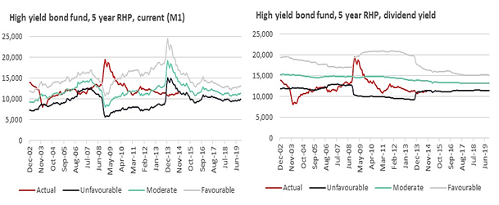

### 6. Concentrated global Growth Stocks fund

We have carried out some initial testing on a global growth fund with concentrated holdings. This fund had a high proportion of non-distributing assets. The portfolio is made up of 37 assets on average over the testing period, with the proportion of distributing assets declining from just over 60% to about 30%. The consultation paper outlines that non-distributing assets should be assigned a dividend yield value of zero (so the assumption is made that those particular assets grow at the risk-free rate). We wanted to test whether this assumption was correct or if it would be better to exclude non-distributing assets rather than giving them a value of 0.

The chart on the right hand side of Figure 9 shows that when applied to the global growth fund, the dividend yield methodology generates performance scenarios that underestimate performance. Actual performance falls above the favourable scenario 46% of the time. By comparison, under the original methodology, which we have shown to be inherently flawed, actual performance exceeds the favourable scenario 38% of the time. The DY methodology, as it is proposed, does not appeared to work for funds with significant growth stock holdings.

**Figure 9: Concentrated global equity fund scenarios under original methodology (left) and proposed DY methodology (right)**

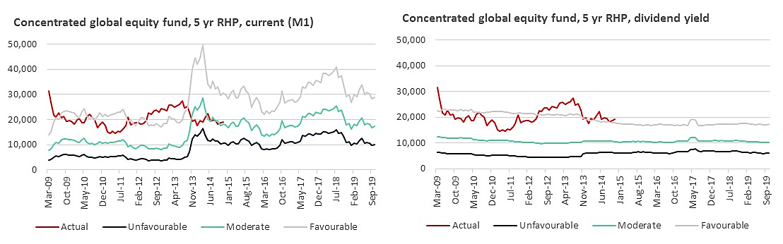

The methodology requires average dividend yields to be calculated by country and sector. Given that the portfolio is very concentrated, the charts above were calculated on a country basis only. Rather than applying a zero value to the non-distributing assets, we have also excluded the assets from our calculations altogether to see how this affects the performance of the methodology. The effect is a slightly improved result (39% above the favourable) but this approach still generates scenarios that underestimate performance. Relying on the sample of dividend yields from the 10 distributing assets and extrapolating these to calculate the expected growth rate of the fund (composed of 37 holdings) is flawed. Fundamentally, the assumption that the 27 assets with no dividend yield grow at the risk free rate is incorrect.

### 7. Applying the dividend yield methodology at a Market level

In addition to the testing carried out at the fund level using the look through approach prescribed in the consultation paper, we have also carried out some testing at an index or market level across different asset classes, including commodities. Given the results of the testing so far, if the dividend yield methodology is adopted, we would prefer that it is applied using a sector, peer group or index. Future performance scenarios are intended to be indicative and we have already highlighted some of the issues created by presenting fund specific scenarios.

When applying the methodology to a market or an index, we have used monthly return data, not daily return data. We have also only been able to test how well the dividend yield methodology works for commodities using index data, rather than fund data. It would be useful to do more fund specific testing on commodities but the initial indication is that the dividend yield methodology works for commodities at an index level (See Figure 12).

-For equities, we have seen the methodology work reasonably well using index data (see Figure 10) in capturing the bounds within which actual performance lies. There are some notable exceptions:

-The scenarios generated for French equities from 1993-1996 would have grossly underestimated actual performance.

The scenarios generated for US equities do not perform well, perhaps reflecting the exclusion of share buybacks from the market data.

**Figure 10: Performance scenarios generated under the dividend yield methodology applied at index level- equities**



Applying the methodology to a sterling corporate bond index (Figure 11), we can see that the methodology once again addresses the issue of pro-cyclicality. The correlation between the moderate scenario and actual performance also improves from -63% to 57%. However, the bond index scenarios modelled using the dividend yield methodology perform worse than the current M1 methodology, falling below the unfavourable scenario 40% of the time compared with 37% of the time above/below the favourable/unfavourable scenarios under M1.

**Figure 11: Performance scenarios generated under the dividend yield methodology applied at index level- bonds**

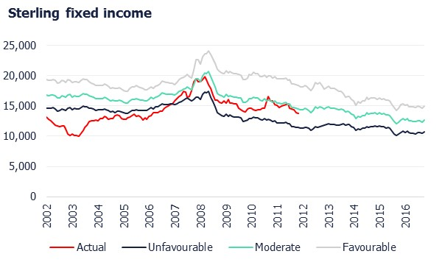

Figure 12 shows that when applied at an index level, the dividend yield methodology performs reasonably well for a € denominated commodities index. There is a 65% correlation between the dividend yield methodology and the moderate performance scenario – this compares with a 12% correlation between actual performance and the moderate scenario when we used the original methodology. Actual performance is higher than the favourable performance scenario 6% of the time compared with 12% when we tested the commodities index using the original methodology. Actual performance falls below the unfavourable scenario 8% of the time, which compares with 16% for the original methodology.

**Figure 12: Performance scenarios generated under the dividend yield methodology applied at index level-commodities** 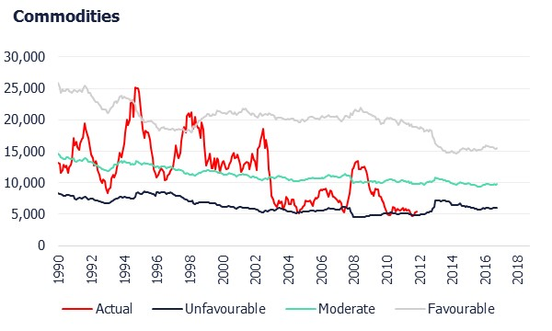

# Part Two. Initial Analysis of Maximum Growth Rates

The inclusion of the “maximum growth rates” option in the consultation paper is an acknowledgement of the complexity of the proposed dividend yield methodology. Our testing has shown the limitations of the dividend yield methodology when it is applied to non-equity asset classes and to different investment strategies such as active/tracker funds and concentrated growth funds. So how would using a set growth rate figure in the formula fare?

To assess the effectiveness of using a maximum growth rate, we have set three growth rates for three different historic periods. To do this, we have done some quick calculations based on growth rates observed for UK equities over these three periods. In reality, the rates selected would need to be empirically set and annually reviewed to reflect the changing economic environment. As firms are required to re-calculate the PRIIPs KID annually, we do not think that setting the rates annually is unreasonable.

#### UK Equity Funds

We have taken the equity funds used for testing the dividend yield methodology and applied the growth rate figures in the table below. The rates set are very rough estimates and any rates by the ESAs would be set empirically, however we believe that our results give some indication of the viability of the maximum growth rate approach.

**Table 5: Growth rates for testing period 2003-2019**

|  |  |
| --- | --- |
| **Period** | **Growth rate, UK equities** |
| 2003-2008 | 6.5% |
| 2009-2014 | 5.5% |
| 2014-2019 | 4.0% |

Given that the regulation specifies that performance should be calculated net of all costs, applying the same standardised rate to active and passive funds in the same asset class will always favour passives. We therefore assume that the rates in Table 5 are net of all costs, so that the same rate is applied for different investment strategies.

Figure 13 below looks at the impact on the scenarios generated based on fixed growth rates versus the DY methodology. Although not a perfect match to the scenarios generated under the DY methodology, the results are broadly similar. Given the advantages offered by a simpler methodology with less onerous data requirements, we believe that the maximum growth rate approach should be seriously considered by the ESAs.

**Figure 13: Comparison of scenarios generated for UK equity funds based on a proposed dividend yield methodology vs. a fixed growth (MG) rate**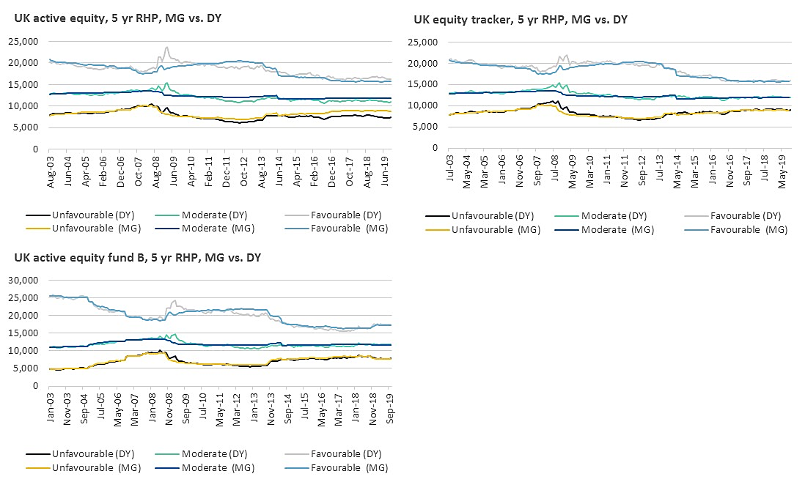

Despite the patent advantages of using a simpler methodology such as fixed growth rates, the scenarios generated would still be subject to some of the same issues arising from the application of the dividend yield methodology:

-Differentiating between active and index tracking strategies remains problematic as fund-level net return data is still used to calculate the volatility, skew and excess kurtosis

-It is still unclear how effective the maximum growth rate strategy is across different asset classes, particularly hybrid/complex funds and more clarity is needed on what constitutes a complex fund

-The ESAs have proposed broad asset classes when there is likely to be merit in looking at narrower sectors/peer groups

-The methodology that the ESAs will use to calculate the maximum growth rate should be confirmed so that further testing can be carried out.

# Part Three: Simplifying the dividend yield methodology – results of the modelling

If the ESAs are to push forward with the dividend yield methodology, we are in favour of adopting a simplified approach as set out in Section II of this paper. We explore below the results of using simplified inputs compared with the results achieved by using the more complex dividend yield methodology to see how they differ.

Figure 14 shows the results of our modelling using the original M1 methodology. Figure 15 then compares how the dividend yield methodology proposed in the consultation paper compares with methodologies using simplified inputs. We tested:

-Using one reference rate that corresponds to the underlying currency of the fund (UK RF) but still applying a look through approach to the yield of the underlying holdings decomposed by asset and country weighting – we refer to this approach as DY (UK RF)

-Using the reference rate approach prescribed by the dividend yield methodology but applying a simple weighted average (SWA) yield calculation rather than the look through approach – we refer to this approach as DY (SWA)

-Using a reference rate that corresponds to the currency of the fund and a simple weighted average – we refer to this approach as DY (SWA, UK RF)

Our testing shows that the results generated by using one reference rate and a simple weighted average are just as effective as the more complex approaches. However, in Figure 16 we look at the impact of applying a reference rate that corresponds to the highest country weighting of the underlying assets and found this to be more accurate than using a reference rate that corresponds to the currency of the funds.

**Figure 14: Current methodology**

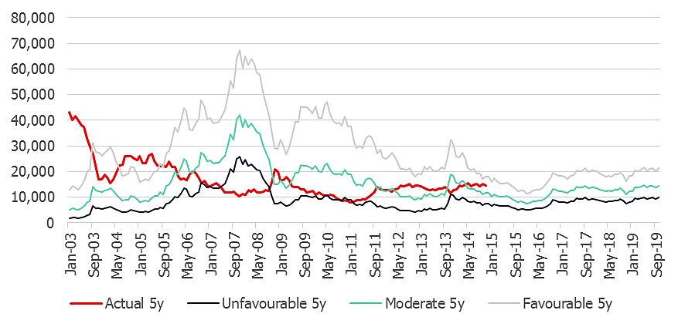

Figure 15 shows that calculating the average dividend yield weighted by sector and country does not make much of a difference in capturing the range of actual performance. Calculating the weighted average dividend yield of the fund returns similar results. The greatest impact on the effectiveness of scenarios comes from the choice of reference rate.

The methodology in the consultation paper requires an average dividend yield to be calculated on a sector and country weighted basis. The reference rate for the fund also needs to be calculated as a weighted average based on the geographical composition of the fund. This means that when we carried out testing on a global emerging market fund, the data collection was extremely challenging: the fund had historical exposure to almost 50 countries, many of which we could not obtain reference rate data for. We had to use a reference rate proxy based on a subjective determination of regions that would be similar. Figure 15 shows that the extra effort required to do this complex calculation has not yielded significantly better results.

**Figure 15: Comparison of the scenarios with simplified inputs**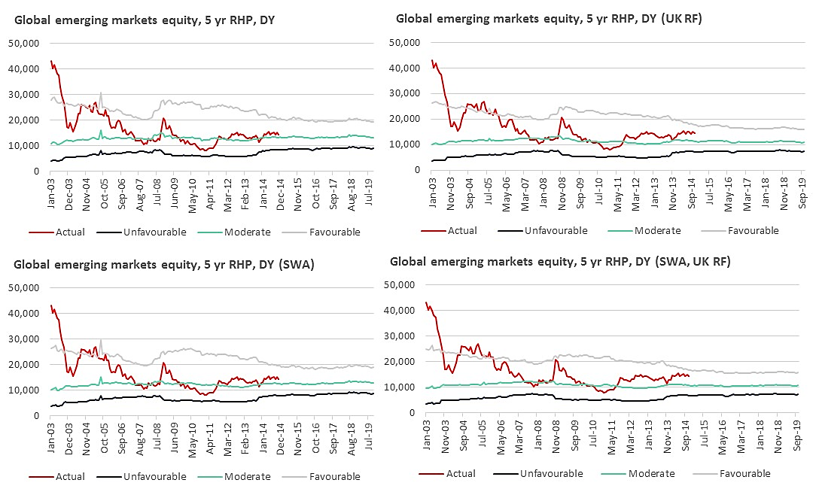

All simplified versions of the methodology perform better than the M1 approach and none of the methodologies produce unfavourable scenarios above the actual performance.

**Table 5: Comparison of dividend yield methodology and M1 against actual performance**

|  |  |  |  |  |  |
| --- | --- | --- | --- | --- | --- |
|  | M1 vs. Actual | DY vs. Actual | DY (UK RF) vs. Actual | DY (SWA) vs. Actual | DY (SWA, UK RF) vs. Actual |
| % less than unfavourable | 16% | 0% | 0% | 0% | 0% |
| % less than moderate | 50% | 29% | 24% | 27% | 19% |
| % more than favourable | 16% | 10% | 16% | 13% | 18% |
| Corr (actual, moderate) | -52% | -41% | -20% | -45% | -22% |

We repeated the analysis using a simple weighted average dividend yield and a reference rate more reflective of the geographical exposure of the fund. The fund has quite mixed geographical exposure, but among the countries with the highest exposure over the testing period is India. Figure 16 shows that by applying the Indian reference rate we generated scenarios that are much closer to the dividend yield methodology. This approach performs slightly better than applying a UK reference rate suggesting that the choice of reference rate appears to be key. We conclude that the reference rate most closely representing the portfolio exposure should be selected.

**Figure 16: Scenarios produced using ESAs prescribed dividend yield methodology vs. simplified inputs (simple weighted average, India reference rate)**

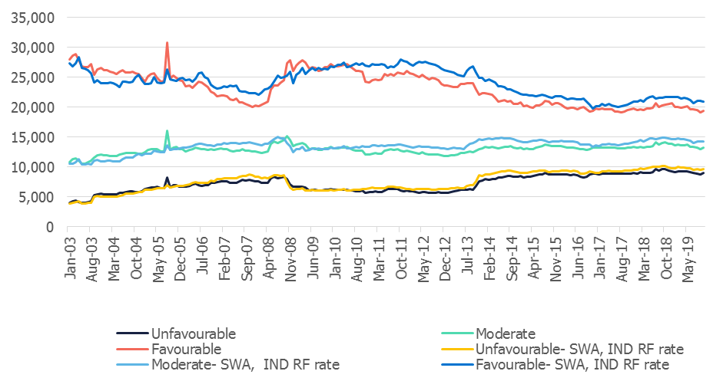

<ESA_COMMENT_PKID_1>

1. : Are there provisions in the PRIIPs Regulation or Delegated Regulation that hinder the use of digital solutions for the KID?

<ESA_QUESTION_PKID_1>

Yes. The PRIIPs framework hinders the ability to offer digital solutions providing the most relevant information to investors in PRIIPs. The PRIIPs framework describes a rigid one-size-fits-all paper document, or durable image thereof, the maximum length of which is defined by reference to pieces of paper of a fixed size. It necessitates reliance on core assumptions when interactive digital solutions could allow investors to explore a range of personal circumstances. Effective digital solutions, such as the online cost calculator tools anticipated in the PRIIPs Regulation, rely on good quality, consistent core data uncompromised by assumptions.

In respect of online cost calculator tools, recital 16 of the PRIIPs Regulation states that *“in order that the calculators are as useful as possible to consumers, they should cover the costs and fees charged by the various PRIIP manufacturers, together with any further costs or fees charged by intermediaries or other parts of the investment chain not already included by the PRIIP manufacturers.”* This reflects the highly intermediated market for PRIIPs. Nevertheless, the cost information contained in the KID is based on assumptions about the size, time horizon and future performance of an investment in a PRIIP that makes it impossible to align with an individual investors circumstances or to combine with the costs of intermediation.

In order to reflect the highly intermediated market for PRIIPs, the PRIIPs framework needs to complement the investor protection provisions of MiFID and IDD. These Directives require the intermediaries to disclose to their clients aggregated costs taking into account both their own costs and the costs of the products they sell. Therefore, the PRIIPs framework needs to provide consistent factual cost data to intermediaries in order to facilitate aggregation.

In order to provide the most coherent information to investors, product information specified under the PRIIPs framework needs to be a standard specification of data items that must be transmitted to intermediaries in order that they can fulfil their onward obligations to their clients most effectively. Rules concerning the format and layout of documentation should be stripped out of product regulation and specified instead, to the extent necessary, in the MiFID and IDD frameworks in a form fit for the digital era.

Achieving this requires a wholesale review of the PRIIPs Regulation which is not currently in progress. Nevertheless, a quick win available to the ESAs as part of the current review of the Delegated Regulation would be to ensure a consistent, assumption-free cost data set is defined and presented, and thereby providing a robust regulatory underpinning of the data required by intermediaries to fulfil their obligations under MiFID and IDD.

<ESA_QUESTION_PKID_1>

1. : Do you agree that it would be helpful if KIDs were published in a form that would allow for the information to be readily extracted using an IT tool?

<ESA_QUESTION_PKID_2>

As set out in our response to question 1, in order to reflect the highly intermediated market for PRIIPs, the PRIIPs framework needs to complement the investor protection provisions of MiFID and IDD. These Directives require the intermediaries to disclose to their clients aggregated costs taking into account both their own costs and the costs of the products they sell. In order to provide the most coherent information to investors, intermediaries need to access a standard data set and import it into their own systems in order that they can fulfil their onward obligations to their clients most effectively.

<ESA_QUESTION_PKID_2>

1. : Do you think that the amendments proposed in the consultation paper should be implemented for existing PRIIPs as soon as possible before the end of 2021, or only at the beginning of 2022?

<ESA_QUESTION_PKID_3>

We would prefer an approach where all amendments are implemented at the beginning of 2022 in order to ensure the most coherent transition for investors and their advisers and to synchronise with the end of the UCITS exemption period. It would also ensure that PRIIPs manufacturers have time to build or modify their business practices in an orderly fashion after the final rules are made.

<ESA_QUESTION_PKID_3>

1. : Do you think that a graduated approach should be considered, whereby some of the requirements would be applied in a first step, followed by a second step at the beginning of 2022?

<ESA_QUESTION_PKID_4>

We do not support a graduated approach to implementation because a single switch date to the new format KID ensures the most coherent transition for investors and their advisers.

<ESA_QUESTION_PKID_4>

1. : Are there material issues that are not addressed in this consultation paper that you think should be part of this review of the PRIIPs Delegated Regulation? If so, please explain the issue and how it should be addressed.

<ESA_QUESTION_PKID_5>

We appreciate the efforts of the ESAs to try to tackle the issues created by the PRIIPs Delegated Regulation. However, we are disappointed in the absence of a review of the Level One PRIIPs Regulation by the Commission as required by Article 33 thereof. Moreover, the European Parliament clearly expected more work to be done in this respect when they extended the deadline for such a review to the end of 2019. Level One remains the source of a number of issues that cannot be properly dealt with at Level Two.

The PRIIPs Regulation requires “appropriate performance scenarios” to be included in the KID and it is the interpretation of appropriate scenarios that has led to the KID becoming such an unpopular document. This terminology, or at least the interpretation that it requires forward-looking projections, needs to be reconsidered.

Also, it specifies the KID purpose as being "to enable retail investors to understand and compare the key features and risks of the PRIIP” which would appear to give equal weight to understanding and comparability. Nevertheless, a number the current issues arise due to the seeming prioritisation of comparability over understanding. In reality there is an extremely wide variety of PRIIPs, ranging from structured products with a lifespan of days, to insurance products designed to span a lifetime. In its drive for comparability across such a wide array of different products, the ability to understand and compare similar products in a meaningful way has been dramatically compromised. This imbalance needs to be redressed in order to ensure that investors can form a proper understanding of a PRIIP and form reasonable expectations about its key features.

The constraint of three sides of A4 paper, in effect mandating a blank side of paper, needs to be reconsidered given the additional demands for space arising from replicating Articles 7 and 21 of the UCITS KIID Regulation, incorporating a section on past performance and, in future, building in new disclosures in respect of environmental and social objectives.

More broadly the PRIIPs framework need to be considered as being complementary to, and facilitative of, other regulations aimed at those that market and sell financial products to EU citizens, in particular, MiFID and IDD. This theme comes up repeatedly throughout our response, but especially in our answers about digitalisation and cost presentation.

<ESA_QUESTION_PKID_5>

1. : Do you have comments on the modifications to the presentation of future performance scenarios being considered? Should other factors or changes be considered?

<ESA_QUESTION_PKID_6>

The consultation paper proposes that an “estimated chance that the scenario occurs” should be included in the table alongside the favourable, moderate and unfavourable scenarios and we understand that this presentation is being shown to consumers in the consumer testing. This has already been subject to previous consumer testing related to the PRIIP KID and has shown that consumers did not understand probabilities: “Respondents often wrongly assumed likelihoods when shown performance scenarios… respondents also made mistakes when provided with information on the probability of the scenarios”.

Given that the scenarios can only ever be indicative of future performance and are in no way an accurate projection of future performance, assigning a probability that the scenario occurs would mislead investors if they attach an inappropriate degree of certainty to them as it is impossible to calculate the probability that the scenario will occur. We are most concerned about presenting investors with the statement that there is “a 50 in 100 chance you do worse” than the moderate scenario. The results of our testing show that this is typically incorrect: actual performance bears very little relation to the moderate scenario in the funds that we tested. **Therefore, we recommend that the estimated probabilities should not be presented alongside the performance scenarios.**

<ESA_QUESTION_PKID_6>

1. : If intermediate scenarios are to be included, how should they be calculated for Category 3 PRIIPs (e.g. structured products)? If intermediate scenarios are not shown in the performance section, which performance assumption should be used for the ‘What are the costs?’ section?

<ESA_QUESTION_PKID_7>

Although it is useful to include intermediate scenarios to illustrate the impact of early exit, we do not think their removal will make a significant difference to consumers. The European Commissionhas previously tested a presentation of performance scenarios over 1 period (RHP) as well as the current presentation which shows 3 periods. The results were not significantly different between the two options.

Our testing results shown in **Table 1** demonstrate that the methodology does not work effectively for the intermediate scenarios. Actual performance is more likely to fall above the favourable or below the unfavourable over the intermediate periods compared to a five-year RHP.

**Table 1: Percentage of time over 1, 3 and 5 years that actual performance is above favourable or below unfavourable scenario for three equity funds**

|  |  |  |
| --- | --- | --- |
|  |  | Total above favourable/ below unfavourable |
| 1 year | Equity fund A | 34% |
| Equity fund B | 28% |
| Equity fund C | 25% |
| 3 years | Equity fund A | 26% |
| Equity fund B | 23% |
| Equity fund C | 17% |
| 5 years  (RHP) | Equity fund A | 7% |
| Equity fund B | 8% |
| Equity fund C | 2% |

If the ESAs are to remove the intermediate scenarios, we are in favour of their removal for all PRIIPs. Removal should not be limited to Category 3 PRIIPs.

In relation to the cost section of the KID, we recommend using a performance assumption in the RIY calculation that illustrates the costs on the basis that an investor will get back their original investment after all costs have been taken. In effect, this assumes the performance generated is sufficient to exactly cover all costs – in other words, the net return after all costs is nil. This ensures that the RIY figures presented in the cost section represent only the impact of costs and do not include the impact of estimated future performance on those costs. Critically, this approach allows the cost calculations to be performed without reliance on information about future performance scenarios.

<ESA_QUESTION_PKID_7>

1. : If a stress scenario is included in the presentation of future performance scenarios, should the methodology be modified? If so, how?

<ESA_QUESTION_PKID_8>

We are in favour of removing the stress scenario. Previous testing has shown that the information presented to investors is too extreme and does not reflect actual performance during times of stress. We do not see the stress scenario as presenting additional meaningful information to investors beyond the information presented by the unfavourable scenario. The inclusion of the stress scenario could lead to confusion over the difference between the stress and the unfavourable scenarios.

The wording of the disclaimer in the table on page 67 of the consultation paper provides a warning “*There is no minimum guaranteed return. You could lose some or all of your investment.”* Consumer testing should look at whether this warning is adequate in ensuring that savers understand that the unfavourable scenario does not present the worst possible outcome, and that they could lose their initial investment.

<ESA_QUESTION_PKID_8>

1. : Do you agree with how the reference rate is specified? If not, how should it be specified?

<ESA_QUESTION_PKID_9>

The reference rate has to be calculated on an **asset weighted basis**. This causes issues for funds with diverse geographical exposures, particularly funds investing in emerging markets. The consultation paper does not specify the maturity of the sovereign bond used; our assumption is that the specified reference rate requires sovereign bond maturities of five years or more. Our testing has shown that it can be challenging to get sovereign bond data with long enough maturities (five years) in certain emerging markets and would require a subjective assessment of what constitutes a suitable proxy for countries where no reference rate data is available. Our testing has used bonds with ten-year maturity, based purely on data availability.

An alternative that does not require firms to calculate the reference rate on an asset weighted basis would be preferable and we have tested this. Our testing has shown that for example, using a reference rate that corresponds to the country of origin of the investor, e.g. a UK reference rate for UK investors, seems to work reasonably well for a global emerging market fund (See figure 15 of our Technical Commentary in Part III of Annex One). Alternatively, selecting a single reference rate more reflective of the geographical composition of the fund has been shown by our testing to work just as well as calculating the reference rate on an asset weighted basis.

<ESA_QUESTION_PKID_9>

1. : The revised methodology specifies that the risk premium is determined by future expected yields. The methodology further specifies that future expected yields should be determined by the composition of the PRIIP decomposed by asset class, country and sector or rating. Do you agree with this approach? If not, what approach would you favour?

<ESA_QUESTION_PKID_10>

Our testing has shown that the methodology specified to calculate the asset specific risk premium is unnecessarily complex. The requirement for calculating the dividend yield of the equity is very granular: firms are expected to use the average dividend yield **for each country and sector** represented in the fund, weighted by its representation in the fund. A globally diversified fund, with a reasonable spread of shares by sector would end up requiring a complex calculation on an asset, country and sector weighted basis.

Our members have found it extremely challenging to extract the yield data weighted by asset and by country. No firm has been able to provide data that is also weighted by sector for our testing, narrowing the range of funds available for us to test. This in itself tells a significant story.

Some of the inputs of the methodology would require greater clarity:

**- Determining the country of origin of the asset**: (for example, primary listing, country of incorporation, country of headquarters). We have been informed that the ESAs are using the primary listing to determine the country of the asset. Although primary listing is often a key determinant of the country of the asset, it is not the sole determinant used by many investment managers and the data vendors. Requiring that primary listing determines the country of the asset would set a precedent that would have far reaching consequences beyond PRIIPs

**- Determining the sector of an asset:** There is no clarity on how the sector of the asset should be determined in the consultation paper. Data vendors allocate assets to a sector but again, there is no industry standard for assigning a sector. This could lead to a wide range of interpretations and inconsistency in the production of future performance scenarios.

**- Share buyback data:** Share buyback data is not readily available in Europe and there is little clarity on the availability of data. Most of our member firms do not have access to this data in Europe, and may struggle to obtain this for the US as well.

**- Dividend yield data for fund of funds:** Fund of funds investing externally would require access to dividend yield and other cash distribution data from third party fund managers, adding an additional layer of complexity. Our data shows that this profile of fund has been consistently favoured by retail investors in the last 15 years and should not be overlooked. Our members’ inability to provide the data required for the dividend yield methodology on holdings in externally managed funds has limited our ability to test it for funds with a mixed asset allocation.

We are not in favour of any approach that requires firms to look through to the underlying assets to calculate performance scenarios because of its complexity. Our testing of the dividend yield methodology has shown that the level of granularity outlined in the consultation paper makes no significant difference to the scenarios generated. Using fund level dividend yields (i.e. not weighted by sector or country) returns very similar, sometimes almost identical results.

As we set out in our opening statement, our preferred approach would be a simpler approach to illustrating performance scenarios that is based on historical observations and that is cost effective to apply. We provide more detail in our response to question 18 on some of the proposals that we believe could better meet these criteria than the dividend yield methodology.

<ESA_QUESTION_PKID_10>

1. : The ESAs are aware that historical dividend rates can be averaged over different time spans or that expected dividend rates can be read from market data providers or obtained from analyst reports. How should the expected dividend rates be determined?

<ESA_QUESTION_PKID_11>

There is no clarity in the consultation paper on the time period over which historic dividend rates should be averaged but if firms were required to determine these, it would require them to produce more data in an already data intensive proposal. Without further guidance, interpretation of an appropriate time span is likely to vary from firm to firm. One proposal in the consultation paper, the production of a table of ‘maximum’ growth rates determined by the ESAs, could also be applied to historical dividend rates by producing a table of historical rates averaged over time.

Our testing has not used historical dividend rates averaged over time, and we cannot comment on the impact on scenarios generated on this basis.

Obtaining expected dividend rates from market data providers, whilst easier than combing analyst reports, could incur significant additional market data costs. We outlined our concerns over market data costs in our response to question 10. Our members were unable to extract expected dividend rate data from internal systems to support our modelling. While they have visibility of the dividends received by the fund, these are not necessarily stored in internal databases as dividend yields broken down by individual holdings. Data licence restrictions also prevented them from sharing data from third party databases. It is likely that members would be reliant on third party databases to calculate expected dividend rates which will be burdensome for smaller firms.

<ESA_QUESTION_PKID_11>

1. : How should share buyback rates be estimated?

<ESA_QUESTION_PKID_12>

It is our understanding that share buybacks are principally a US phenomenon and are a less important driver of portfolio distributions in Europe. Share buyback data is not readily available from third party databases: most of our member firms do not have access to this data in Europe, and may struggle to obtain this for the US as well. One firm commented that they could get the data but that it required a manual calculation for each holding, which would be extremely onerous for all but the most concentrated portfolios.

Our members have not been able to provide us the necessary share buyback data to support our testing, so we have been forced to exclude them from our modelling. We acknowledge that excluding share buybacks from funds with a reasonable allocation to US equities makes the dividend yield methodology less effective. We tested the dividend yield methodology on a global equity fund that has steadily increased its exposure to US equities from just over one third (36%) at the start of the testing period to three-fifths (60%) as of 2019. As US exposure increased, the scenarios generated started to diverge more significantly from actual performance with realised returns almost consistently above the favourable scenario from 2011-2014. We cannot demonstrate that including share buyback data would improve this result, but logically for US equities it could.

Share buyback data should only be included where there is exposure to US equities. However, there remains a serious question over how firms can reasonably obtain this data and at what cost? If the dividend yield methodology is applied at the fund-level, the ESAs should specify that it is relevant for funds invested in US equities until there is sufficient evidence that share buybacks are a significant phenomenon in other geographies.

The ESAs propose a standardised table of growth rates that could be applied at the asset class level in the consultation paper. If equities are further split into geographies in this table then the growth rate for US equities should incorporate the impact of share buybacks.

<ESA_QUESTION_PKID_12>

1. : Do you agree with the approach for money-market funds? Are there other assets which may require a similar specific provisions?

<ESA_QUESTION_PKID_13>

We have been advised by an independent expert that there is some merit in using the volatility implied by options prices to estimate the future variance for money market funds. We also understand that money market fund managers should be able to apply this method without it imposing additional data requirements that are too onerous. Whilst it is more complicated than using the history of daily returns, it is likely to be a more appropriate method for estimating the future variance of money market funds.

<ESA_QUESTION_PKID_13>

1. : The methodology proposes that the future variance be estimated from the 5-year history of daily returns. Should the volatility implied by option prices be used instead? If so, what estimate should be used if option prices are not available for a particular asset (equities namely)?

<ESA_QUESTION_PKID_14>

We are not in favour of using implied volatility to estimate the future variance for funds that are not money market funds. Obtaining implied volatility data from options prices is an unnecessary complication and would be an additional cost for many firms who have not previously needed access to options data. Historical volatility data is easily accessible to firms. Options prices are not always available for equities, ruling this approach out in our view.

<ESA_QUESTION_PKID_14>

1. : Do you think compensatory mechanisms for unforeseen methodological faults are needed? If yes, please explain why.

<ESA_QUESTION_PKID_15>

The need for a compensatory mechanism suggests that the ESAs expect that the probabilistic performance scenarios will fail in some instances, as we have seen in our testing. Any methodology used to generate future performance scenarios is likely to fail at some point, particularly in exceptional market conditions. That is the nature of attempting to estimate future performance.

Our members are universally concerned about explaining the dividend yield methodology as outlined in the consultation paper to investors and intermediaries. Adding a compensatory mechanism, which would mean that at times the scenarios are based on a complicated dividend yield methodology and at times based on past performance, would likely add further confusion.

There is little guidance on the circumstances in which the ESAs feel that the compensatory mechanism should be used other than the statement “issues will arise.” The use of such mechanisms is unlikely to be applied with any consistency. The potential inconsistency in application will reduce comparability.

Two options for the compensatory mechanism proposed by the ESAs are based on lowering the favourable scenario to match the maximum return observed in the past and raising the unfavourable scenario to match the minimum return observed in the past. There are clear similarities between these options and EFAMA’s proposal that performance scenarios should be “appropriate scenarios based on historical observations” (See our response to question 18). Rather than introducing a compensatory mechanism, it would be more consistent for investors if the ESAs adopted this proposal (with the standard caveat that past performance is no guarantee of future outcomes). This would remove the need for a compensatory mechanism and improve comparability across linear PRIIPs.

<ESA_QUESTION_PKID_15>

1. : Do you favour any of the options above? If so, which ones? How would you ensure that the information in the KID remains comparable for all products?

<ESA_QUESTION_PKID_16>

See our response to question 15.

<ESA_QUESTION_PKID_16>

1. : Are there any other compensatory mechanisms that could address unforeseen methodological faults? If yes, please explain the mechanism; explain how it ensures that scenario information in the KID allows investors to compare PRIIPs, and explain how the information for similar products from different manufacturers remains sufficiently consistent.

<ESA_QUESTION_PKID_17>

We are not in favour of introducing a compensatory mechanism that could address unforeseen methodological faults. Considering the need for a compensatory mechanism illustrates the drawbacks of using a complex approach to calculate the performance scenarios and the challenges in applying this methodology to a diverse set of PRIIPs with significant differences in characteristics.

Presenting consistent information would be difficult to achieve, particularly if there are different interpretations as to when a compensatory mechanism should be applied within similar product sets. By using a simpler approach that is based on empirical evidence, as set out in our response to question 18, we believe that it is possible to avoid a compensatory mechanism being necessary.

<ESA_QUESTION_PKID_17>

1. : What are your views on the use of a simplified approach such as the one detailed above, instead of the use of probabilistic methodologies with more granular asset specific requirements?

<ESA_QUESTION_PKID_18>

Our preference is for a simplified approach that is in essence based on historical observations. This approach should be practical to implement and help investors to understand how a product might perform in different market conditions.

Our position on the challenges of adopting a complex methodology is set out in our opening statement and in our response to questions 9 and 10.

**Appropriate scenarios based on historical observations**

EFAMA’s response to this Consultation Paper sets out a proposal for appropriate scenarios based on historical observations. We are supportive of this proposal.

This approach would show investors how a product would have performed over the recommended holding period by presenting scenarios based on historical observations over a time frame of two times the recommended holding period.

EFAMA has provided a detailed outline of how these scenarios should be presented to consumers in its response to question 18.

We include the table and structure that EFAMA has proposed as **Table 2**. The observed results are based on the performance of a representative UK equity fund used in our modelling.

**Table 2: Example of performance scenario table with past performance used as ‘appropriate’ scenarios for a UK equity fund as of October 2019**

|  |  |  |  |
| --- | --- | --- | --- |
| **Example scenarios based on historical observations** | **If you invest €10,000** | **Observed results** | **Results observed over a 5-year recommended holding period, based on the last 10 years of the product’s life** |
| Unfavourable | What you would have got back after costs at the end of 5 years | €6,911.42 | Worst 5-year performance observed over the last 10 years |
| Average yearly return | -7.12% |
| Average | What you would have got back after costs at the end of 5 years | €12,914.83 | Average 5-year performance observed over the last 10 years |
| Average yearly return | 5.25% |
| Favourable | What you would have got back after costs at the end of 5 years | €18,630.02 | Best 5-year performance observed over the last 10 years |
| Average yearly return | 13.25% |

EFAMA’s proposal looks at three examples to illustrate how information would be presented to savers using funds from different asset classes with varying lengths of recommended holding period (RHP):

- A bond fund with a 3-year RHP

- An equity fund with a 5-year RHP

- A short-term bond fund with a 1.5-year RHP

Observations are taken from rolling five-year periods (for funds with a five-year RHP) that are observed over twice the recommended holding period. For funds without sufficient historical data, proxies can be used as an illustrative example.

Ultimately, the only data that can be relied upon is historic fund and/or market data, which provides important indications of the behaviour of the fund and/or asset class. The merits of using historical observations as performance scenarios is that they are based on fact, and would be simple to apply using data that is easily accessible. It also has the advantage that it would be far easier to explain to investors and intermediaries.

We must reinforce that appropriate wording should be included alongside the scenarios to help investors to interpret what the scenarios represent. It is important that investors do not see these scenarios as predictions (past performance can never be used confidently as an indicator of future returns) but rather as illustrations of how a fund might behave in a range of market conditions. Investors should appreciate that the information presented is based on the fund’s historic performance in the best and worst cases over the observed time period and on average.

A reasonable version of probabilistic scenarios may be more appropriate for other types of PRIIPs that are sold on the basis of a specific outcome in the future, such as some insurance products or structured products. Structured products could continue to show a range of outcomes based on future performance scenarios. The views of manufacturers of those products on the optimal approach will be the most instructive on this point.

**Scenarios based on a maximum or standardised set of growth rates**

The inclusion of the “maximum growth rates” option in the consultation paper is an acknowledgement of the complexity of the proposed dividend yield methodology.

There is clear merit in the maximum growth rate approach tabled in the consultation paper, which would be far less complex to apply and more operationally effective as the data inputs required are simpler.

We agree with EFAMA’s proposal that a single, independent European body should be responsible for setting the growth rates and that these should be provided free of charge. This would ensure that there is a consistent set of data being used across Europe.

From a viability perspective, we know that a similar approach has been used by the FCA to calculate long-term pension projections. If there are concerns about re-calculating rates on an annual basis, we would make the point that the dividend yield methodology requires firms to re-calculate future performance scenarios annually and, in addition, if the performance of the fund declines by 5% or more. Calculating the growth rate annually should not be too onerous. We acknowledge the concerns raised about setting rates in changing market conditions. If the rates are applied annually, we think that should be sufficiently frequent to accommodate changing market conditions. However, one option would be to set three rates for each asset class. A maximum, average and worst-case rate that could be applied in changing economic environments including a rapid market downturn.

The table presented by the ESAs in the consultation paper suggests that growth rates should be applied to broad asset classes:

- Equities

- Bonds

- Property

- Cash

- Hybrid/Complex

It is our view that subclasses for equities and bonds could be introduced to these broad asset classes. These sub-classes should be aligned with the categories used in the tables set out in point 21 of Annex VI of the PRIIPs Delegated Regulation. Hybrid/mixed asset products should then apply the appropriate growth rate according to the weighting of the asset or sub-class in the portfolio.

We have carried out initial testing on equity funds to assess the effectiveness of using a maximum growth rate, setting three growth rates for three different historic periods based on growth rates observed for UK equities over each of these periods.

Our results give some indication of the viability of the maximum growth rate approach. Although not a perfect match to the scenarios generated under the dividend yield methodology, the results generated under this simplified approach are broadly similar. Given the advantages offered by a simpler methodology with significantly less onerous data requirements, we believe that the maximum growth rate approach should be seriously considered by the ESAs.

Despite the patent advantages of using a simpler methodology such as standardised growth rates, the scenarios generated would still be subject to some of the same issues arising from the application of the dividend yield methodology:

- Differentiating between active and index tracking strategies remains problematic as fund-level net return data is still used to calculate the volatility, skew and excess kurtosis. Given that the regulation specifies that performance should be calculated net of all costs, applying the same standardised rate to active and passive funds in the same asset class will always favour passives. Rates set by the ESAs should be net of all costs, so that the same rate is applied for different investment strategies.

- It is still unclear how effective the maximum growth rate strategy is across different asset classes, particularly hybrid/complex funds and more clarity is needed on what constitutes a complex fund.

- The ESAs have proposed broad asset classes. More granular asset classes such as those used for the transaction cost tables for new PRIIPs would allow for more meaningful comparison between products.

- The methodology that the ESAs will use to calculate the standardised growth rate should be confirmed so that further testing can be carried out. Growth rates should be based on a long historical record: the 40 years suggested in the consultation paper sounds reasonable but testing this properly would clarify this.

**A simplified dividend yield methodology**

Putting aside the limitations of the methodology we outlined in our response to question 10, we strongly believe that the dividend yield methodology outlined in the consultation paper is unnecessarily complex and will be incredibly difficult for firms to implement. In our illustrative modelling, we have tested the dividend yield methodology using simplified data inputs. The simplified dividend yield methodology consists of:

- One reference rate – a reference rate that corresponds to the highest country weighting of the underlying assets. Our testing uses sovereign bonds with a ten-year maturity as the reference rate. We have looked at using a reference rate that corresponds to the currency denomination of the fund but this is less effective.

- Dividend yield calculated by portfolio weighting or at index/peer group level, not decomposed by country and sector of the asset.

- Monthly net return data, not daily data, to calculate the volatility, skew and excess kurtosis

- Non distributing assets are not given a weight of 0% but are excluded from the calculation. We recognise that excluding non-distributing assets from funds with a high concentration of growth stocks remains problematic but early results suggests this could improve scenarios. We would stress that presenting information at the asset class level would ameliorate this problem.

- Share buyback data should only be included where there is exposure to US equities. If future performance scenarios were presented at an index-level, then share buyback data would be incorporated into the yield/income distribution of the index anyway. If the dividend yield methodology has to be applied at the fund-level, the ESAs should specify that it is relevant for funds invested in US equities until there is evidence that this has a significant impact on income in other geographies.

The results of our testing suggest that simplified inputs produce very similar results to the methodology as outlined in the consultation paper and urge the ESAs to consider whether academic integrity should come at the expense of operational viability. Even with a simplified methodology, some of the same issues highlighted in our response to question 10 remain. The risk of misleading data could be reduced by using an index or peer group or an asset class to present the scenarios. Product-level data is likely to be misleading, whatever the methodology.

<ESA_QUESTION_PKID_18>

1. : Do you consider the use of a single table of growth rates appropriate? If no, how should the methodology be amended?

<ESA_QUESTION_PKID_19>

See our response to question 18

<ESA_QUESTION_PKID_19>

1. : More generally, do your views about the use of a probabilistic methodology vary depending on the type of product (e.g. structured products vs non-structured products, short-term vs long-term products)? For which type of products do you see more challenges to define a probabilistic methodology and to present the results to investors?

<ESA_QUESTION_PKID_20>

One of the objectives in developing the probabilistic methodology has been to find a performance measure that can be applied effectively across the diverse range of PRIIPS, not all of which have past performance data – structured products being the notable example here. Whilst a laudable aim, we believe that our research has proved that this is not possible without the potential to present investors with misleading information.

If we ignore for the moment structured products and insurance products, there are categories of linear PRIIPs for which a probabilistic methodology does not appear to work, particularly if this methodology is applied at the fund level.

It has been challenging to test the probabilistic methodologies proposed in the consultation paper on outcome-oriented investment products such as targeted absolute return funds. The difficulties in obtaining the data for these funds precluded us being able to test them in the time available. It could be the case that this type of investment strategy requires an alternative approach. We are not clear whether CAPM would be viable for these products. One advantage of using “appropriate performance based on historical observations” is that it could be applied to products with these outcome-oriented investment strategies.

Funds investing in a concentrated portfolio of growth stocks are another example of funds where there are clear issues that we have been unable to resolve in our testing.

We do not think that it is viable to apply the same methodology across all categories of PRIIPs. Whilst there are issues with probabilistic methodologies, we accept that they could reasonably still be applied for some insurance products or structured products that are sold on the basis of a specific outcome in the future and where past performance data is unavailable.

<ESA_QUESTION_PKID_20>

1. : Do you think these alternative approaches should be further assessed? If yes, what evidence can you provide to support these approaches or aspects of them?

<ESA_QUESTION_PKID_21>

We have looked at two of the alternative proposals outlined in the consultation paper in our testing in conjunction with Professor Andrew Clare:

The CAPM model

The proposal to use volatility-based risk premia (ie. Sharpe ratios)

Our modelling compared these approaches against the dividend yield methodology and the original methodology.

We found that using volatility-based risk premia was subject to similar issues of pro-cyclicality as the current methodology, as it is based on the historical returns of the fund. We are aware that others have looked at using longer term Sharpe ratios to estimate future performance than we used in our analysis. They have argued that long term rates (10, 15, 20 years) are considerably more stable and less pro-cyclical than the original methodology.

The CAPM methodology performed better in our testing across equities, bonds and commodities but it did not perform as well as the dividend yield methodology. Our testing of the CAPM at market level has shown it to be highly sensitive to the choice of the market portfolio. For example, using MSCI World does not work for fixed income. If an asset class specific market portfolio is chosen, our testing shows it appears to be a reasonable alternative to the dividend yield methodology. However, this approach would require the market portfolio to be defined, and cannot be adopted without extensive testing. CAPM’s relative simplicity compared with the dividend yield methodology was a notable advantage.

<ESA_QUESTION_PKID_21>

1. : Are there any other approaches that should be considered? What evidence are you able to provide to support these other approaches?

<ESA_QUESTION_PKID_22>

We have outlined the other approaches that should be considered in our response to question 18. We acknowledge the efforts of the ESAs to address the issues relating to the existing PRIIP KID and that the approach proposed in the consultation paper is an improvement on the current methodology. However, we cannot support the proposal as outlined in the consultation paper given the fundamental issues highlighted in our response to question 10.

We provide evidence on these proposals in our Technical Commentary set out in Annex One.

<ESA_QUESTION_PKID_22>

1. : Do you think illustrative scenarios should be included in the KID as well as probabilistic scenarios for structured products?

<ESA_QUESTION_PKID_23>

The proposal for illustrative scenarios, which would require that more narrative disclosures accompany the scenarios, has only been presented for structured products. Subject to consumer testing, this could be an alternative to the dividend yield methodology for all PRIIPs, although such narrative disclosures could make comparability between products more difficult. We would need to see clear evidence that consumers were able to derive meaningful information from narrative disclosure and that they are easily understood by consumers to support them.

<ESA_QUESTION_PKID_23>

1. : If not, do you think illustrative scenarios should replace probabilistic scenarios for structured products?

<ESA_QUESTION_PKID_24>

TYPE YOUR TEXT HERE

<ESA_QUESTION_PKID_24>

1. : Do you agree with this approach to define PRIIPs which would show illustrative performance scenarios using the existing definition of Category 3 PRIIPs? If not, why not? Where relevant, please explain why this approach would not be appropriate for certain types of Category 3 PRIIPs?

<ESA_QUESTION_PKID_25>

TYPE YOUR TEXT HERE

<ESA_QUESTION_PKID_25>

1. : Would you be in favour of including information on past performance in the KID?

<ESA_QUESTION_PKID_26>

It is important to restate that no methodology can accurately show investors the returns they might get in the future. Any projection is indicative and should not be subject to spurious accuracy in presentation. Ultimately, the only data that can be relied upon is historic fund and/or market data (whether yield or capital returns), which provides important indications of the behaviour of the fund and/or asset class. In this context, it is critical that past performance is presented alongside future performance scenarios.

Whilst past performance is not an indicator of future returns (and this should be clearly stated), it is based on fact. Past performance is included in the UCITS KIID and helps investors to determine if a fund is meeting its stated objectives, as well as being a useful illustration of volatility of returns.

Retaining the tried and tested components of the existing UCITS KIID, a document that we believe is well understood by investors, has universal support from our members and our European colleagues. We are in favour of including past performance in the KID because, unlike performance scenarios, it is purely empirical and verifiable information. Previous consumer testing of the UCITS KIID (IFF Research and YouGov, UCITS Disclosure Testing Research Report prepared for European Commission, June 2009) has found that investors expect to see past performance information in the KID and that *“it was clear that this was information that consumers expected to see and hence its exclusion could reduce likelihood to engage with the document altogether.”*

The same consumer testing has found that the majority of consumers understand the important caveat that past performance is no indicator of future performance. The graphical presentation of ten-year performance allows consumers to understand that returns are volatile and can be both positive and negative. Given that our testing has shown that performance scenarios under the dividend yield methodology are fairly stable year on year, inclusion of past performance will allow investors to see that actual performance is more volatile than the scenarios would suggest.

As discussed in our response to question 6, the exclusion of past performance from consumer testing is a missed opportunity. A robust testing process would look at how effectively investors interpret different types of disclosure, including the presentation of past performance alongside the performance scenarios. It should also look at what impact these different disclosures have on decision-making

<ESA_QUESTION_PKID_26>

1. : Would your answer to the previous question be different if it were possible to amend Article 6(4) of the PRIIPs Regulation?

<ESA_QUESTION_PKID_27>

We would not answer the previous question differently. Notwithstanding the three-page limit set in Article 6(4), it is critical that a way is found to accommodate past performance alongside the future performance scenarios.

It is worth noting at this point that the material specified in Articles 7 and 21 of the UCITS KIID Regulation, material that the ESAs propose in section 9 of the consultation paper to import into the PRIIP KID, typically takes up about half a side of A4 paper. Moreover, it is expected that further space will need to be found in the PRIIP KID to accommodate “specific environmental and social objectives” once the sustainable finance action plan is delivered.

There is also the question of moving from document-based disclosure to digital disclosure as European distribution networks evolve. Article 6(4) does not clearly address this transition and we discuss this further in our response to question 1.

<ESA_QUESTION_PKID_27>

1. : Do you think that it can be more appropriate to show past performance in the form of an average (as shown in the ESA proposal for consumer testing) for certain types of PRIIPs? If so, for exactly which types of PRIIPs?

<ESA_QUESTION_PKID_28>

We do not support showing past performance as an average. The current methodology used in the UCITS KIID shows discrete annual returns over the last ten years and has been tried and tested. Our response to question 26 highlights that previous consumer testing of the presentation of past performance in the UCITS KIID shows that consumers expected to see this information and that it enhanced their understanding. As we said in our response to question 26, one of the key benefits of including past performance is to show the volatility of returns - taking averages is likely to suppress volatility.

<ESA_QUESTION_PKID_28>

1. : Do you have any comments on the statement that would supplement the display of past performance (e.g. with regard to the presentation of costs which are not included in the net asset value (NAV))?

<ESA_QUESTION_PKID_29>

We support the inclusion of the statements supplementing the presentation of past performance, including the warning about any costs that are not deducted from the net asset value. We also agree that this is relevant only for entry and exit charges and that the statement specified in point 5(b) of the ESAs’ proposed Annex X is not required where these charges do not apply.

<ESA_QUESTION_PKID_29>

1. : Are you of the opinion that an additional narrative is required to explain the relationship between past performance and future performance scenarios?

<ESA_QUESTION_PKID_30>

If past performance is presented alongside future performance scenarios this will certainly require additional narrative to help consumers better understand the potential returns available and the associated risks.

This narrative should include the disclaimer that past performance is not an indicator of future performance. It should also set out the limitations of future performance in showing potential investment outcomes. We recommend including text to explain that future performance scenarios are based on historical market data.

A distinction should be made in the text between past performance, which presents factual information, and future performance scenarios that serve as an illustrative guide to potential future performance. Some explanation of the relationship between the two scenarios could be useful if it aids consumer understanding of the information presented.

Any additional narrative should be subject to consumer testing. This testing should explore the level of understanding of the information included in the narrative. It should also look at the level of certainty consumers attach to future performance scenarios and the credence that they place in past performance being replicated.

<ESA_QUESTION_PKID_30>

1. : Do you see merit in further specifying the cases where the UCITS/AIF should be considered as being managed in reference to a benchmark, taking into account the provisions of the ESMA Questions and Answers on the application of the UCITS Directive[4]?

<ESA_QUESTION_PKID_31>

We have no issue with requiring clear benchmark disclosure for UCITS/AIFs being managed in reference to a benchmark. That said, we would welcome a consistent approach to benchmark disclosure in order to minimise the proliferation of different standards that would lead to confusion and extra costs. Further guidance from the ESAs on what constitutes a benchmark would help to avoid confusion and to ensure consistent disclosure.

<ESA_QUESTION_PKID_31>

1. : Do you see the need to add additional provisions for linear unit-linked insurance-based investment products or linear internal funds?

<ESA_QUESTION_PKID_32>

TYPE YOUR TEXT HERE

<ESA_QUESTION_PKID_32>

1. : Do you agree that a fixed intermediate time period / exit point should be used instead of the current half the recommended holding period to better facilitate comparability?

<ESA_QUESTION_PKID_33>

We agree with the analysis that three different time periods are excessive for many products and contributes to an overload of information for the investor. We recommend reducing the number of time periods to ensure that investors are confronted with additional time periods only where these provide more meaningful insights into the overall cost structure.

For short term products a single time period should be sufficient. For other products two time periods are likely to be appropriate, with the shorter period always being a fixed period of one year. The longer period could be either the recommended holding period or a fixed term period of (say) five years.

For the longest-term products, such as those with recommended holding periods of at least eight years, three time periods may be appropriate. In such cases we agree that the intermediate periods should be fixed periods of one and five years. The longest period could be either the recommended holding period or a longer fixed term period.

In determining the whether the longest period should be the recommended holding period or a fixed length period, as discussed in relation to question 35, it is necessary to consider how monetary costs will be presented. The use of an annual average cost figure is best suited to information for the recommended holding period. If a total accumulated cost figure is to be presented, comparability can be preserved only by fixing the length of all the periods.

<ESA_QUESTION_PKID_33>

1. : In this case (of a fixed intermediate time period), do you agree to show costs if the investor would exit after 5 years for all PRIIPs with a recommended holding period of at least 8 years? Or do you prefer a different approach such as:

<ESA_QUESTION_PKID_34>

For these longer-term products, we agree that three time periods may be appropriate. In such cases we agree that the intermediate periods should be fixed periods of one and five years. Our preference would be for these products to be defined by having recommended holding periods of at least ten years. The longest period could be either the recommended holding period or a longer fixed term period.

For the longest-term products (eg. above 15 years) the ESAs should consider whether the longer intermediate period gives results that are sufficiently different to the longest period so as to give more meaningful insights into the overall cost structure.

<ESA_QUESTION_PKID_34>

1. : Do you think it would be relevant to either (i) use an annual average cost figure at the recommended holding period, or (ii) to present both an annual average cost figure and a total (accumulated) costs figure?

<ESA_QUESTION_PKID_35>

We agree that it is most relevant to use an annual average cost figure in order to maximise comparability where information relates to different holding periods, as is discussed in relation to question 33. We think it is most relevant not to also present a total accumulated cost figure. Such a figure would make comparison difficult and it could become more appropriate to fix the length of all periods for which cost information is presented instead of using the recommended holding period.

<ESA_QUESTION_PKID_35>

1. : Do you think that it would be helpful, in particular for MiFID products, to also include the total costs as a percentage of the investment amount?

<ESA_QUESTION_PKID_36>

In order to reflect the highly intermediated market for PRIIPs, it is essential to include the breakdown of costs expressed as percentages of the relevant investment amount in order to complement the investor protection provisions of MiFID and IDD. These Directives require the intermediaries to disclose to their clients aggregated costs taking into account both their own costs and the costs of the products they sell. Therefore, in order to provide the most coherent information to investors, the PRIIPs framework needs to provide for consistent factual cost data to be prepared in accordance with a standard specification and made available to intermediaries in a format they can readily use to fulfil their onward obligations to their clients most effectively.

Achieving this requires a wholesale review of the PRIIPs Regulation which is not currently in progress. Nevertheless, a quick win available to the ESAs as part of the current review of the Delegated Regulation would be to ensure a consistent, assumption-free cost data set is defined and presented, and thereby providing a robust regulatory underpinning of the data required by intermediaries to fulfil their obligations under MiFID and IDD. This requires an appropriate breakdown of costs expressed as percentages of the relevant investment amount.

Including total costs on the same basis as the breakdown of costs described above will help investors to understand the link between the figures in the two tables and between the PRIIPs cost figures and the figures disclosed under MiFID and IDD.

<ESA_QUESTION_PKID_36>

1. : In this context, are there PRIIPs for which both performance fees and carried interests are applied?

<ESA_QUESTION_PKID_37>

TYPE YOUR TEXT HERE

<ESA_QUESTION_PKID_37>

1. : Do you agree with this analysis from the ESAs? If yes, what are your views on the extent to which fees related to the management of the underlying real estate assets, i.e. the properties themselves, should be taken into account in the calculation of the cost indicators?

<ESA_QUESTION_PKID_38>

We agree that the performance fee narrative needs to be adjusted to provide flexibility to accurately describe different approaches to calculating performance fees.

We agree that additional clarity is required in relation to costs relating to underlying real estate assets. We recommend that, in order to ensure consistency with PRIIPs that invest in financial instruments, costs relating to individual real estate assets should not be included in the cost disclosures of PRIIPs. In this respect point 5(b)(vi) of Annex VI of the PRIIPs Delegated Regulation should be amended to remove the reference to property management services.

Real estate assets are different to financial instruments in that they have a physical existence. Buildings need to be managed and looked after otherwise their value will gradually be eroded away until they become unusable. Commercial buildings need to be furbished, maintained and insured, they have service costs for utilities, they need cleaners and security guards. Agents are required to market space for rental, to negotiate leases with tenants and collect rent. These costs are essential in order to maintain the rental value of a building but are not costs arising due to the buildings being owned by a PRIIP. Therefore, they should not be disclosed as costs of a PRIIP.

It would be wrong to include real estate costs in PRIIPs disclosures but if they are included it is essential that they are disclosed separately in table 2 and explained.

<ESA_QUESTION_PKID_38>

1. : Do you agree with the ESAs’ preferred option 3 to revise the cost tables?

<ESA_QUESTION_PKID_39>

Overall, we agree with the ESAs that the cost tables need substantive amendments in order to improve the compatibility with MiFID and to aid a better understanding of the main types of cost. At the same time care needs to be taken to avoid further overloading the investor with too much cost information - we notice that all of the options presented have more data points than the current layout.

We consider that three of the four options presented are a significant improvement on the current layout but we consider option 4, although appealing in its simplicity, to be lacking in both MiFID compatibility and the essential information about each type of cost. Overall, we prefer option 1 to option 3. In our response to question 40 we offer some suggestions as to how the ESAs proposals can be further refined and we set out examples in Annex Two.

The calculation of the RIY currently relies on the moderate performance scenario to estimate future benefits. This creates an inconsistency and reduces the comparability of the figures produced for PRIIPs with different historical performance records. We recommend removing this distortion from the RIY calculation by assuming an investor will get back their original investment after all costs have been taken. In effect, this assumes the investment return generated is sufficient to exactly cover all costs. This ensures that the RIY figures presented represent only the impact of costs and do not include the impact of estimated future performance on those costs. This approach also allows cost calculations to be performed for intermediate time periods following the removal of the intermediate performance scenarios as proposed in section 5.3 of the consultation paper.

<ESA_QUESTION_PKID_39>

1. : If not, which option do you prefer, and why?

<ESA_QUESTION_PKID_40>

Our preference is to use option 1 with a small number of further enhancements. We offer some suggestions as to how the ESAs options can be further refined in our response to question 40 and we set out examples in Annex Two.

An attractive feature of the current layout is the simplicity of table 1 with the detail being given in table 2. This gives the investor the choice to look at just the key headlines or engage further in the detail. We recommend maintaining this split focus in the new table and this leads us to prefer the current table 1 to any of the options proposed. However, the least positive aspect of the proposals is the inclusion of the returns before and after costs. This adds unnecessary and potentially misleading data-points to an already crowded section of the KID. We expand on our conceptual objections to these fields in our response to question 41.

We see merit in all three options for table 2 the key to which is to deliver coherent descriptions of the main cost types. However, all three fail to deliver the necessary compatibility with MiFID. MiFID and IDD apply to the intermediaries that give advice and sell PRIIPs and therefore provide the interface between manufacturer and customer. In order to reflect the highly intermediated market for PRIIPs, the PRIIPs framework needs to complement the investor protection provisions of MiFID and IDD. These Directives require the intermediaries to disclose to their clients aggregated costs taking into account both their own costs and the costs of the products they sell. Therefore, the PRIIPs framework needs to provide consistent factual cost data in a readily usable form to intermediaries in order to facilitate aggregation. We expand on steps to improve alignment with MiFID in our response to question 42.

<ESA_QUESTION_PKID_40>

1. : In particular, do you think that the proposed changes to the presentation of the impact of costs on the return in percentage terms (i.e. including reduction in return before and after costs) is an improvement on the current presentation?

<ESA_QUESTION_PKID_41>

We think this proposal is the least positive aspect of the proposals for cost presentation. In particular, we object to the inclusion of the entirely theoretical “return before costs” because it overstates the potential return that is achievable. In order to generate any return, it is necessary to actually invest in something and this necessarily incurs transaction costs. Therefore, the best that can be achieved is the return after transaction costs and we elaborate on this point further in our general comments about understanding transaction costs.

<ESA_QUESTION_PKID_41>

1. : Do you have other comments on the proposed changes to the cost tables?

<ESA_QUESTION_PKID_42>

In order to fulfil their obligations under MiFID and IDD, intermediaries need generic cost information about PRIIPs expressed as annual percentages by reference to the value of the investment. These percentages can be applied to any given size of client investment and aggregated with the intermediary’s own costs. The results can then be used to build the cost disclosures and illustrations required to be disclosed to investors.

At the same time it is essential to present costs in a way that they can be understood by readers of the KID. This requires expressing the core information about each type of cost relative to the key driver of that cost. **Table 3** illustrates this point:

**Table 3: Core cost information and the key drivers of cost**

|  |  |  |  |
| --- | --- | --- | --- |
| **Type of cost** | **Key driver of cost** | **Core information about cost** | **Requirements of intermediaries** |
| **Entry cost** | Initial amount invested by client | X% of amount invested | X% |
| **Exit cost** | Amount withdrawn by client | X% of amount withdrawn | X%  (typically with details of a reducing scale over time) |
| **Management fees and other costs** | Value of the investment | X% of net asset value per year | X% |
| **Transaction costs** | Value of underlying investments traded | X% of value traded | X% multiplied by portfolio turnover, divided by net asset value (average over 3 years) |
| **Performance fees** | Outperformance of a target return | X% of outperformance | X% multiplied by outperformance, divided by net asset value (average over 5 years) |

All three of the ESAs options for the new table 2 capture the core information about cost within the description of each type of cost. Our suggestions in Annex Two provide some enhanced descriptions for the ESAs to consider. We agree in particular with the description of performance fees accommodating a more flexible approach and an acknowledgement that the key figure is the percentage of outperformance rather than a percentage of the value invested. We recommend taking a similar approach to transaction costs by presenting the percentage of the value traded for the reasons set out in the understanding transaction costs section of our general comments.

We prefer the use of annual percentages to monetary figures in table 2 in order to provide factual data points for use by intermediaries. Monetary figures are problematic because they require an assumption to be made about the amount invested that will be different to an investor’s actual investment amount. Monetary figures would need to be converted to percentages to be used by intermediaries and restated as different monetary amounts for use by investors.

We prefer presenting costs for one year in table 2 because the disclosure of costs over multiple years materially understates the amount of any entry cost.

In summary, our suggestions in Annex Two are based on the following enhancements to option 1 as presented in the consultation paper:

**- Table 1:** remove the returns before and after costs, remove the second of the three time periods, add an additional row setting out the total costs in percentage terms and add a footnote explaining what the RIY represents.

**- Table 2:** Change the first column into section headings explaining each type of cost, revise the descriptions of each type of cost and change the monetary figures to annual percentages to provide alignment with MiFID.

The consultation paper does not include draft text specifying the items to be displayed in the revised cost tables in section 12.6.1. We would be happy to assist the ESAs with this drafting once the final cost tables are established. In particular we expect amendments will be required to Article 5 and Annex VI, points 63 to 69, 71 (to remove the reference to the moderate performance scenario) and 90 (to clarify the monetary amounts are actual amounts not RIY amounts).

We also recommend that the ESAs take the opportunity to fix the definition of transaction costs in points 65 to 67 of Annex VI. The effect of these points is to aggregate transaction costs arising in underlying PRIIPs with the ongoing charges of the top level PRIIP and therefore giving a false impression that there are no transaction costs. It is an established fact that transaction costs are fundamentally different to ongoing charges – hence they are presented separately in the second cost table. It makes no sense to show transaction costs differently in a “fund of funds” style PRIIP compared to a directly invested PRIIP.

## Annex two: Enhanced template for cost presentation

Enhanced cost template layout

What are the costs?

The total costs you pay and how they affect what you might get back depend on how long you hold the product and how well the product does.

[Where applicable, i.e. where possible] **Be aware that the person selling you or advising you about this product may charge you additional costs.** If they do they will provide you with information about these costs, and show you the impact that all costs will have on your investment over time.

|  |  |  |
| --- | --- | --- |
| **Costs over time** | **If you exit after 1 year** | **If you exit after RHP years** |
| **Total costs per year:** |  |  |
| - as a percentage of the value of your investment | % | % |
| - if you invest a lump sum of €10,000 | € | € |
| **Effect of costs on your investment each year\*** | % | % |

* The effect of costs illustrates how costs could erode your investment each year over the specified holding period. The actual costs you might incur each year will vary depending on the composition of costs.

|  |  |  |
| --- | --- | --- |
| **Composition of total costs per year**  as a percentage of the value of your investment | | **If you exit after 1 year** |
| **One-off costs incurred before or after you invest** | |  |
| **Entry costs** | **X%** of the amount you pay in when entering this investment. [There is no entry fee for this product.] | % |
| **Exit costs** | **X%** of the amount you take out of this investment before it is paid out to you. [There is no exit fee for this product.] | % |
| **Ongoing costs incurred over course of each year** | |  |
| **Management fees and other costs** | **X%** of the average value of your investment per year based on actual costs over the last year. | % |
| **Transaction costs** | **X%** of the value of the underlying investments bought and sold for the product per year. The actual amount will vary depending on how much we buy and sell. The figures given are the average over the last 3 years. | % |
| **Incidental costs incurred under certain specific conditions** | | |
| **Performance fees** | **X%** of [describe performance fee including the performance target in no more than 100 characters] each year. The actual amount will vary depending on how well your investment performs. The figures given are the average over the last 5 years. [There is no performance fee for this product.] | % |

[Where applicable]: different costs apply depending on the investment amount…[explain circumstances or use an example in maximum 100 characters] More information on costs can be found in the prospectus which is available at [website location].

Enhanced cost template with illustrative figures

This illustration is based on a net return of zero which means the investment returns generated are sufficient to exactly cover costs – in other words it assumes the investors will get back exactly the amount of their original investment.

What are the costs?

The total costs you pay and how they affect what you might get back depend on how long you hold the product and how well the product does.

[Where applicable, i.e. where possible] **Be aware that the person selling you or advising you about this product may charge you additional costs.** If they do they will provide you with information about these costs, and show you the impact that all costs will have on your investment over time.

|  |  |  |
| --- | --- | --- |
| **Costs over time** | **If you exit after 1 year** | **If you exit after RHP years** |
| **Total costs per year:** |  |  |
| - as a percentage of the value of your investment | 5.80% | 1.80% |
| - if you invest a lump sum of €10,000 | €578 | €180 |
| **Effect of costs on your investment each year\*** | 6.11% | 1.84% |

* The effect of costs illustrates how costs could erode your investment each year over the specified holding period. The actual costs you might incur each year will vary depending on the composition of costs.

|  |  |  |
| --- | --- | --- |
| **Composition of total costs per year:**  - as a percentage of the value of your investment  - if you invest a lump sum of €10,000 | | **If you exit after 1 year** |
| **One-off costs incurred before or after you invest** | |  |
| **Entry costs** | **5.0%** of the amount you pay in when entering this investment. | 5.0% |
| **Exit costs** | There is no exit fee for this product. | - |
| **Ongoing costs incurred over course of each year** | |  |
| **Management fees and other costs** | **0.5%** of the average value of your investment per year based on actual costs over the last year. | 0.5% |
| **Transaction costs** | **0.4%** of the value of the underlying investments bought and sold for the product per year. The actual amount will vary depending on how much we buy and sell. The figures given are the average over the last 3 years. | 0.2% |
| **Incidental costs incurred under certain specific conditions** | | |
| **Performance fees** | **20%** of any returns achieved above the XYZ index each year. The actual amount will vary depending on how well your investment performs. The figures given are the average over the last 5 years. | 0.1% |

[Where applicable]: different costs apply depending on the investment amount…[explain circumstances or use an example in maximum 100 characters]. More information on costs can be found in the prospectus which is available at [website location].

<ESA_QUESTION_PKID_42>

1. : What are your views on the appropriate levels of these thresholds? Please provide a justification for your response.

<ESA_QUESTION_PKID_43>

Section 8.2 of the consultation paper deals with a number of issues related to transaction costs and refers to an interest in feedback on a more principles-based approach. It is surprising that there is only one formal question in this section, and consequently we make all our comments regarding the transaction cost calculations in response to this one question. We support the preference for the amended version of the ESAs’ option 2 as proposed by EFAMA in their response to question 43, and we suggest amendments to the detailed drafting of option 1 that would give broadly the same outcome.

Without prejudice to our earlier comments on the coherence of transaction cost disclosures, the overall package of amendments to the transaction cost methodology provides, in our view, technical improvements in a number of areas. In particular, we welcome the alternative methodologies for OTC transactions and transactions in real assets. We agree that implicit transaction costs should be included in the disclosures on the basis that they represent a tangible loss of value when one asset is exchanged for another, notwithstanding that, by their nature, they can only be estimated rather than measured. We also agree that the figures shown should be an accurate reflection of the actual costs incurred and we believe this necessitates the presentation of factual information that is, to the extent possible, free from assumption and estimation.

Nevertheless, the proposals do not address our long-held belief that the current slippage approach is not fit for purpose; reliant as it is on the assumption that market fluctuations are random and should average out to approximately zero. The validity of this assumption has been the subject of much debate, but the fact remains that the assumption will be invalidated by certain investment and trading strategies, one directional market trends and specific one-off events affecting markets. In our view, rather than rely on an assumption about market fluctuations, a more effective approach would be to eliminate such fluctuations by removing the delay between the arrival time and the execution time. This can easily be achieved by redefining the arrival price as being “the mid-market price of the investment at the time when the order to transact is executed” whilst preserving the essence of the slippage calculation which is to calculate transaction costs by reference to the actual price at which the trade is executed. This approach would deliver the principle set out on page 80 of the ESAs draft RTS, November 2015: *“The principle of the methodology for calculating transaction costs is that transaction costs represent the difference between the value of an asset when owned by a PRIIP, and the prices at which the PRIIP transacts in that asset.”* This principle implies a simultaneous exchange of assets (stock for cash) that can only be respected if the arrival time and execution time are simultaneous.

Whichever definition of the arrival price is used, we find the addition whereby the most recently available price is used to be helpful, subject to specifying it is the most recently available price on the day of the transaction.

However, we would recommend deleting the fall-backs to opening or last closing prices where a recent price is not available in favour of using a fallback to the spread as determined in point 20(b).

We find the proposal to ignore negative transaction costs to be wholly inappropriate and in contradiction to the ESAs statements on page 42 of the consultation paper that *“the figures shown in the KID [need to be] an accurate reflection of the actual costs incurred”* and that *“negative implicit costs are not necessarily inaccurate”*. At the core of the current slippage calculation is the assumption that market fluctuations are random and should average out to approximately zero. In practice, unless this assumption is perfect (which it clearly is not), transaction costs will be either understated or overstated. Although frequently the amount of market fluctuation captured within transaction costs may be small and relatively immaterial, there will be occasions when it is significant. Material understatements can, in the extreme give rise to negative costs. Material overstatements give rise to higher costs. To ignore negative costs because they are counter-intuitive whilst perpetuating overstated costs serves only to further confuse the disclosure landscape – it serves to mask the symptom rather than fix the cause. If the ESAs are to retain the current slippage calculation it must be on a basis that accepts negative transaction costs are not necessarily inaccurate and allows for their disclosure. To this end we recommend deleting the new point 9 and consequently points 13 and 14 which are redundant without point 9.

We agree that the methodology should be proportionate but we do not think a threshold is the appropriate way to achieve this. Allowing products that trade less than others to use a simplified approach risks creating a bias in favour of closed-ended compared to open-ended products due to the need for the latter to trade in response to inflows and outflows. It would be likely that a passive index tracking fund with no discretionary trading would fail to qualify for the simplified approach whilst an actively managed investment trust could operate below the threshold. It also raises the risk of behavioural incentives when operating close to the threshold. We believe a better approach would be to assess proportionality by comparing the usefulness of the disclosures provided with the cost of providing those disclosures. If the ESAs are to retain a volume-based threshold it must be assessed based on average turnover over a three-year period excluding turnover due to investor inflows and outflows, and it must accommodate breaches of the threshold without triggering a wholesale change of methodology.

We welcome the new provisions for OTC transactions and recommend that this approach should be made available for all transactions in financial assets. We think a number of clarifications could be made to point 20(b) sub-points (i) and (ii) and we recommend removing the hierarchy whereby live market quotes are given precedence where they are available. In (i) we believe live market prices should be reliable and executable. The problem with OTC markets for this purpose is that prices might be available but are not reliable or executable. At times counterparties might quote prices to deter trading with them. It would also be helpful to elaborate on what is meant by “a composite” - we expect that this is intended to ensure that the bid and offer price used to determine the spread should be from the same source, but we are aware other interpretations may be possible. In (ii) we think the point could be better structured and clarified to show the three options which we believe are being proposed:

- Spreads based on the manufacturer’s previous transactions in assets bearing similar characteristics and liquidity,

- Spreads based on data verified by an independent third-party – in our view this is intended to accommodate arrangements such as the formulation of the AFG table de demi spreads,

- Spreads provided by an independent third party to value the asset – in our view this would accommodate spreads derived from pricing sources used to perform the calculation of net asset values for unit pricing purposes.

In our view the approach to calculating transaction costs for new PRIIPs can be simplified. The current approach for bonds requires a rigorous analysis of the constituents of relevant indices but for equities the comparable information approach is available. We recommend simplifying the new PRIIPs methodology such that the equity/listed instruments approach is made more widely available to bonds and OTCs.

## Annex three: Calculation of transaction costs

The following text shows our suggested amendments to the ESAs proposed option 1 set out as in section 12.7.1 of the consultation paper and are shown on the basis that the ESAs proposed amendments have already been incorporated. We have not included consequential amendments to cross-references.

**Calculation of specific types of costs of investments funds**

*Transaction costs*

1. Transaction costs shall be calculated on an annualised basis, based on an average of the transaction costs incurred by the PRIIP over the previous three years. Where the PRIIP has been operating for less than three years, transaction costs shall be calculated using the methodology set out in point 25 of this Annex.
2. The aggregate transaction costs for a PRIIP shall be calculated as the sum of the transaction costs as calculated in accordance with points 9 to 29 of this Annex in the base currency of the PRIIP for all individual transactions undertaken by the PRIIP in the specified period. ~~This sum shall be converted into a percentage by dividing by the average net assets of the PRIIP over the same period.~~
3. ~~Where implicit transaction costs are negative, a minimum of explicit transaction costs shall be disclosed.~~
4. When calculating the transaction costs incurred by the PRIIP over the previous three years, actual transaction costs shall be calculated using the methodology described in points 13 to 25 of this Annex for investments in the following instruments:
5. transferable securities as defined by Article 2 of Commission Directive 2007/16/EC;
6. other instruments that there are frequent opportunities to dispose of, redeem, or otherwise realise at prices that are publicly available to market participants and that are either market prices or prices made available, or validated, by valuation systems independent of the issuer.
7. Estimates of transaction costs using the methodology described below in points 24 to 26 of this Annex shall be used for investments in other instruments or assets.

*Treatment of anti-dilution mechanisms*

1. Where a PRIIP has a pricing mechanism that offsets the impact of dilution from transactions in the PRIIP itself, the amount of benefit accruing to the ongoing holders of the PRIIP from anti-dilution mechanisms may be deducted from the transaction costs incurred within the PRIIP using the following methodology:
2. the monetary amount of any anti-dilution levy, or other payment in connection with a transaction in the PRIIP itself, that is paid to the PRIIP may be subtracted from the total transaction costs
3. the benefit to the PRIIP of issuing units (or otherwise enabling investment in the PRIIP) at a price other than the mid price, or of cancelling units (or otherwise enabling redemption of funds from the PRIIP) at a price other than the mid price, provided that the PRIIP itself receives the benefit, shall be calculated as follows and may be subtracted from the total transaction costs:
4. the difference between the price of units issued and the mid price, multiplied by the net number of units issued;
5. the difference between the price of units cancelled and the mid-price, multiplied by the net number of units cancelled.

*Actual transaction costs*

1. ~~Explicit costs include costs and charges incurred by the PRIIP, and paid out of investor’s financial investment in the PRIIP, in order to acquire or dispose of the underlying assets of the PRIIP, such as but not limited to commissions paid to brokers or other intermediaries, stamp duty or market taxes, contract fees and execution fees for OTC derivatives, legal advisers for real estate transactions, clearing fees and booking fees charged by the custodian for other assets, where relevant.~~
2. ~~Explicit costs shall be calculated as the sum of costs incurred by the PRIIP over the previous three years, for all individual transactions undertaken by the PRIIP and in the base currency of the PRIIP, averaged over one year. This sum shall be converted into a percentage by dividing by the average net assets of the PRIIP over the same period.~~
3. The actual transaction costs for each transaction shall be calculated on the following basis:
4. for each purchase undertaken by the PRIIP, the mid-market price of the instrument at the time the purchase is executed ~~order is~~ ~~transmitted to another person for execution~~ (the purchase ‘arrival price’) shall be subtracted from the ~~net realised~~ execution price of the transaction. The resulting value shall be multiplied by the number of units purchased;
5. for each sale undertaken by the PRIIP, the ~~net realised~~ execution price of the transaction shall be subtracted from the mid-market price of the instrument at the time the sale is executed ~~order to sell is transmitted to another person for execution~~ (the sale ‘arrival price’). The resulting value shall be multiplied by the number of units sold.
6. All charges, commissions, taxes and other payments (such as anti-dilution levies) associated with the transactions, either directly or indirectly, where those payments are made from the assets of the PRIIP, shall be added to the results of points (a) and (b).
7. ~~The net realised execution price shall be determined as the price at which the transaction is executed, including all charges, commissions, taxes and other payments (such as anti-dilution levies) associated with the transaction, either directly or indirectly, where those payments are made from the assets of the PRIIP.~~
8. ~~The arrival price shall be determined as the mid-market price of the investment at the time when the order to transact is transmitted to another person. For orders that are transacted on a day that is not the day that the order was originally transmitted to another person, the arrival price shall be determined as the opening price of the investment on the day of the transaction or, where the opening price is not available, the previous closing price. Where a price is not available at the time when the order to transact is transmitted to another person, the arrival price shall be determined as the most recently available price or, where a recent price is not available, as the opening price on the day of the transaction or, where the opening price is not available, the previous closing price. Where an order is executed without being transmitted to another person, the arrival price shall be determined as the mid-market price of the investment at the time when the transaction was executed.~~
9. Where the arrival price ~~information about the time when the order to transact is transmitted to another person~~ is not available (or not available to a sufficient level of accuracy), ~~or where information about the price at that time is not available,~~ it is permissible to calculate transaction costs in accordance with point 20. ~~use as the arrival price the opening price of the investment on the day of the transaction or, where the opening price is not available, the previous closing price.~~ When calculating transaction costs for transactions executed prior to 31 December 2021, arrival prices may be considered as not available.
10. Costs associated with transactions undertaken by PRIIPs and concerning financial instruments that fall within one of the categories referred to in items 4 to 10 of Section C of Annex I to Directive 2014/65/EU shall be calculated in the following way:
11. for instruments that are standardised and where there is regular trading in the instrument itself (for example an index future on a major equity index), transaction costs shall be calculated with reference to the instrument itself. The arrival price shall be determined as the mid-price of the instrument;
12. for linear instruments that are customised, and where there is no price transparency or regular trading in the instrument itself, transaction costs shall be calculated with reference to the underlying asset(s). The arrival price shall be calculated based on the price(s) of the underlying assets, using appropriate weightings if there is more than one underlying asset. Where the cost of transacting in the instrument is materially higher than the cost of transacting in the underlying asset, this must be reflected in the transaction cost calculation;
13. for non-linear instruments, it is permissible to calculate the transaction costs as the difference between the price paid or received for the instruments and the fair value of the instrument, on the basis described in points 36 to 46 of this Annex.
14. By way of derogation from points 13 to 19 of this Annex, for transactions executed on an over-the-counter basis, the actual transaction costs shall be calculated in the following way:

(a) Where a transaction is executed after both bid prices and offer prices have been obtained from more than one potential counterparty, the arrival price shall be taken to be:

1. If the best bid price is below the best offer price, the mid-point between the bjohest bid price and best offer price;
2. If the best bid price is higher than the best offer price, the best bid price in the case of a sale or the best offer price in the case of a purchase.

(b) Where a transaction is executed without both bid prices and offer prices having been obtained, the transaction cost shall be calculated by multiplying the number of units transacted by half the value of the spread ~~between the bid price and the offer price of the instrument. The value of this spread shall be~~ calculated on the following basis:

1. Where available, from a composite of live market bid/offer quotes; or
2. Where live market quotes are not available (or not available to a sufficient level of accuracy), by reference~~,~~ to spreads obtained from one of the following sources:

~~for either~~ previous transactions in assets bearing similar characteristics (e.g. duration, maturity, coupon, call-/ put-ability) and liquidity, using transactions previously executed by the manufacturer;

~~or~~ data verified by an independent third-party;

~~, or from~~ data used by an independent third-party to value the asset.

1. In calculating the costs associated with orders that are initially entered into an auction, the arrival price shall be calculated as the mid-price immediately prior to the auction.
2. ~~By way of derogation from points 13 to 21 of this Annex, where a product undertakes fewer than [250] transactions in a three-year period, or where the total consideration for all transactions undertaken over 3 years is less than [25%] of the net asset value of the product, the manager may calculate transaction costs using the methodology described in point 20.~~
3. In calculating the costs associated with foreign exchange, the arrival price must reflect a reasonable estimate of the consolidated price, and must not simply be the price available from a single counterparty or foreign exchange platform, even if an agreement exists to undertake all foreign exchange transactions with a single counterparty.

*Transaction costs for other assets*

1. In calculating the costs associated with non-financial assets, the aggregate transaction costs shall be calculated as the sum ~~aggregate~~ of the actual costs directly associated with the transaction including all charges, commissions, taxes and other payments (such as anti-dilution levies), where those payments ~~assets~~ are made from the assets of the PRIIP.
2. When estimating transaction costs for assets other than assets as referred to in point 10 and 24 of this Annex, the methodology in point 15 ~~14~~ of this Annex shall be used and the arrival price shall be calculated as follows:
3. for a sale:
4. the arrival price shall be calculated as the previous independent valuation price of the asset, adjusted for market movements, where appropriate, using an appropriate benchmark index;
5. where a previous independent valuation price is not available, the transaction costs must be estimated based on the difference between the transaction price and an appraisal of the fair value of the asset prior to sale;
6. for a purchase:
7. the arrival price shall be calculated as the previous independent valuation price of the asset, adjusted for market movements, where appropriate, using an appropriate benchmark index, where such a price is available;
8. where a previous independent valuation price is not available, the transaction costs must be estimated based on the difference between the transaction price and an appraisal of the fair value of the asset prior to purchase.
9. The transaction cost estimate must not be less than the amount of actual identifiable costs, if any, directly associated with the transaction.

*Transaction costs for new PRIIPs*

1. For PRIIPs that have been operating for less than 3 years and that invest predominantly in assets as referred to in point 10 of this Annex, transaction costs may be calculated either by multiplying an estimate of portfolio turnover in each asset class with the costs calculated according to the methodology referred to in point (c), or as an average of the actual transaction costs incurred during the period of operation and a standardised estimate on the following basis:
2. for the highest multiple of six months that the PRIIP has been operating, transaction costs shall be calculated on the basis described in points 15 ~~14~~ to 23 of this Annex;
3. for the remaining period up to three years, transaction costs shall be estimated by multiplying an estimate of portfolio turnover in each asset class with the costs calculated according to the methodology referred to in point (c);
4. transaction costs (including explicit costs and implicit costs) shall be estimated either by using comparable information (such as the transaction costs of a comparable fund or peer group, or information about transaction costs used to calculate the product’s dealing prices), or by adding estimates of explicit costs to estimates of half the bid-ask spread for the relevant asset class under normal market conditions determined as follows:
5. For the each of asset classes indicated in the table below, estimates of the bid-ask spread ~~transaction costs~~ shall be calculated using previous transactions in assets bearing similar characteristics (e.g. duration, maturity, coupon, call-/ put-ability) and liquidity, or by reference to relevant underlying reference indices. ~~as the average of the estimated cost of transaction (based on bid-ask spreads divided by two) for the relevant asset class under normal market conditions.~~

~~To estimate the cost, one or more reference indexes shall be identified for each asset class. Then, the average bid-ask spreads of the underlying indexes shall be collected. The data collected shall refer to the closing bid-ask spread at the tenth business day of each month during the last year.~~

~~The bid-ask spreads collected shall then be divided by two to obtain the estimated cost of transaction for each point in time. The average of those values is the estimated cost of transaction in each asset class under normal market conditions.~~

|  |  |
| --- | --- |
| Asset classes | |
| Liquidity | Money market instruments (for the sake of clarity, money markets funds not included) |
| Shares developed markets | Large-cap shares (developed markets) |
|  | Mid-cap shares (developed markets) |
|  | Small-cap shares (developed markets) |
| Shares emerging markets | Large-cap shares (emerging markets) |
|  | Mid-cap shares (emerging markets) |
|  | Small-cap shares (emerging markets) |
| Listed derivatives | Listed derivatives |
| Government bonds | Government bonds and similar instruments developed market rating AAA-A |
|  | Government bonds and similar instruments developed market different rating below A |
| Government bonds emerging markets (hard and soft currency) | Government bonds emerging markets (hard and soft currency) |
| Investment grade corporate bonds | Investment grade corporate bonds |
| High yield corporate bonds | High yield corporate bonds |

1. ~~For the asset classes indicated in the table below, transaction costs (including explicit costs and implicit costs) shall be estimated either by using comparable information or by adding estimates of explicit costs to estimates of half the bid-ask spread, using the methodology described in point (i).~~

|  |  |
| --- | --- |
| ~~Asset classes~~ | |
| ~~Liquidity~~ | ~~Money market instruments (for the sake of clarity, money markets funds not included)~~ |
| ~~Shares developed markets~~ | ~~Large-cap shares (developed markets)~~ |
|  | ~~Mid-cap shares (developed markets)~~ |
|  | ~~Small-cap shares (developed markets)~~ |
| ~~Shares emerging markets~~ | ~~Large-cap shares (emerging markets)~~ |
|  | ~~Mid-cap shares (emerging markets)~~ |
|  | ~~Small-cap shares (emerging markets)~~ |
| ~~Listed derivatives~~ | ~~Listed derivatives~~ |

1. For the asset classes indicated in the table below, the transaction cost is the average of the observed cost of transaction (based on bid-ask spreads divided by two) in this asset class under normal market conditions.

When identifying the observed cost of transaction, results of a panel survey or a relevant set of previous transactions may be taken into account.

|  |  |
| --- | --- |
| Asset classes | |
| OTC | OTC Exotic options |
|  | OTC Plain vanilla options |
|  | OTC IRS, CDS and similar |
|  | OTC Swaps and similar instruments (different from IRS, CDS and similar) |
|  | OTC FX Forwards developed markets |
|  | OTC FX Forwards emerging markets |

1. Estimates of portfolio turnover for a PRIIP that has been operating for less than one year must be made on a consistent basis with the investment policy disclosed in the offering documents. Estimates of portfolio turnover for a PRIIP that has been operating for more than one year must be consistent with actual portfolio turnover.
2. For PRIIPs that have been operating for less than three years and that invest predominantly in assets other than assets as referred to in point 10 of this Annex, the PRIIP manufacturer shall estimate the transaction costs ~~on the basis of the fair value method~~ using comparable assets.

<ESA_QUESTION_PKID_43>

1. : If UCITS would fall in the scope of the PRIIPs Regulation, do you agree that the coexistence of the UCITS KII (provided to professional investors under the UCITS Directive) and the PRIIPs KID (provided to retail investors under the PRIIPs Regulation) would be a negative outcome in terms of overall clarity and understandability of the EU disclosure requirements? Are you of the view that the co-legislators should therefore reconsider the need for professional investors to receive a UCITS KII, as the coexistence of a PRIIPs KID together with a UCITS KII (even if not targeted to the same types of investors) would indeed be confusing, given the differences in the way information on costs, risks and performance are presented in the documents? Alternatively, are you of the view that professional investors under the UCITS Directive should receive a PRIIPs KID (if UCITS would fall in the scope of the PRIIPs Regulation)?

<ESA_QUESTION_PKID_44>

Yes, we agree that the coexistence of both a UCITS KIID and a PRIIP KID for a single product would be a negative outcome and would most likely be confusing for retail investors.

Without prejudice to the Article 33 assessment by the co-legislators regarding UCITS, if the UCITS exemption set out in Article 32 is to expire at the end of 2021 without being further prolonged, the co-legislators should remove the need for professional investors to receive a UCITS KIID.

Notwithstanding that professional investors currently receive a UCITS KIID, the UCITS KIID was designed with retail investors in mind and it does not cater for the information needs of professional investors. Professional investors require more complex, or at least more detailed, information as part of their due diligence and, due to their scale, they are generally able to obtain what they need. Therefore, the UCITS KIID is of little, if any, value to professional investors. It follows that the equally retail focused PRIIP KID will have no more value to professional investors than the UCITS KIID and the need to provide a PRIIP KID should not be extended to professional investors. The fact that the PRIIP KID is made publicly available on websites means that professional investors are able to access if they so desire – there is no need to legislate in this respect.

<ESA_QUESTION_PKID_44>

1. : What are your views on the issue mentioned above for regular savings plans and the potential ways to address this issue?

<ESA_QUESTION_PKID_45>

We consider that the PRIIPs approach for regular savings plans is inappropriate and unnecessary and we welcome the ESAs willingness to address the inconsistency. We recommend amending the PRIIPs approach to align with the current practice for UCITS.

<ESA_QUESTION_PKID_45>

1. : Do you agree that these requirements from Article 4 should be extended to all types of PRIIPs, or would you consider that it should be restricted to Management Company of UCITS or AIFs?

<ESA_QUESTION_PKID_46>

We agree that these requirements taken from Article 4 of the UCITS KIID Regulation should be included in Article 1 of the PRIIPs Delegated Regulation and extended to all types of PRIIP.

<ESA_QUESTION_PKID_46>

1. : Do you agree that this requirement should be extended to all types of PRIIPs, or would you consider that it should be restricted to Management Company of UCITS or AIF?

<ESA_QUESTION_PKID_47>

We agree that these aspects of the UCITS Q&A should be included in the PRIIPs Q&A and extended to all types of PRIIP.

<ESA_QUESTION_PKID_47>

1. : Do you agree that these requirements should be extended to all types of PRIIPs, or would you consider that they should be restricted to the Management Company of the UCITS or AIF?

<ESA_QUESTION_PKID_48>

In general, we think more work needs to be done to understand the full implications of copying out aspects of the UCITS KIID regime on different types of PRIIP and to make sure the requirements grafted into the PRIIP KID provide useful information to investors.

Within this context, we agree that the requirements taken from Articles 7, 9 and 21 of the UCITS KIID Regulation should, in general, be included in Article 2 of the PRIIPs Delegated Regulation and extended to all types of PRIIP. It should be noted that the Article 7 material can take up around a quarter of a side of A4 paper in the UCITS KIID.

We agree that the requirements taken from Article 20 of the UCITS KIID Regulation should be included in the PRIIPs Delegated Regulation, to the extent they cannot be dealt with via signposting to a website, and extended to all types of PRIIP. However, they should be included in Article 8 dealing with “other relevant information” and not Article 2. It should be noted that the Article 20 material can take up around a quarter of a side of A4 paper in the UCITS KIID.

<ESA_QUESTION_PKID_48>

1. : Do you have any comments on the proposed approaches in relation to the analysis and proposals in this Section, and in particular on the extent to which some of the abovementioned requirements should be extended to other types of PRIIPs?

<ESA_QUESTION_PKID_49>

TYPE YOUR TEXT HERE

<ESA_QUESTION_PKID_49>

1. : Do you think this proposal would be an improvement on the current approach?

<ESA_QUESTION_PKID_50>

TYPE YOUR TEXT HERE

<ESA_QUESTION_PKID_50>

1. : Do you envisage significant practical challenges to apply this approach, for example for products which allow the investor to choose between a wide range or large number of options?

<ESA_QUESTION_PKID_51>

TYPE YOUR TEXT HERE

<ESA_QUESTION_PKID_51>

1. : Do you see any risks or issues arising from this approach in relation to consumer understanding, for instance whether the consumer will understand that other combinations of investment options are also possible?

<ESA_QUESTION_PKID_52>

TYPE YOUR TEXT HERE

<ESA_QUESTION_PKID_52>

1. : Do you think this proposal would be an improvement on the current approach?

<ESA_QUESTION_PKID_53>

TYPE YOUR TEXT HERE

<ESA_QUESTION_PKID_53>

1. : Are there other approaches or revisions to the requirements for MOPs that should be considered?

<ESA_QUESTION_PKID_54>

TYPE YOUR TEXT HERE

<ESA_QUESTION_PKID_54>

1. : Do you have any comments on the preliminary assessment of costs and benefits?

<ESA_QUESTION_PKID_55>

TYPE YOUR TEXT HERE

<ESA_QUESTION_PKID_55>

1. : Are you able to provide information on the implementation costs of the proposed changes, in particular regarding, (1) the proposed revised methodology for performance scenarios (using a reference rate and asset specific risk premia), and (2) the overall changes to the KID template?

<ESA_QUESTION_PKID_56>

TYPE YOUR TEXT HERE

<ESA_QUESTION_PKID_56>

1. : Are there significant benefits or costs you are aware of that have not been addressed?

<ESA_QUESTION_PKID_57>

TYPE YOUR TEXT HERE

<ESA_QUESTION_PKID_57>

1. COMMISSION DELEGATED REGULATION (EU) 2017/653 of 8 March 2017 supplementing Regulation (EU) No 1286/2014 of the European Parliament and of the Council on key information documents for packaged retail and insurance-based investment products (PRIIPs) by laying down regulatory technical standards with regard to the presentation, content, review and revision of key information documents and the conditions for fulfilling the requirement to provide such documents
2. Regulation (EU) No 1286/2014 of the European Parliament and of the Council of 26 November 2014 on key information documents for packaged retail and insurance-based investment products (PRIIPs), OJ L 352, 9.12.2014, p. 1.
3. Regulation (EU) 2018/1725 OF THE EUROPEAN PARLIAMENT AND OF THE COUNCIL of 23 October 2018 on the protection of natural persons with regard to the processing of personal data by the Union institutions, bodies, offices and agencies and on the free movement of such data, and repealing Regulation (EC) No 45/2001 and Decision No 1247/2002/EC, OJ L 295, 21.11.2018, p. 39.
4. See “Section II – Key Investor Information Document (KIID) for UCITS” (in particular, Q&A 8) of the Q&A document available at: https://www.esma.europa.eu/sites/default/files/library/esma34-43-392_qa_ucits_directive.pdf